Abdul Wahab Jan and M Tahir

by Salman ahmed

Submission date: 24-May-2018 09:34AM (UTC+0500)

Submission ID: 952609115

File name: ..docx (54.99K)

Word count: 3066

Character count: 15932

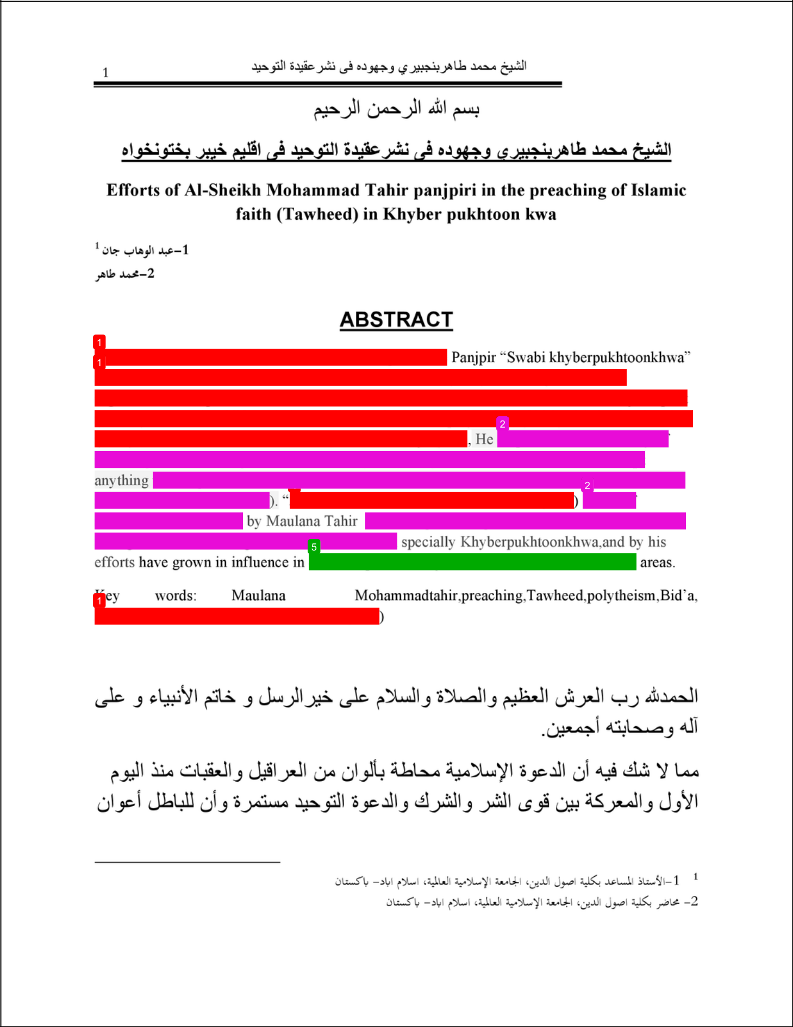

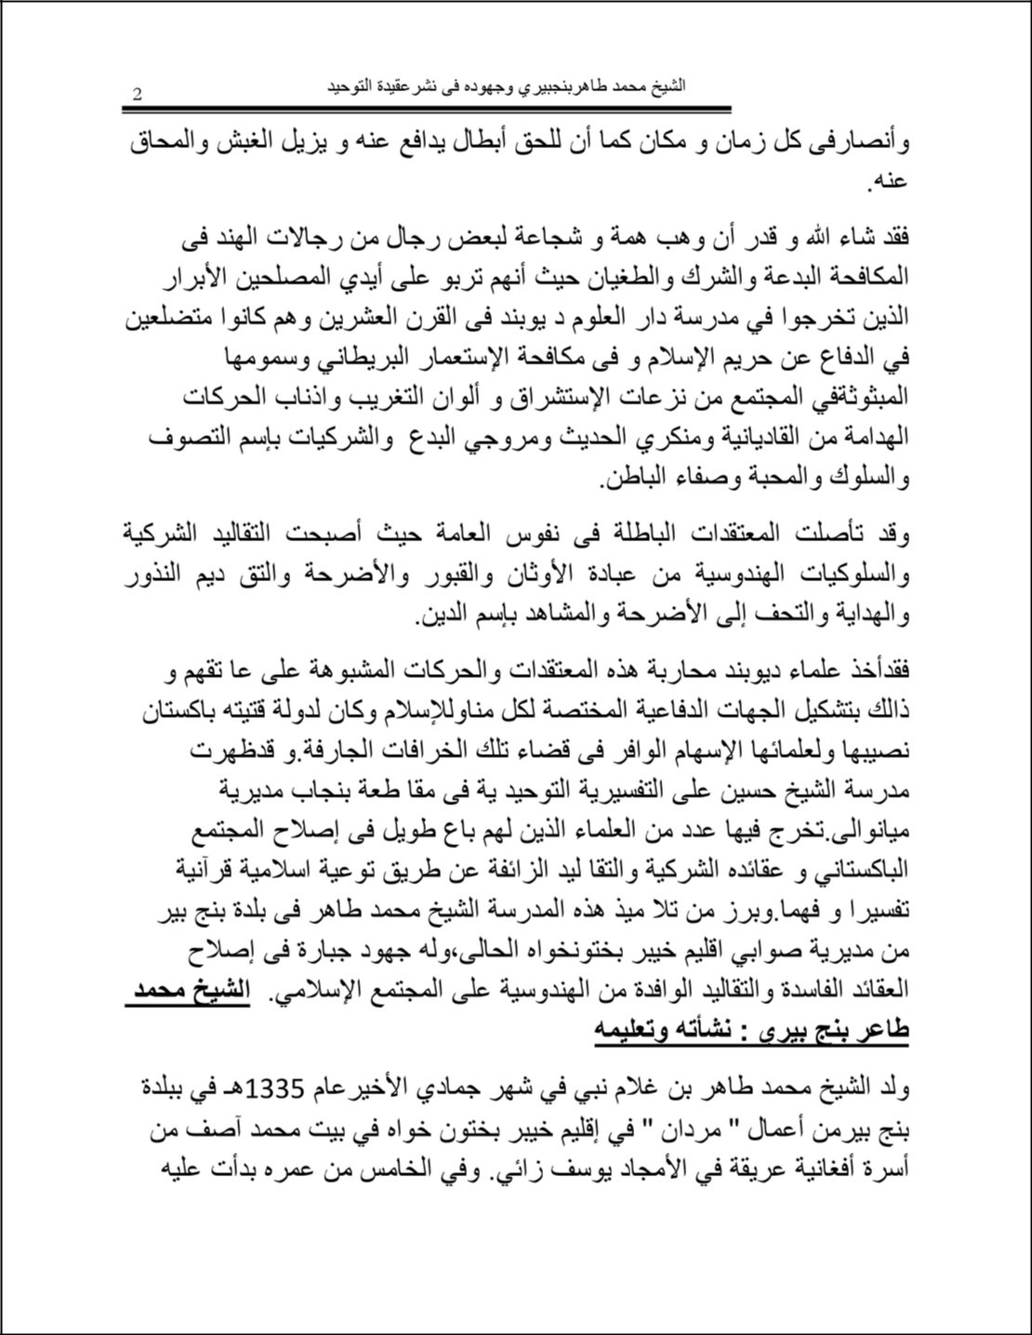

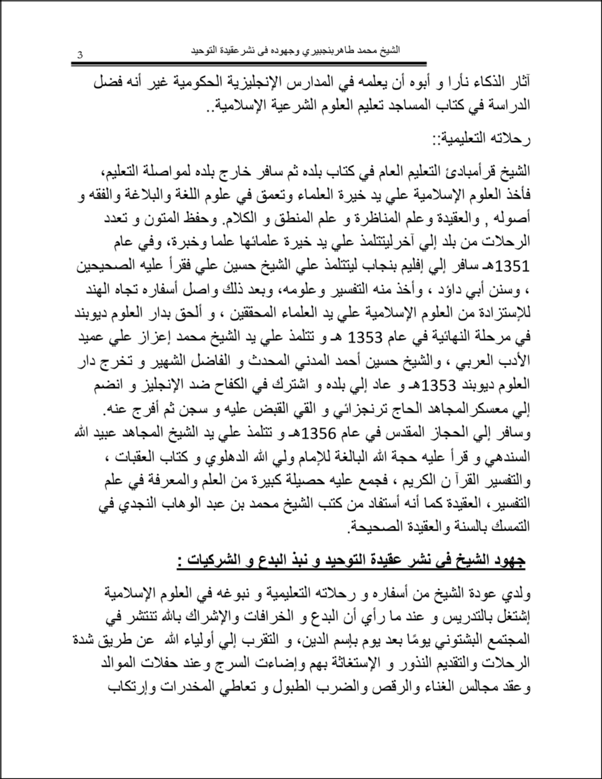

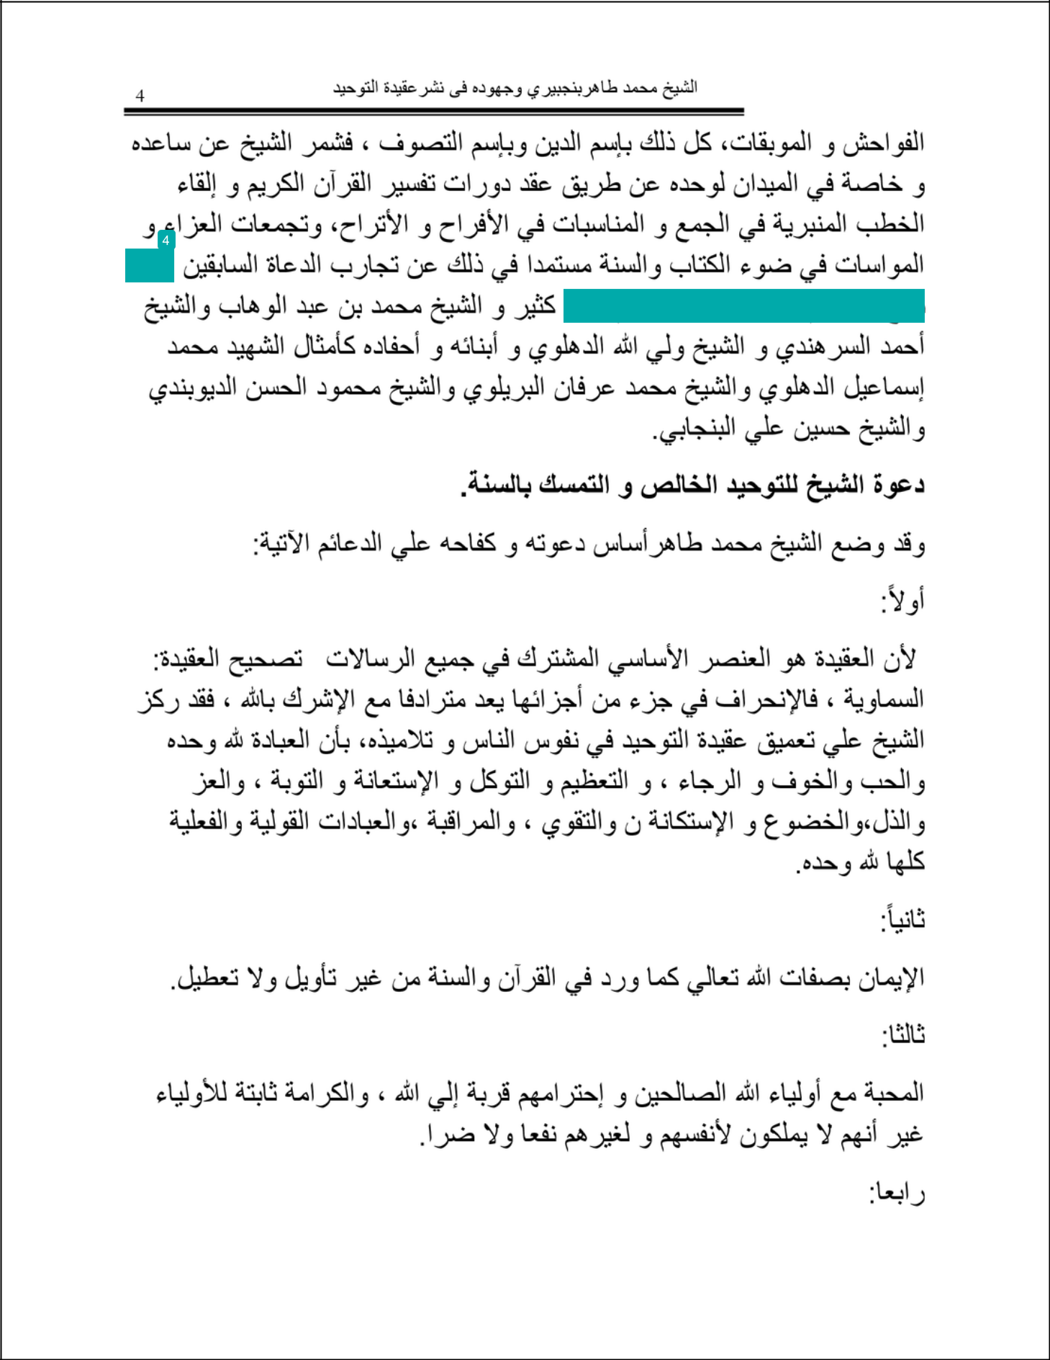

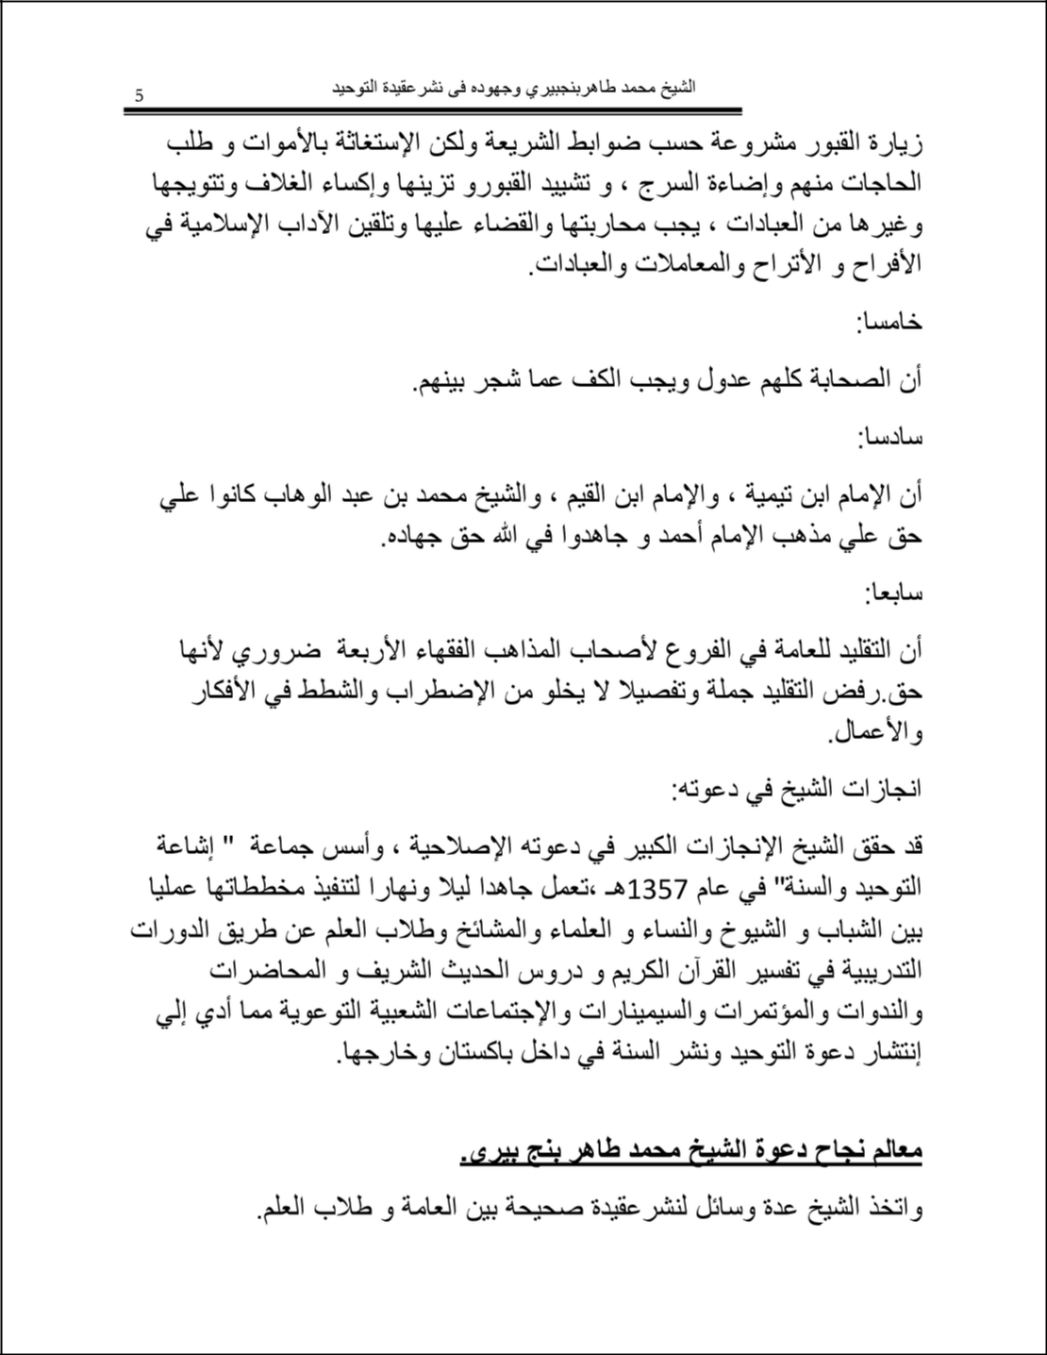

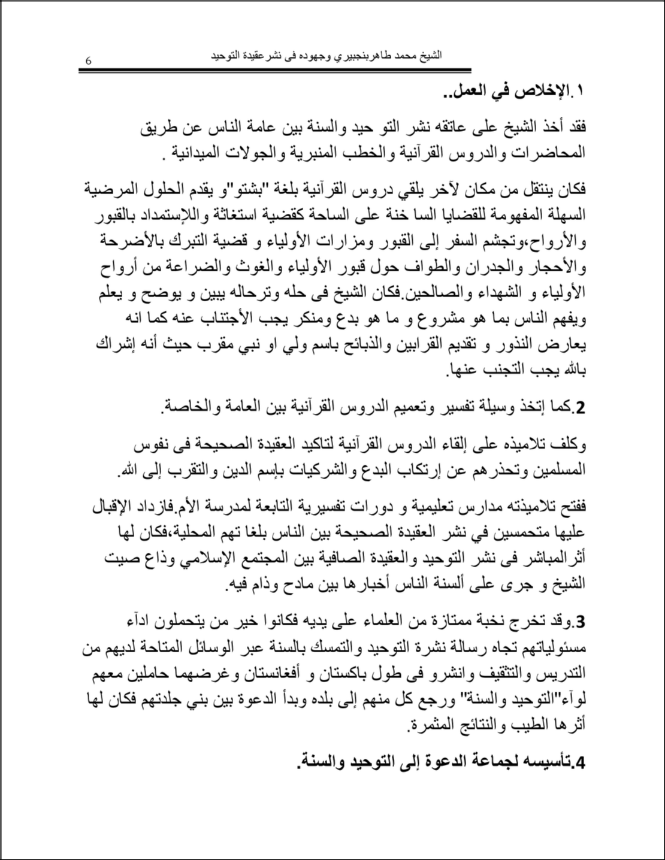

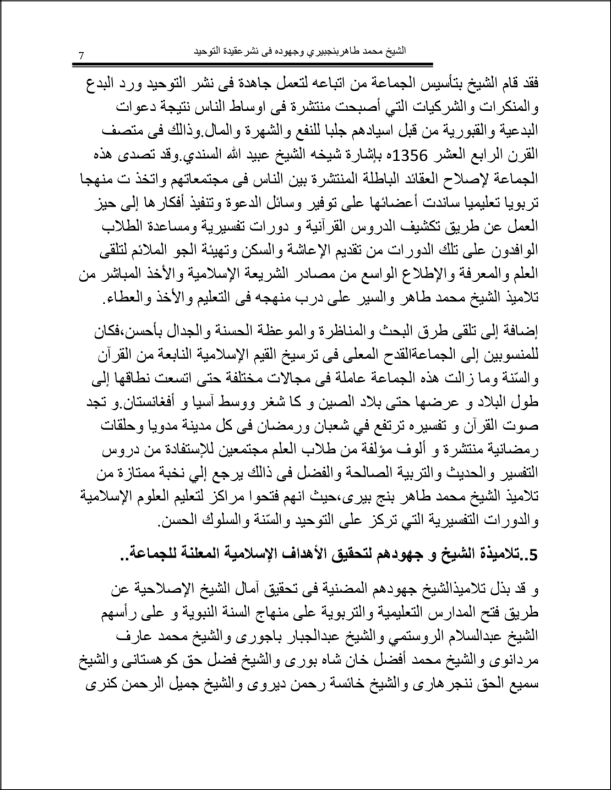

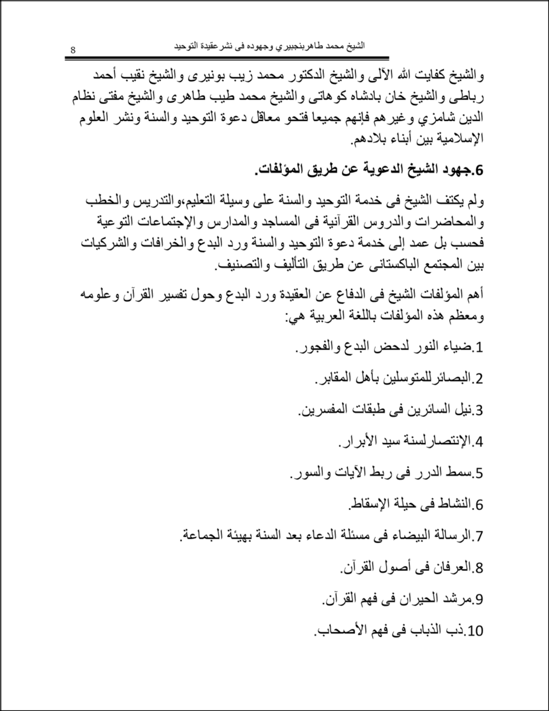

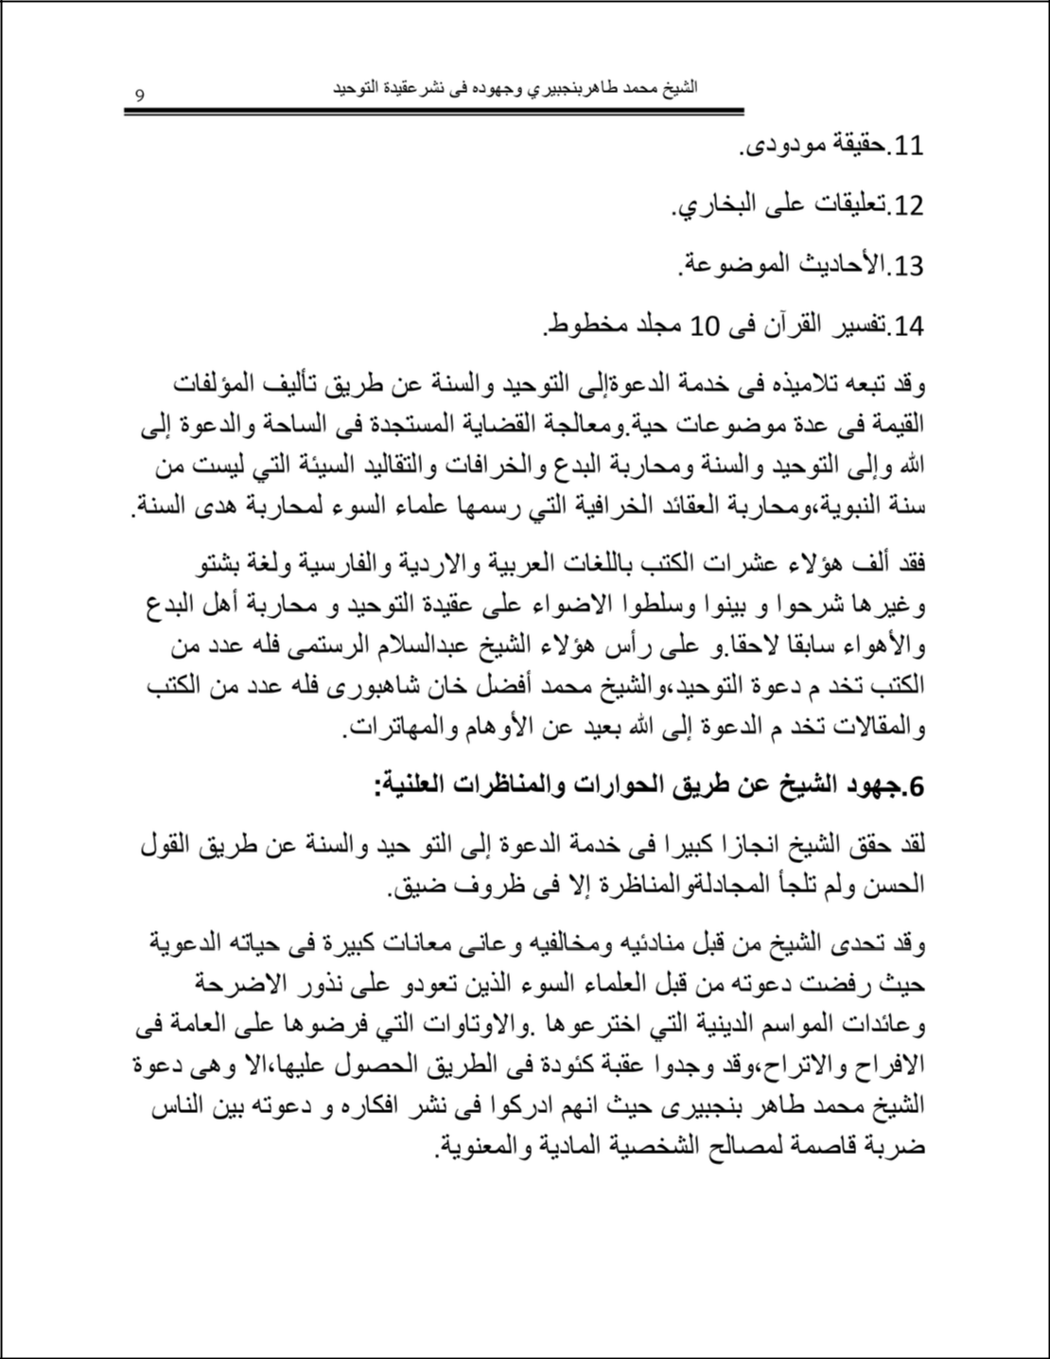

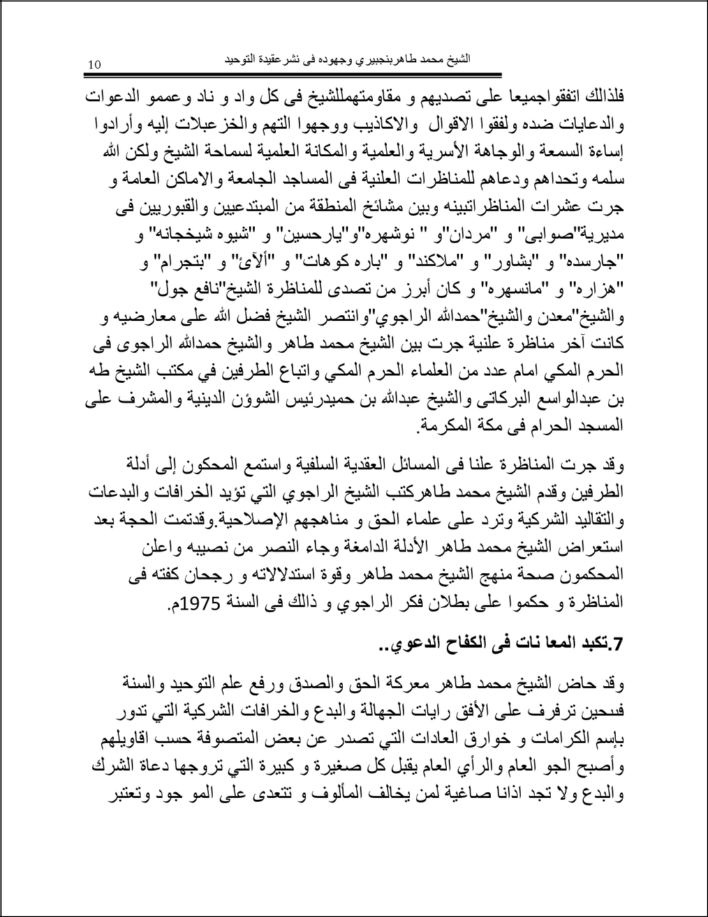

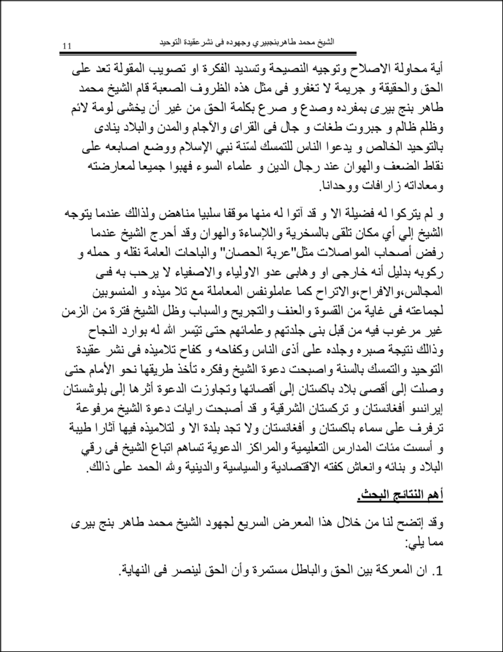

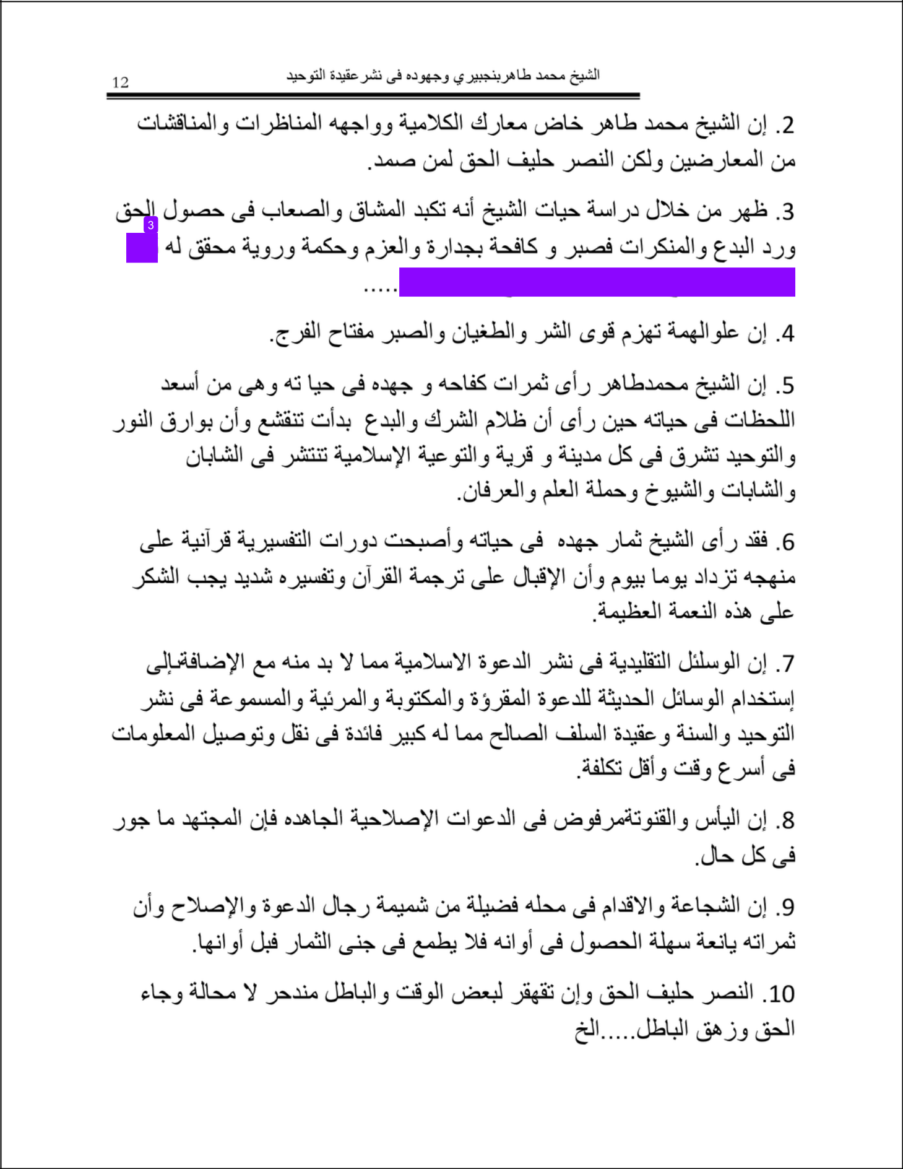

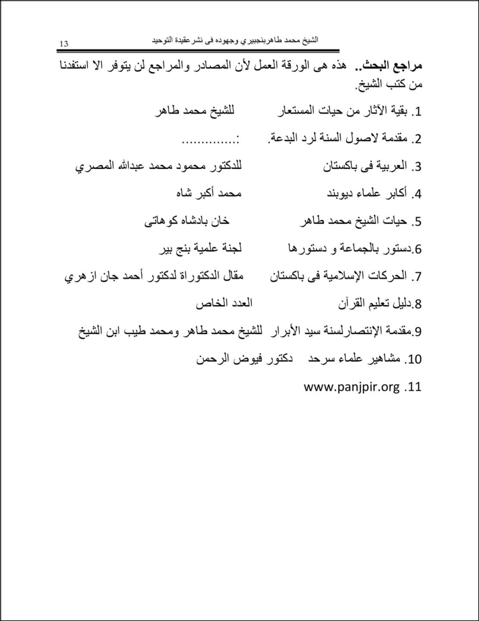

Abdul Wahab Jan and M Tahir

ORIGINALITY REPORT

6% |  |  | 6% | 1% | 1%
 | SIMILARITY INDEX |  | INTERNET SOURCES | PUBLICATIONS | STUDENT PAPERS
 | PRIMARY SOURCES
 |  | defenderofhope.blogspot.fr |  |  | 3%
 | 1
 |  | Internet Source
 |  | www.islamonline.net |  |  | 2%
 | 2
 |  | Internet Source
 |  | muslm.net |  |  | <1%
 | 3
 |  | Internet Source
 |  | anbacom.com |  |  | <1%
 | 4
 |  | Internet Source
 |  | www.tribalanalysiscenter.com |  |  | <1%
 | 5
 |  | Internet Source

Exclude quotes

Of f

Exclude matches

Of f

Exclude bibliography

Of f

