Alhamd Islamika Article Shabir Shehwani

by Salman Ahmed Assistant Director Qec

Submission date: 13-Jun-2019 12:03PM (UTC+0500)

Submission ID: 1143205784

File name: .doc (136.5K)

Word count: 4777

Character count: 18138

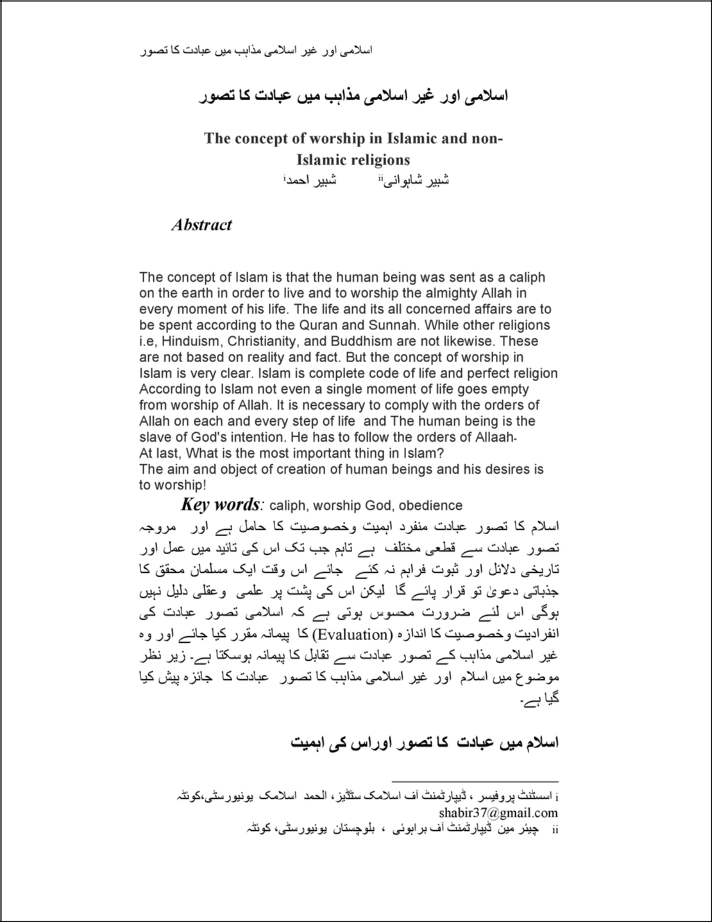

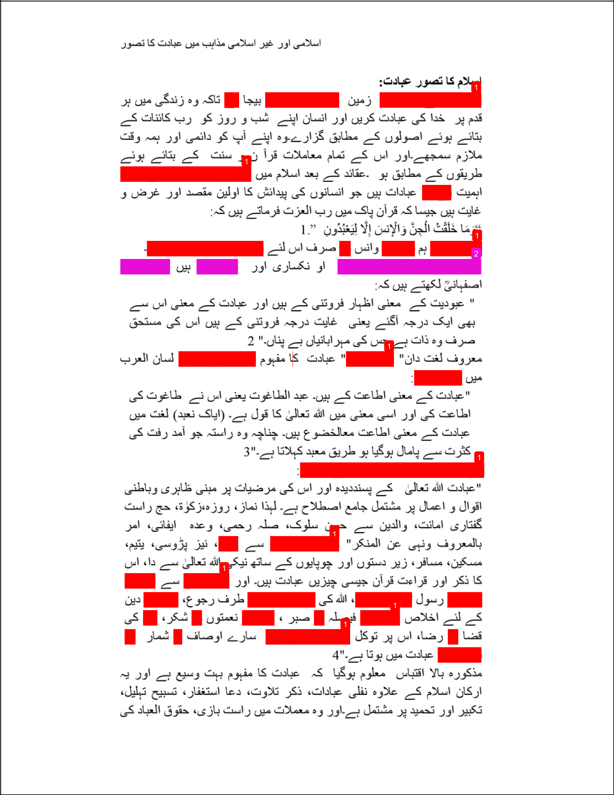

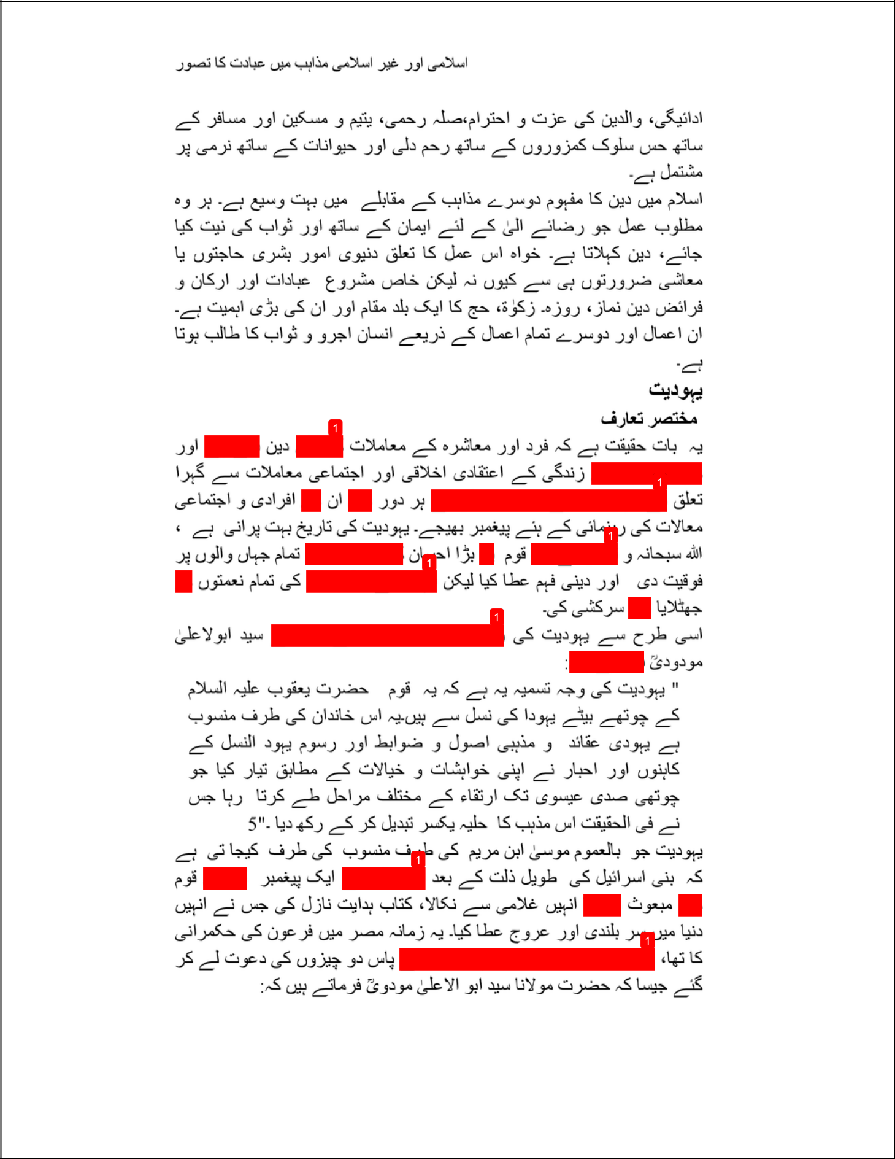

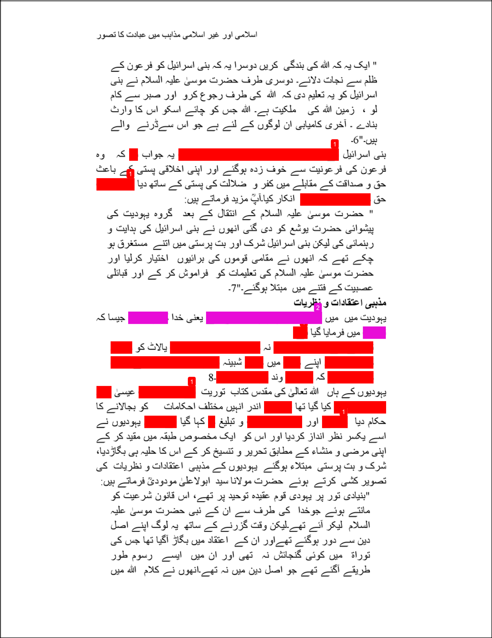

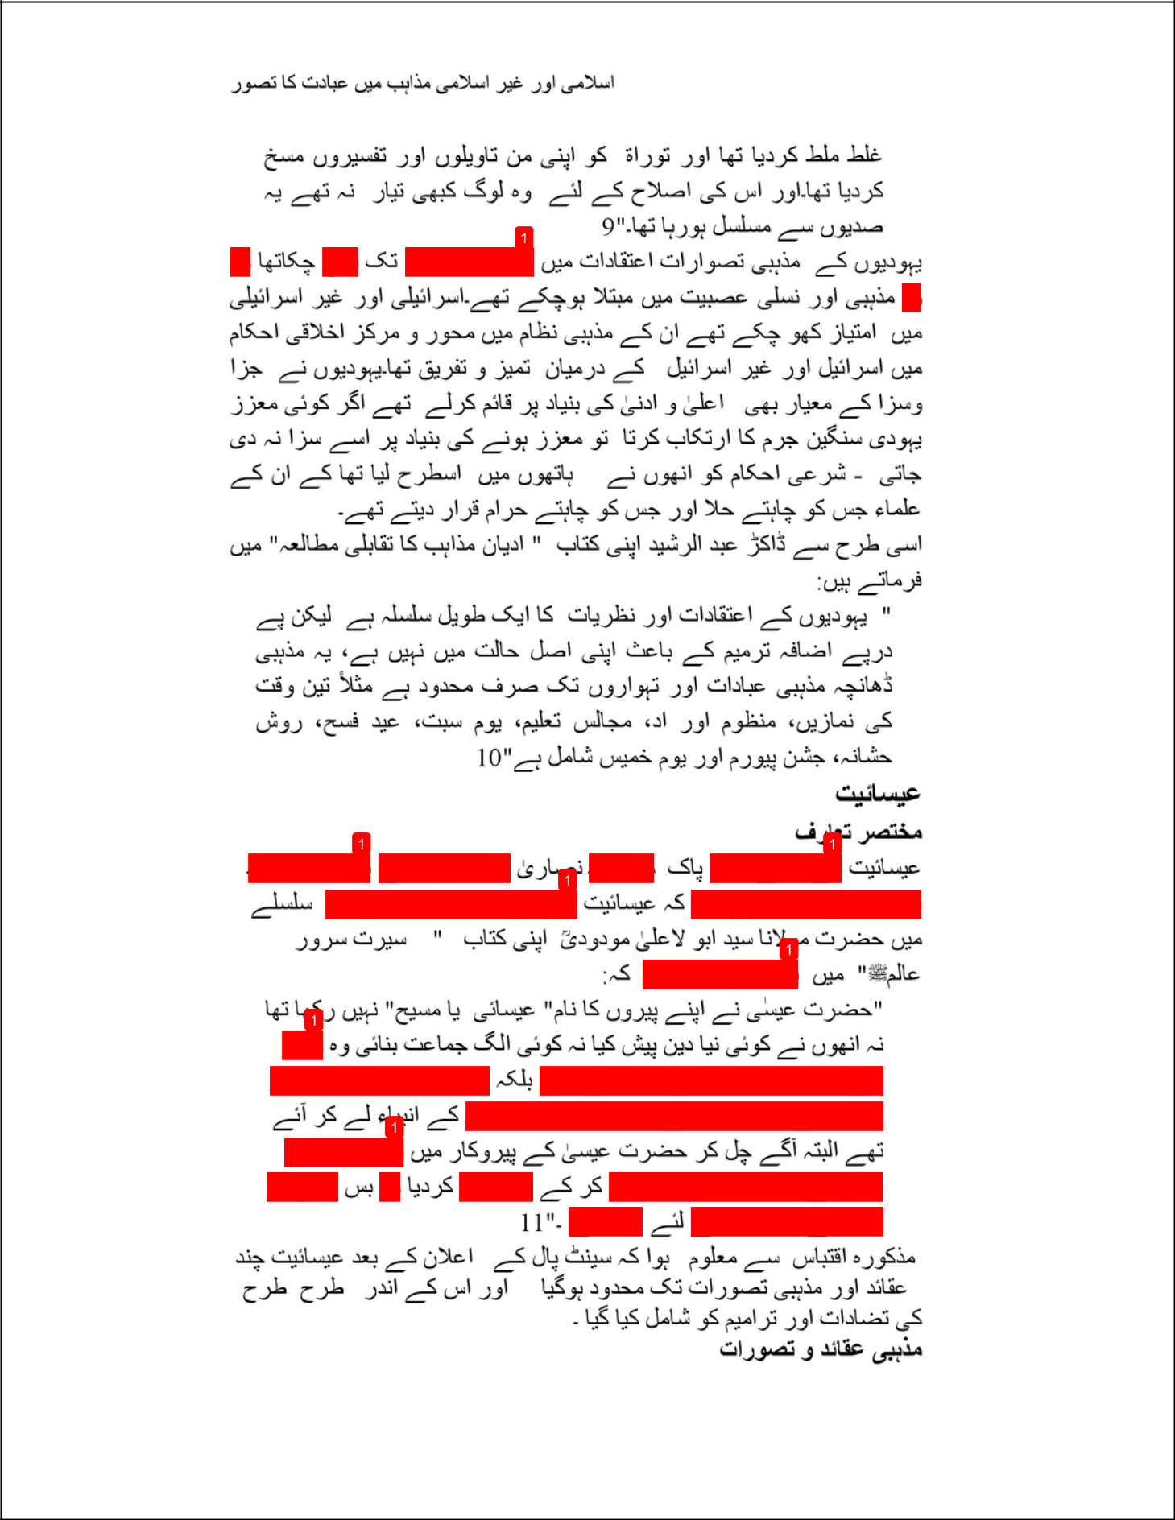

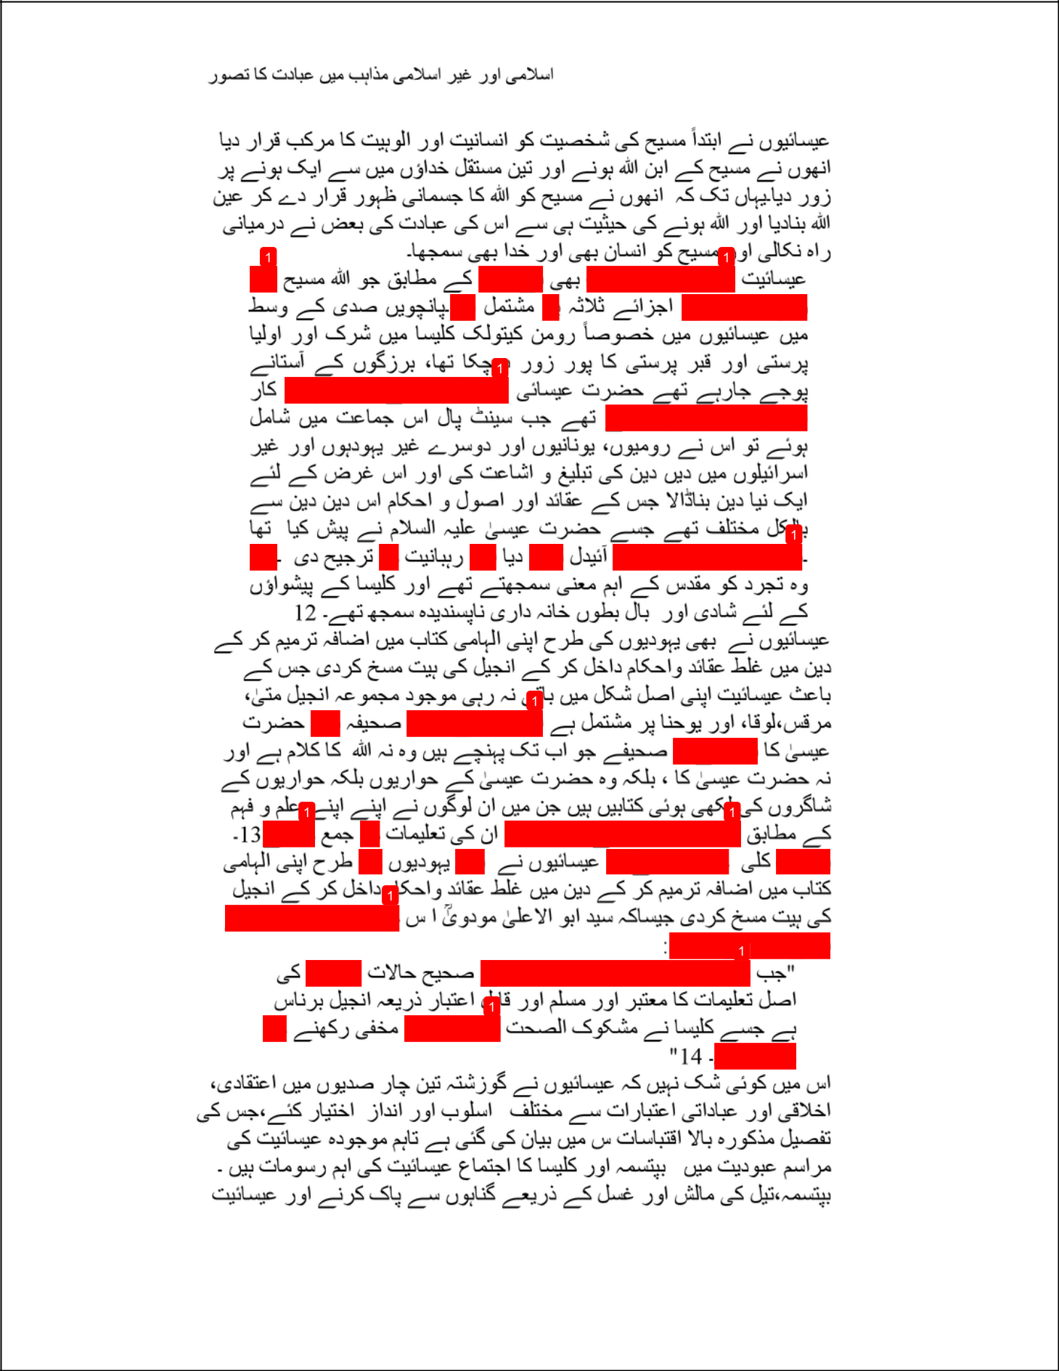

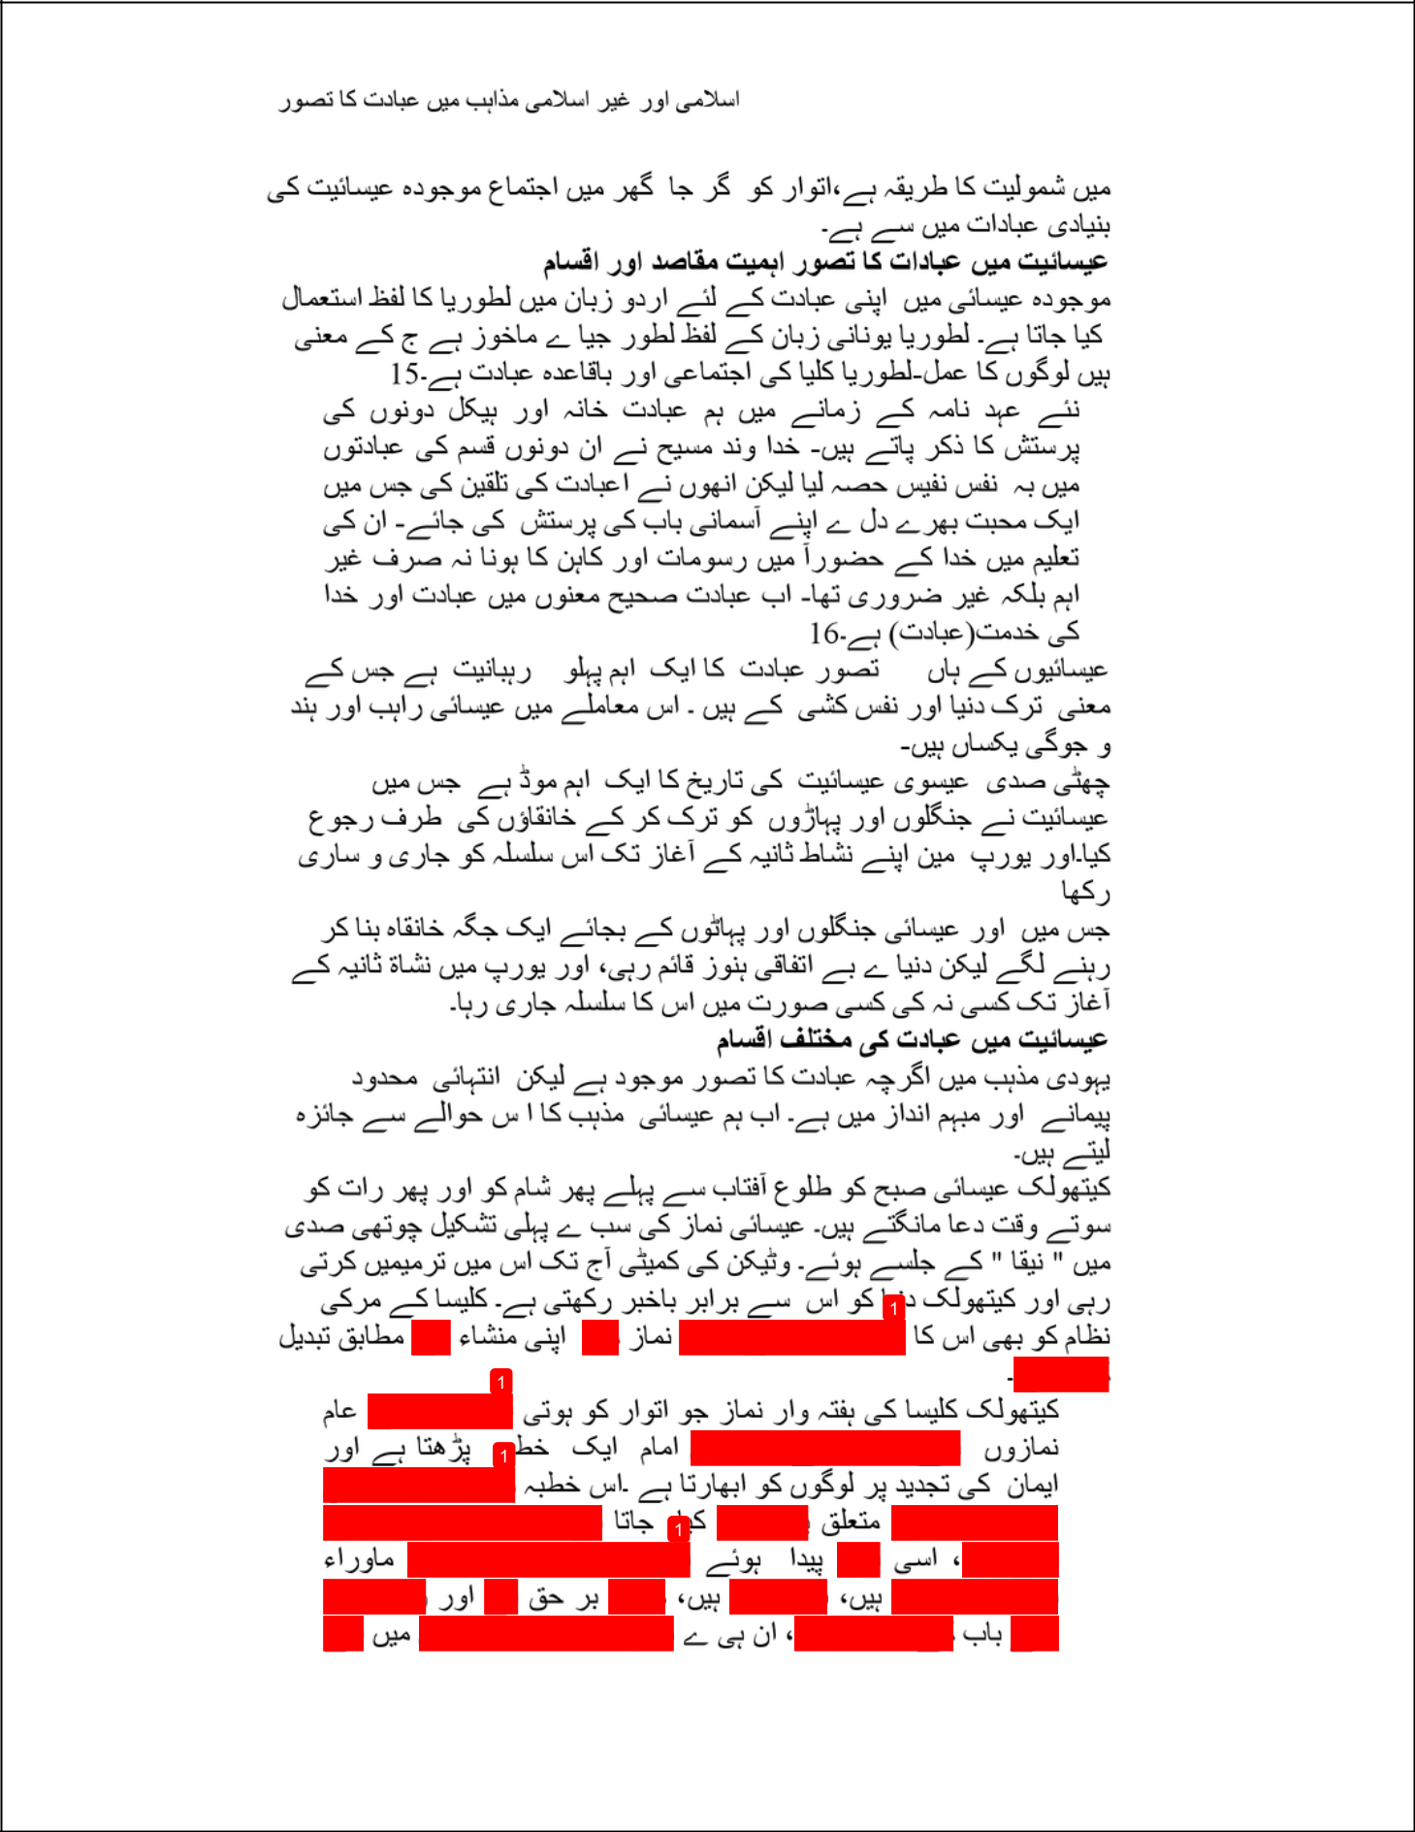

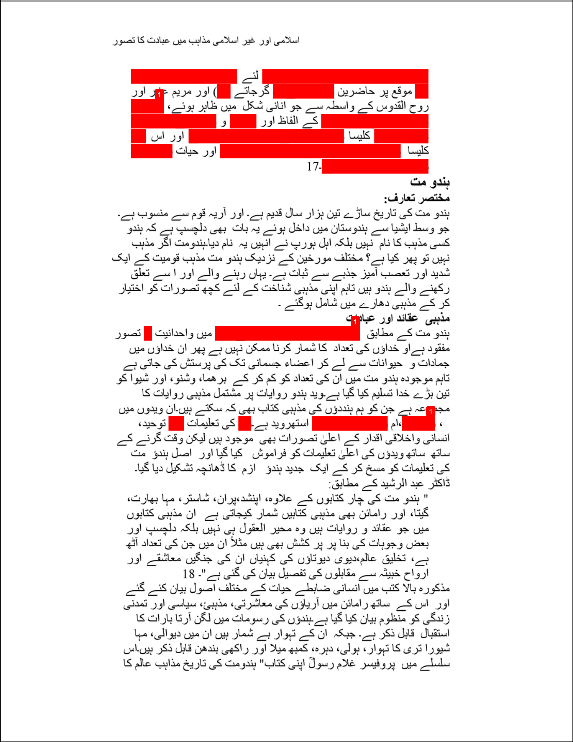

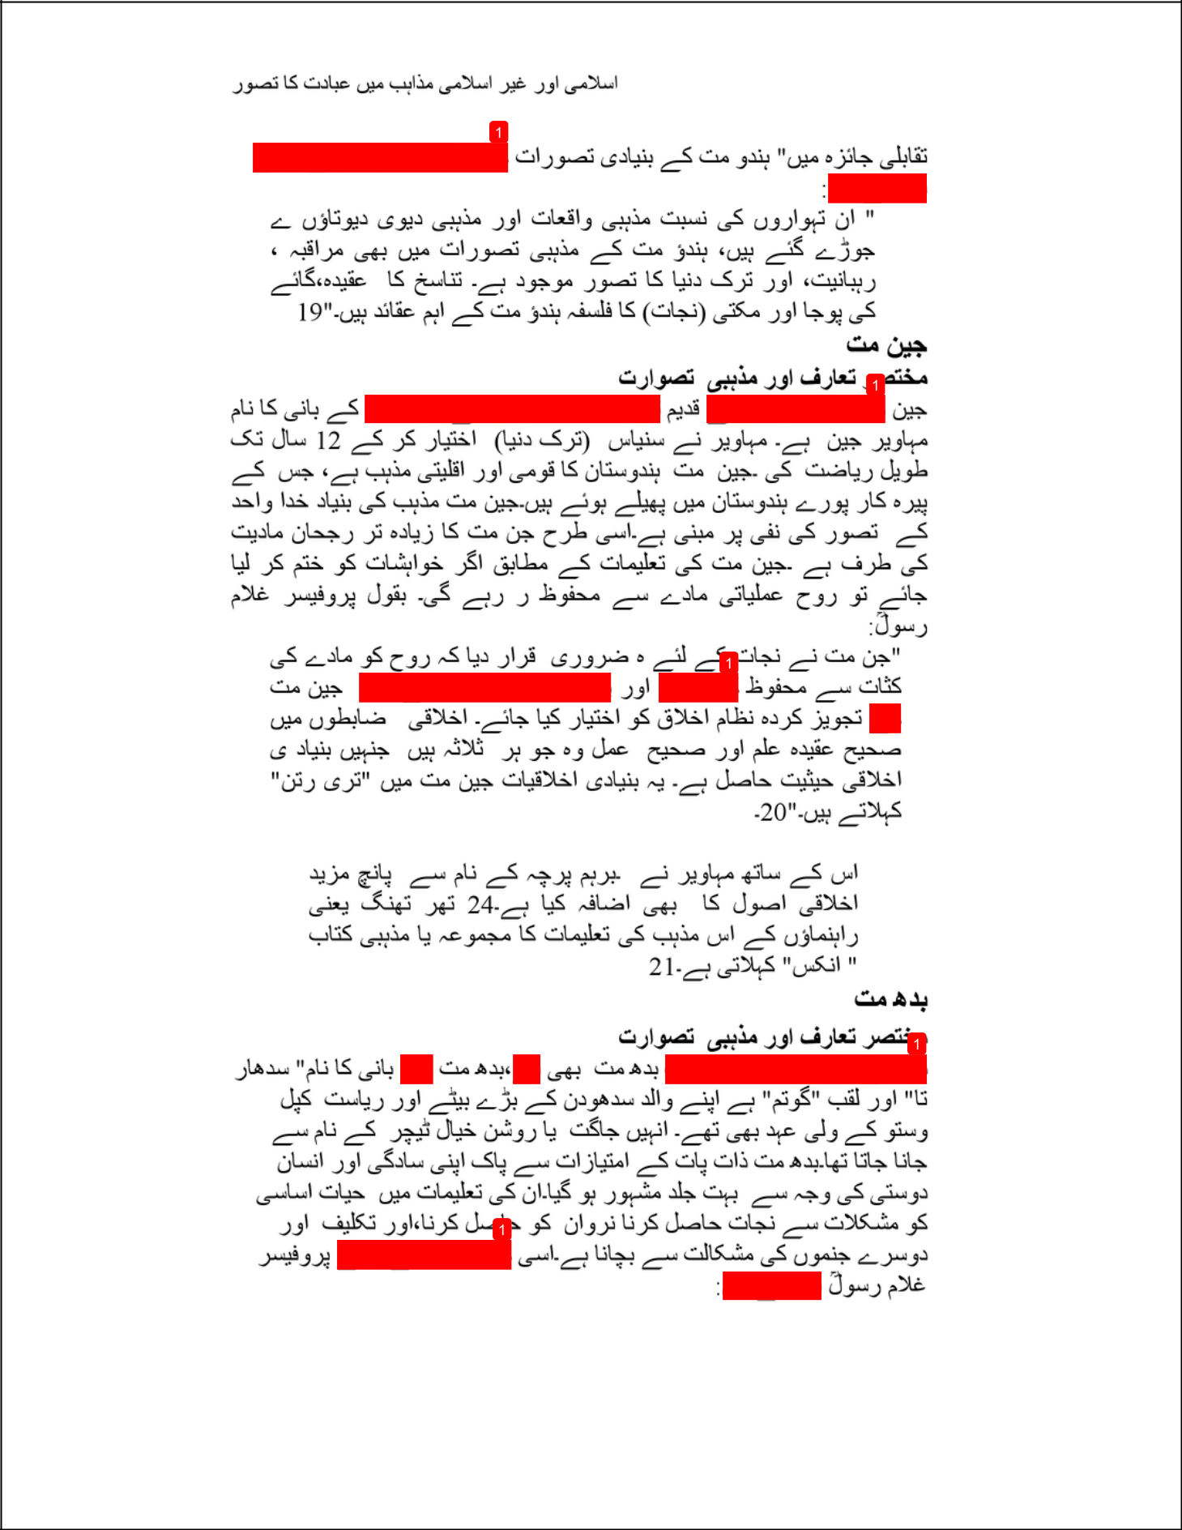

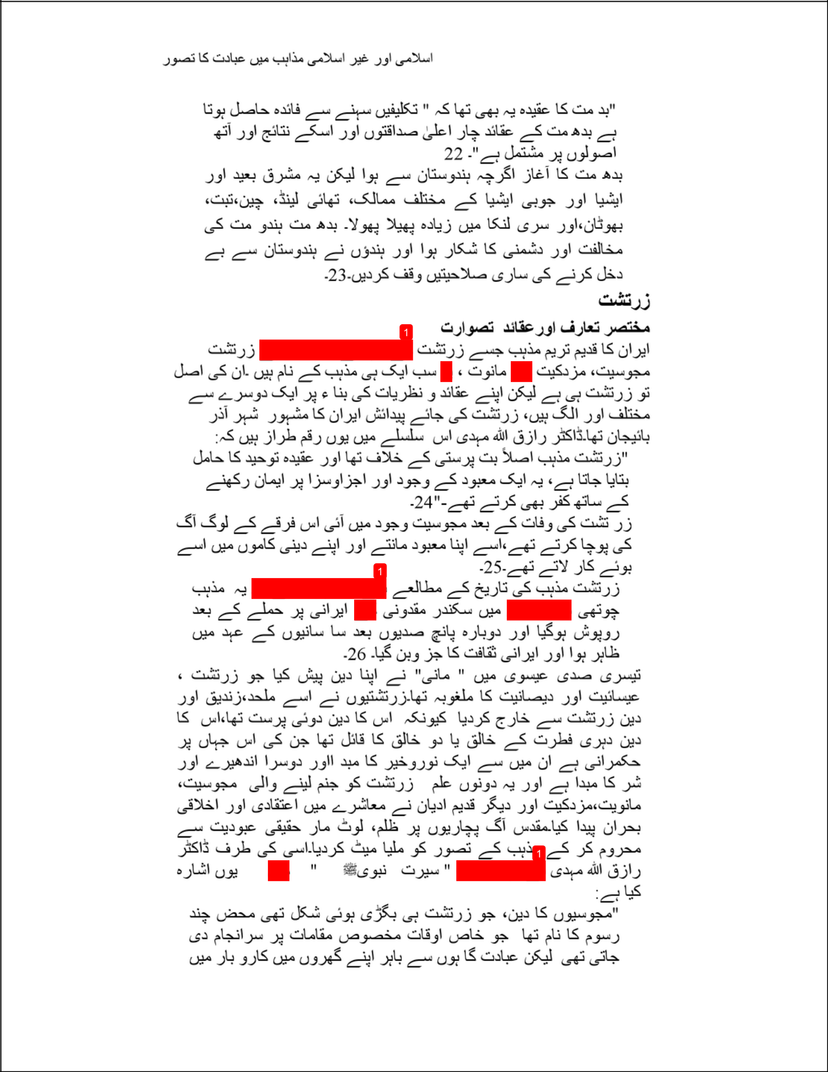

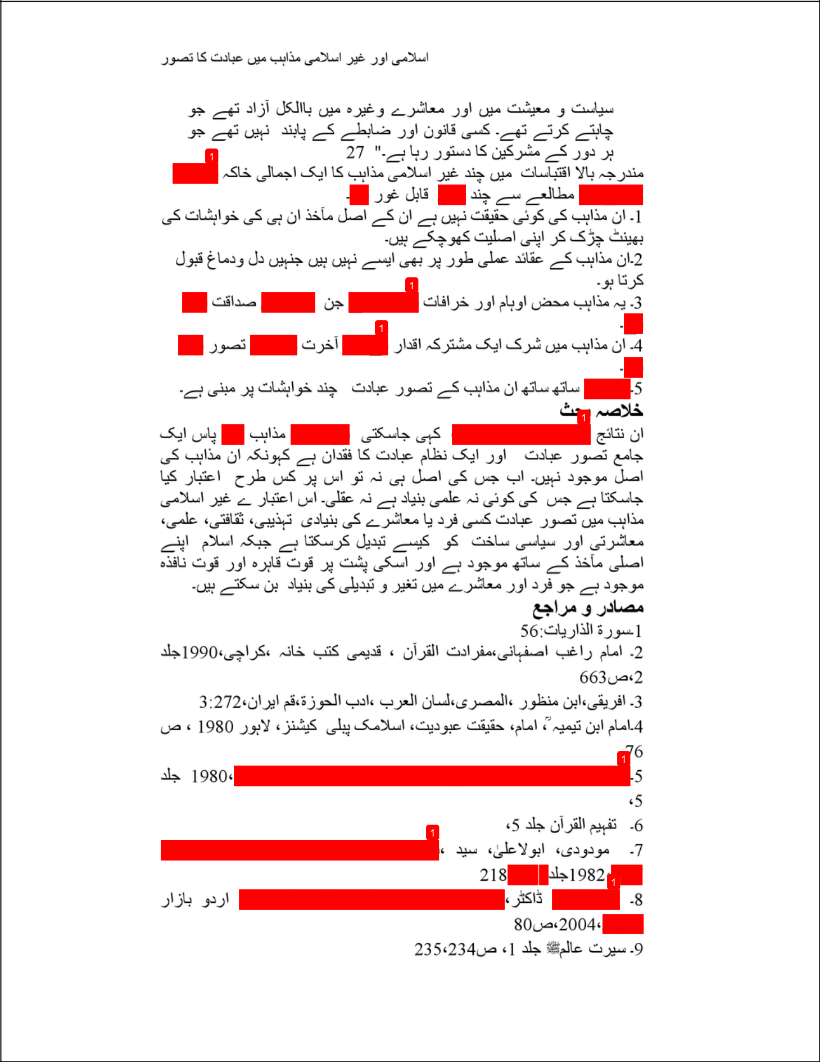

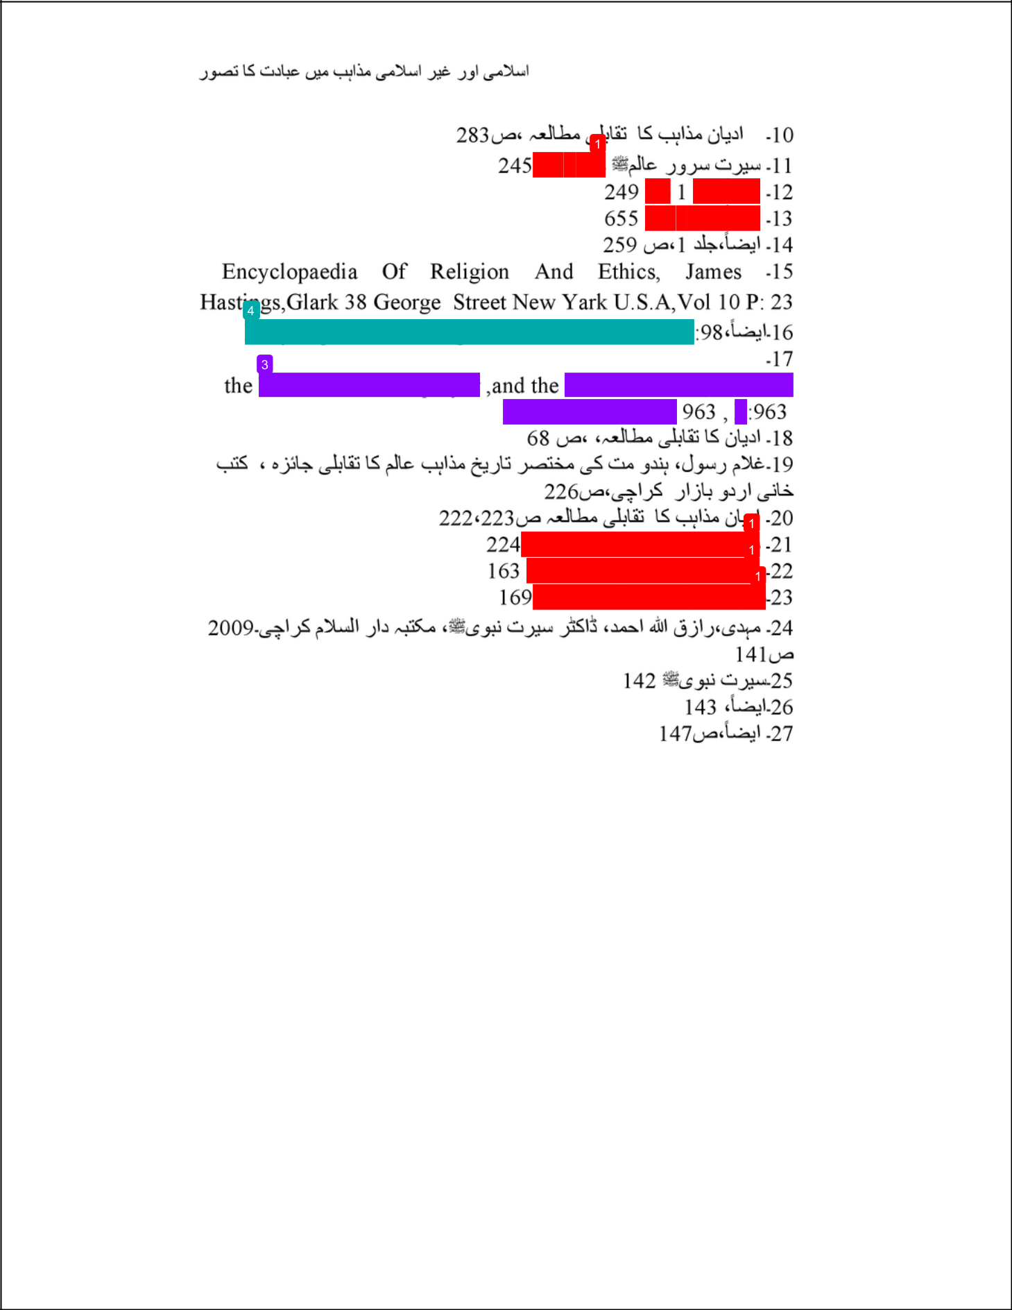

Alhamd Islamika Article Shabir Shehwani

ORIGINALITY REPORT

13% |  |  | 1% | 0% | 13%
 | SIMILARITY INDEX |  | INTERNET SOURCES | PUBLICATIONS | STUDENT PAPERS
 | PRIMARY SOURCES
 |  | Submitted to Higher Education Commission |  |  |  | 12%
 | 1
 |  | Pakistan
 |  | Student Paper
 |  | www.al-mawrid.org |  |  |  | <1%
 | 2
 |  | Internet Source
 |  | crossasia-repository.ub.uni-heidelberg.de |  |  |  | <1%
 | 3
 |  | Internet Source
 |  | enhancedwiki.altervista.org |  |  |  | <1%
 | 4
 |  | Internet Source

Exclude quotes

On

Exclude matches

Of f

Exclude bibliography

On

