Dr. Abdul Achakzai

by Salman ahmed

Submission date: 12-May-2018 01:48PM (UTC+0500)

Submission ID: 952603861

File name: 1.docx (117.25K)

Word count: 6402

Character count: 31380

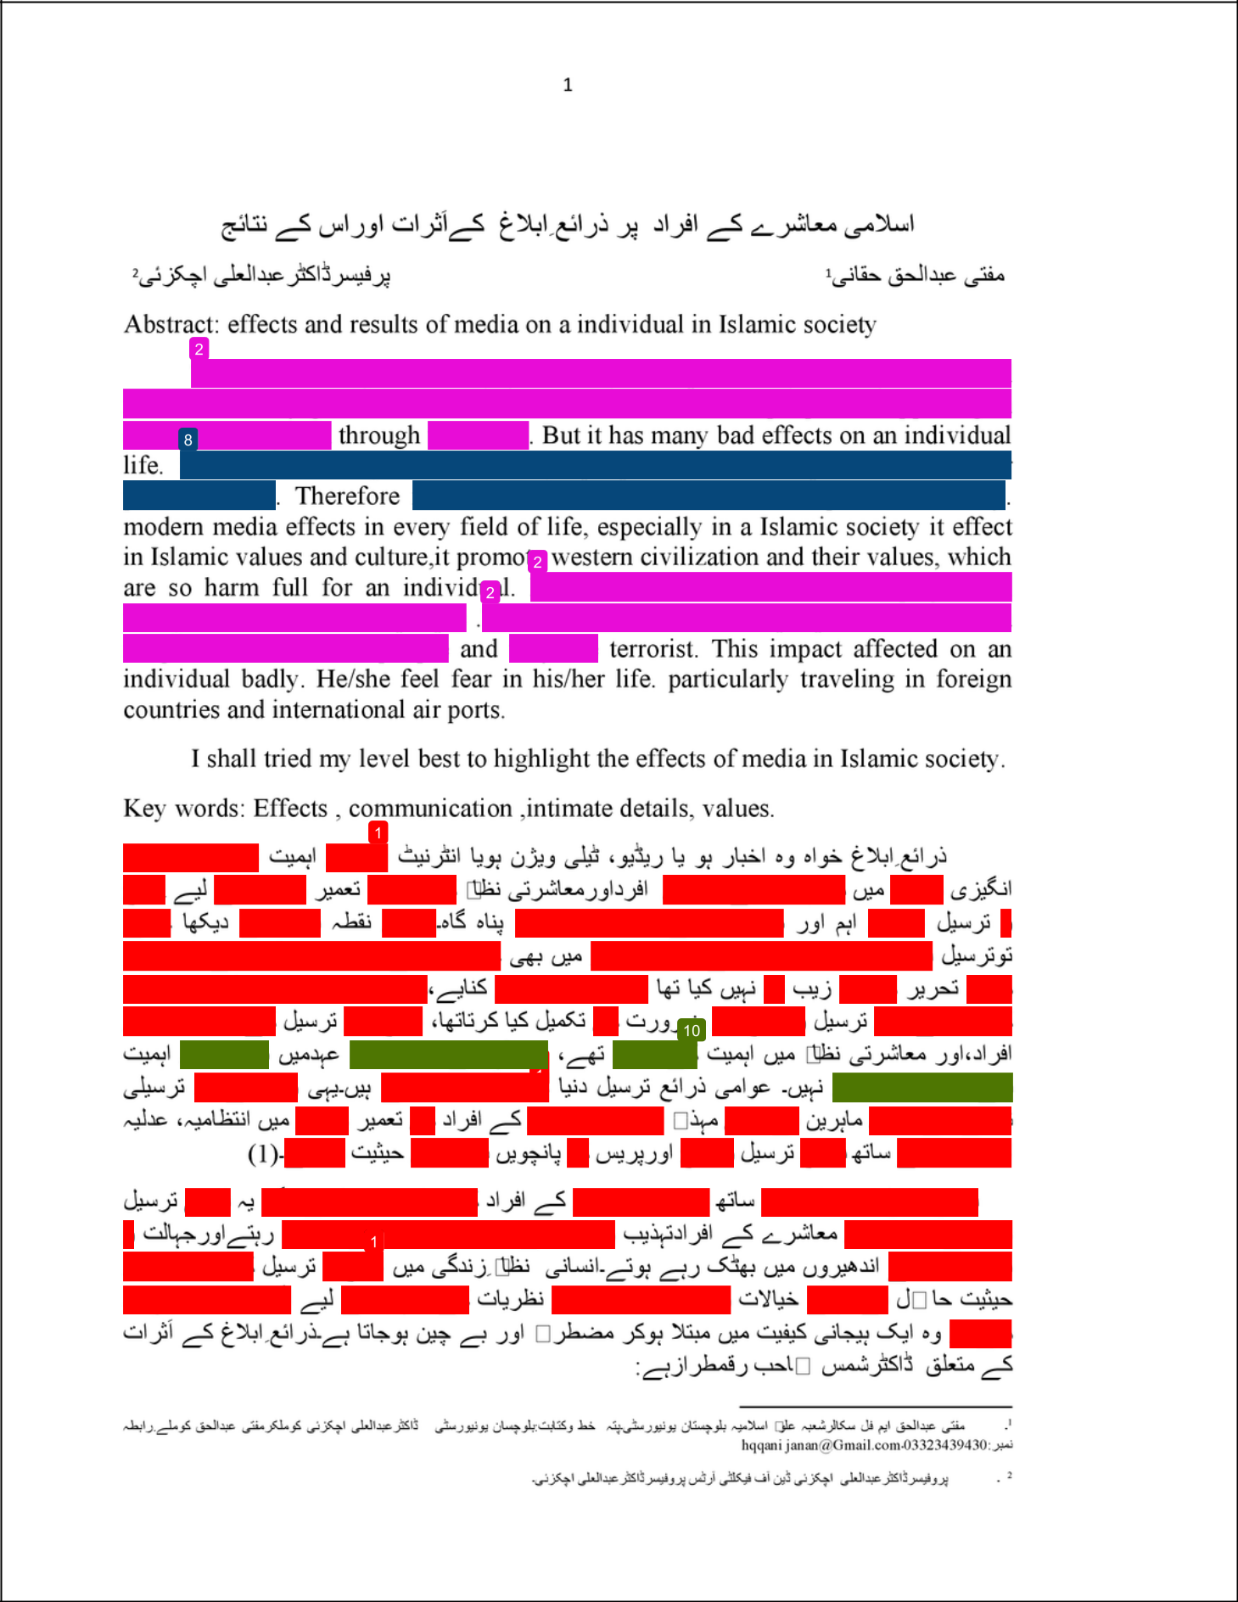

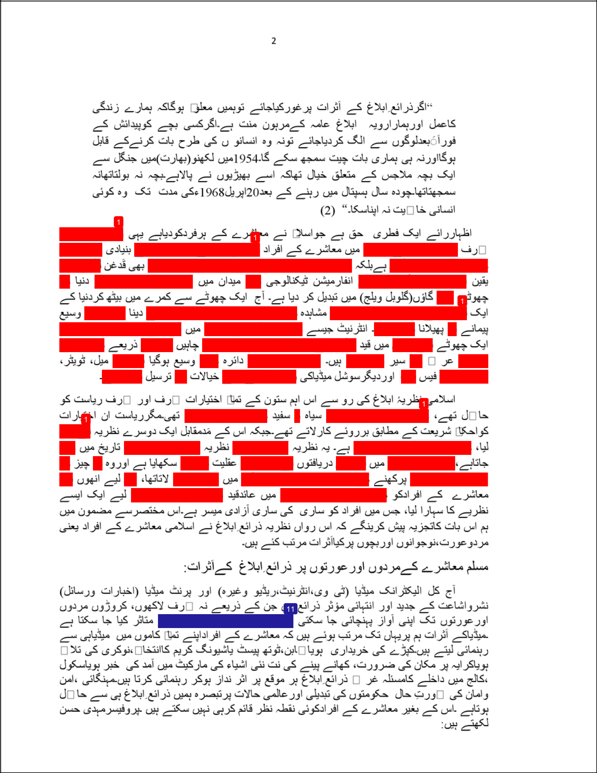

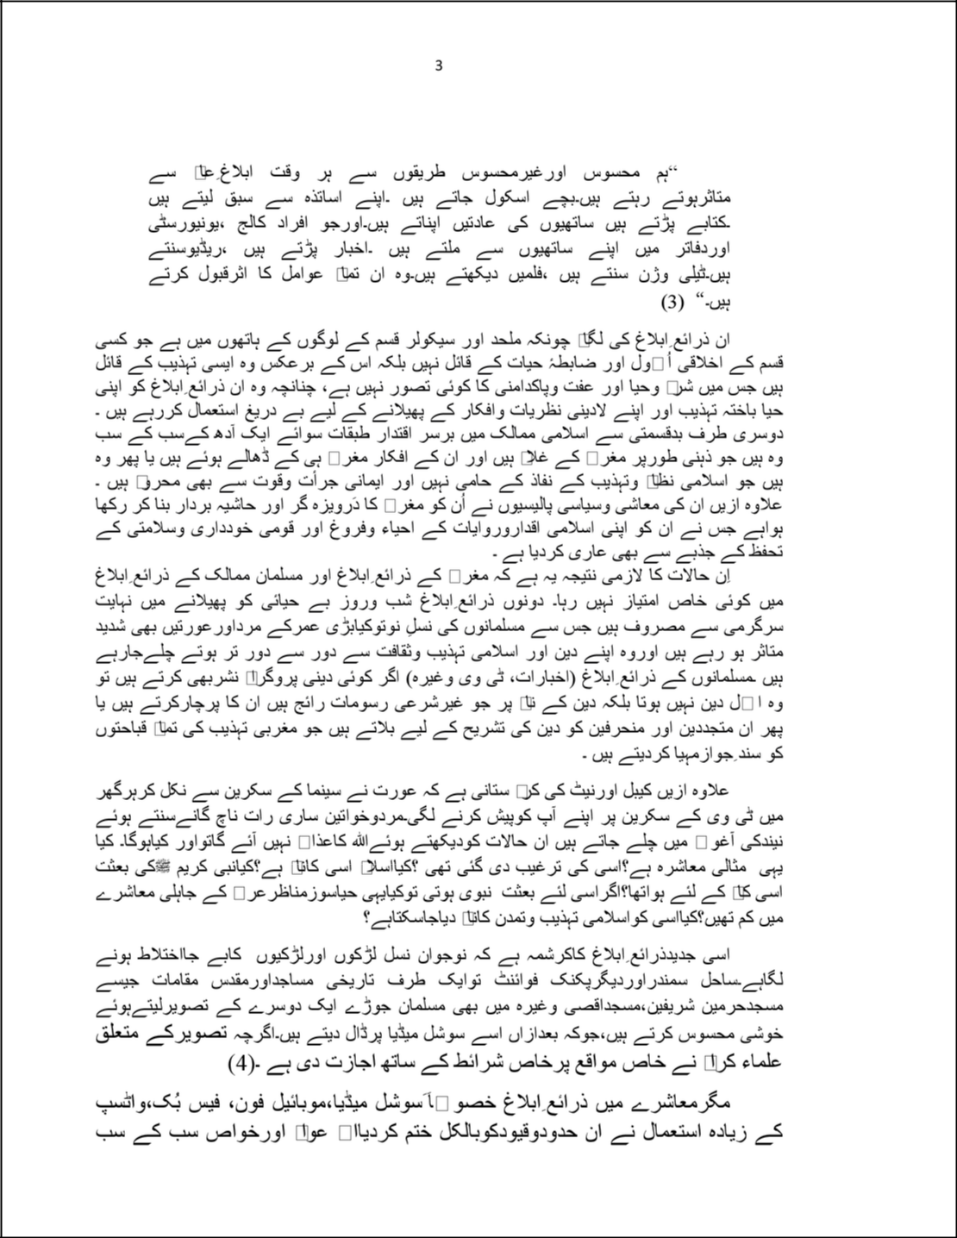

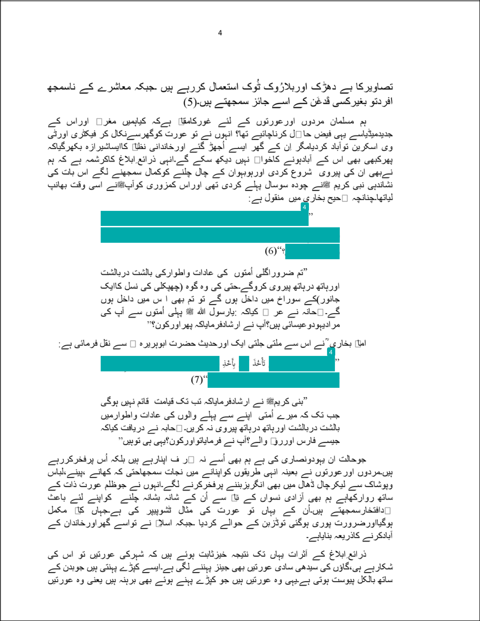

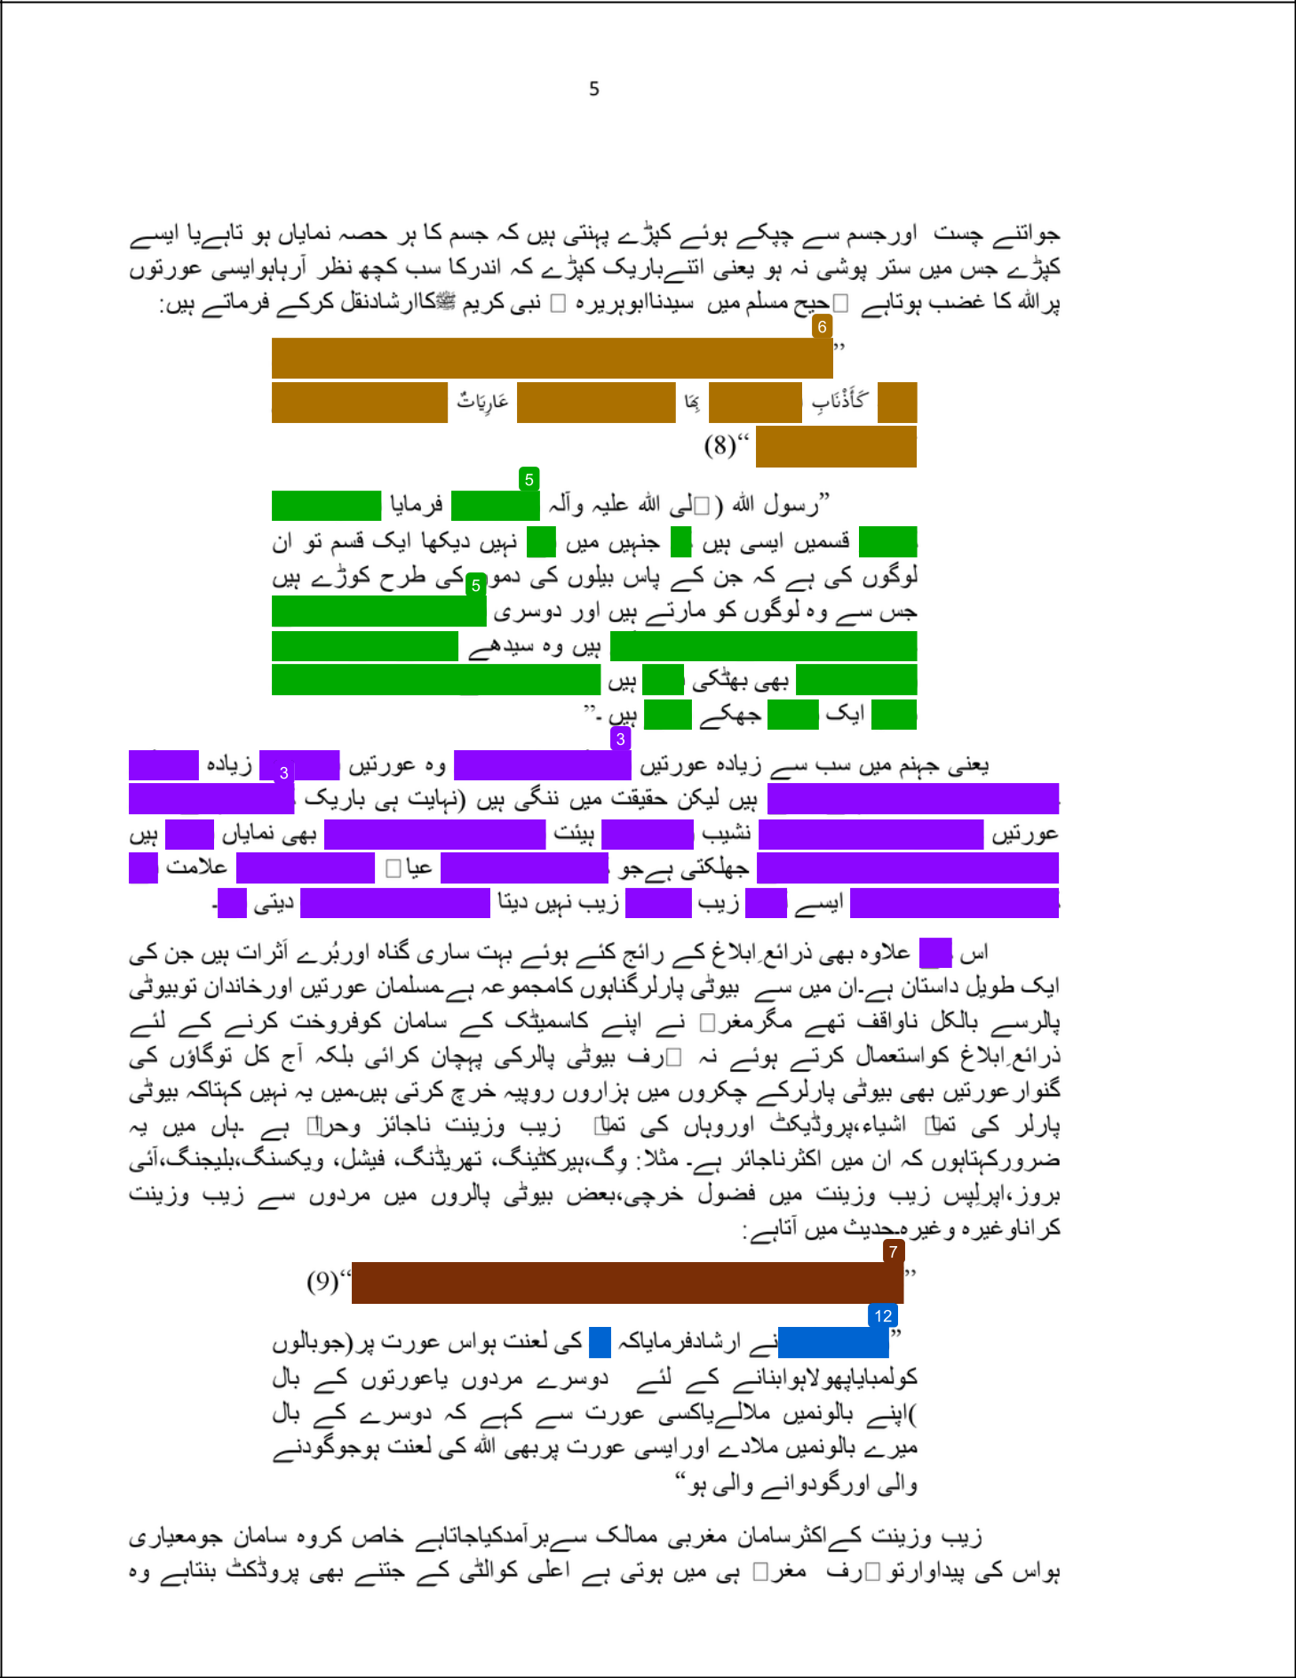

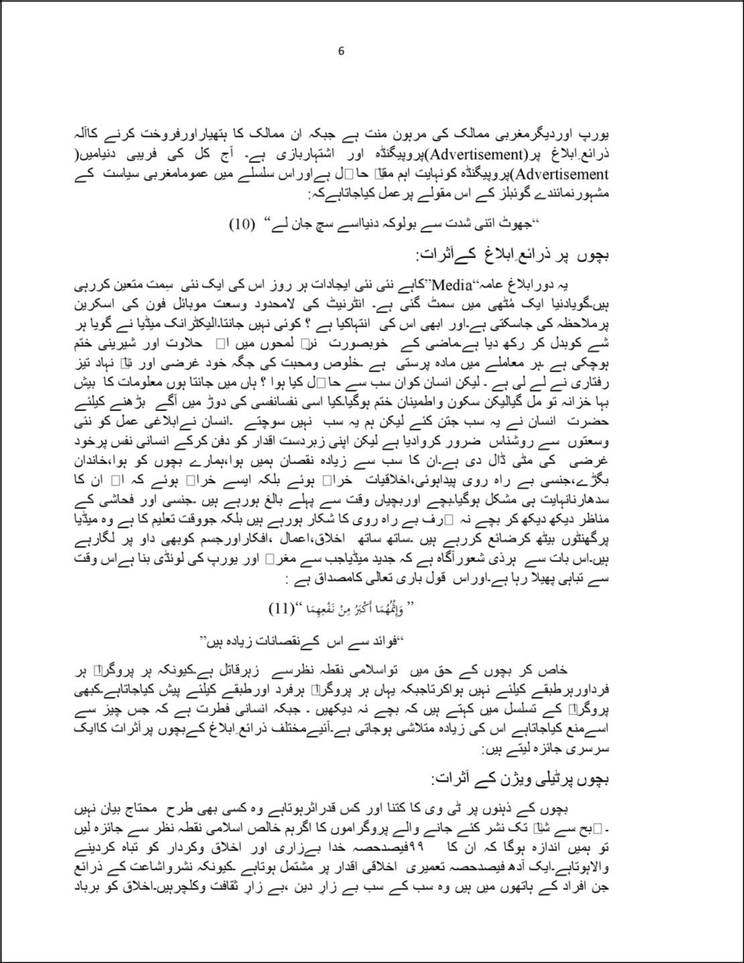

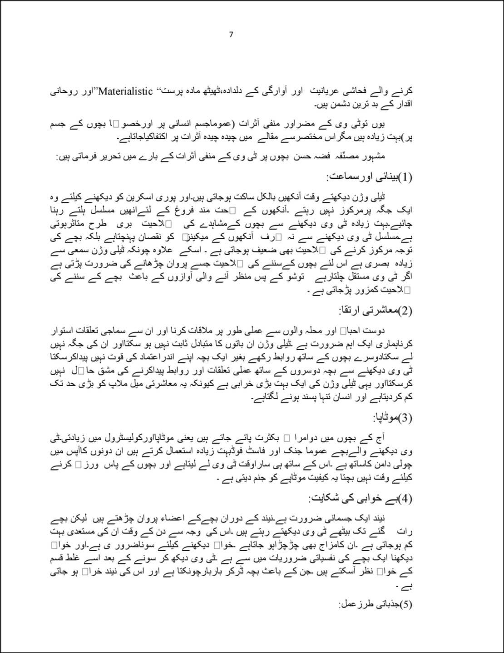

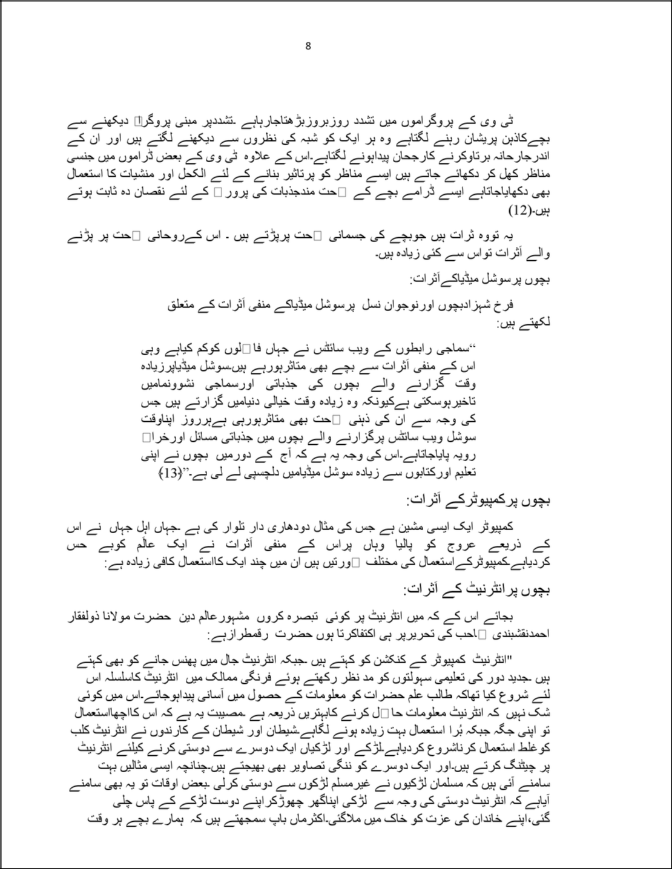

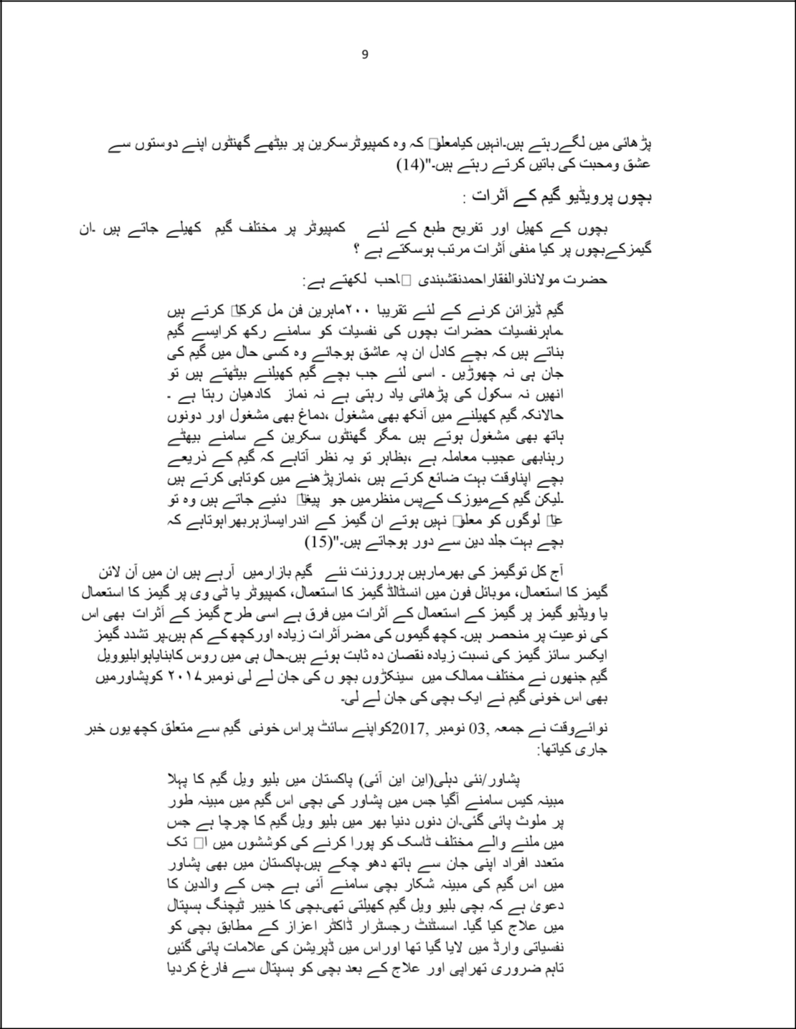

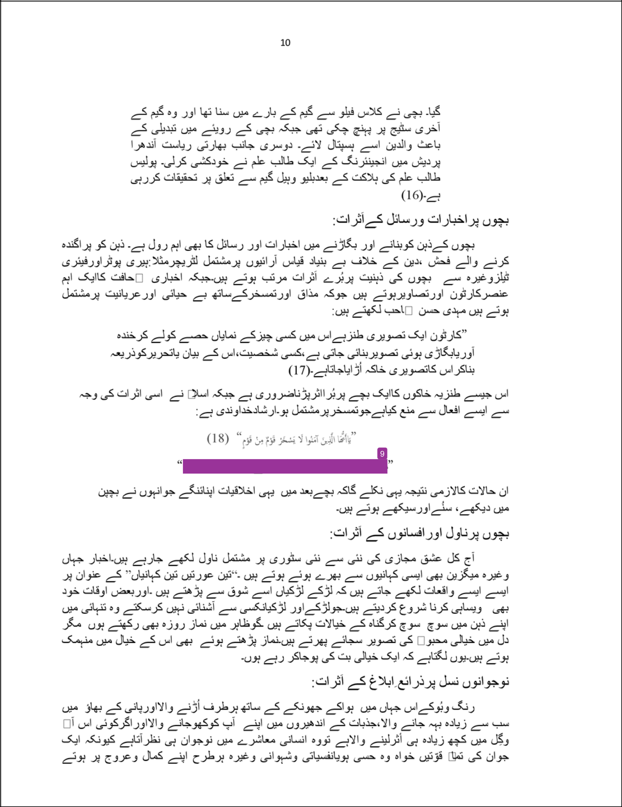

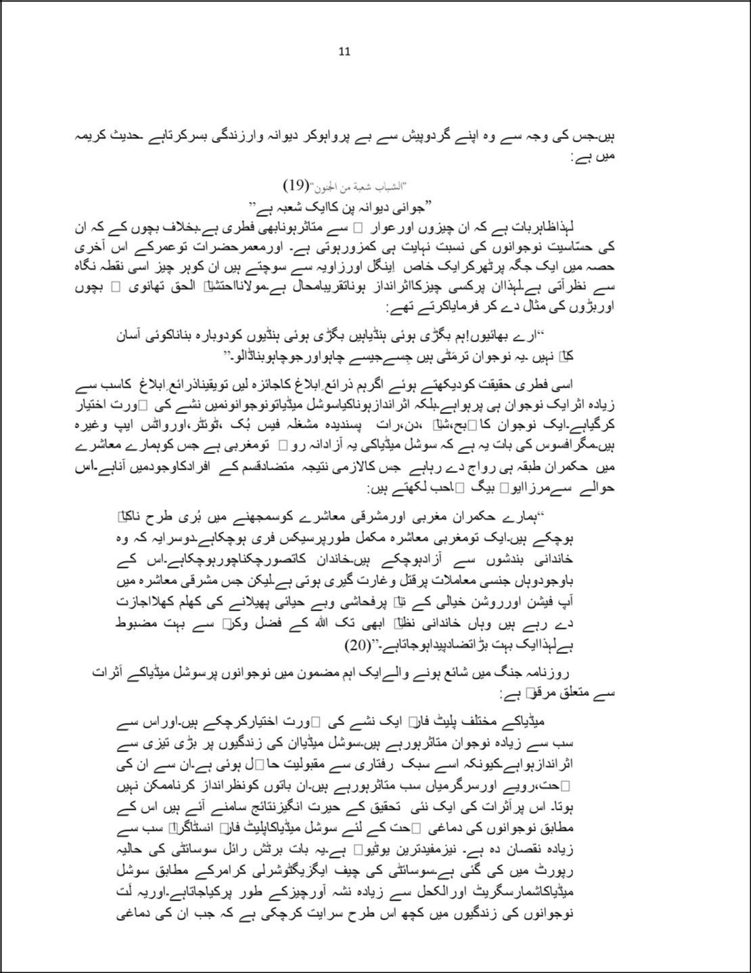

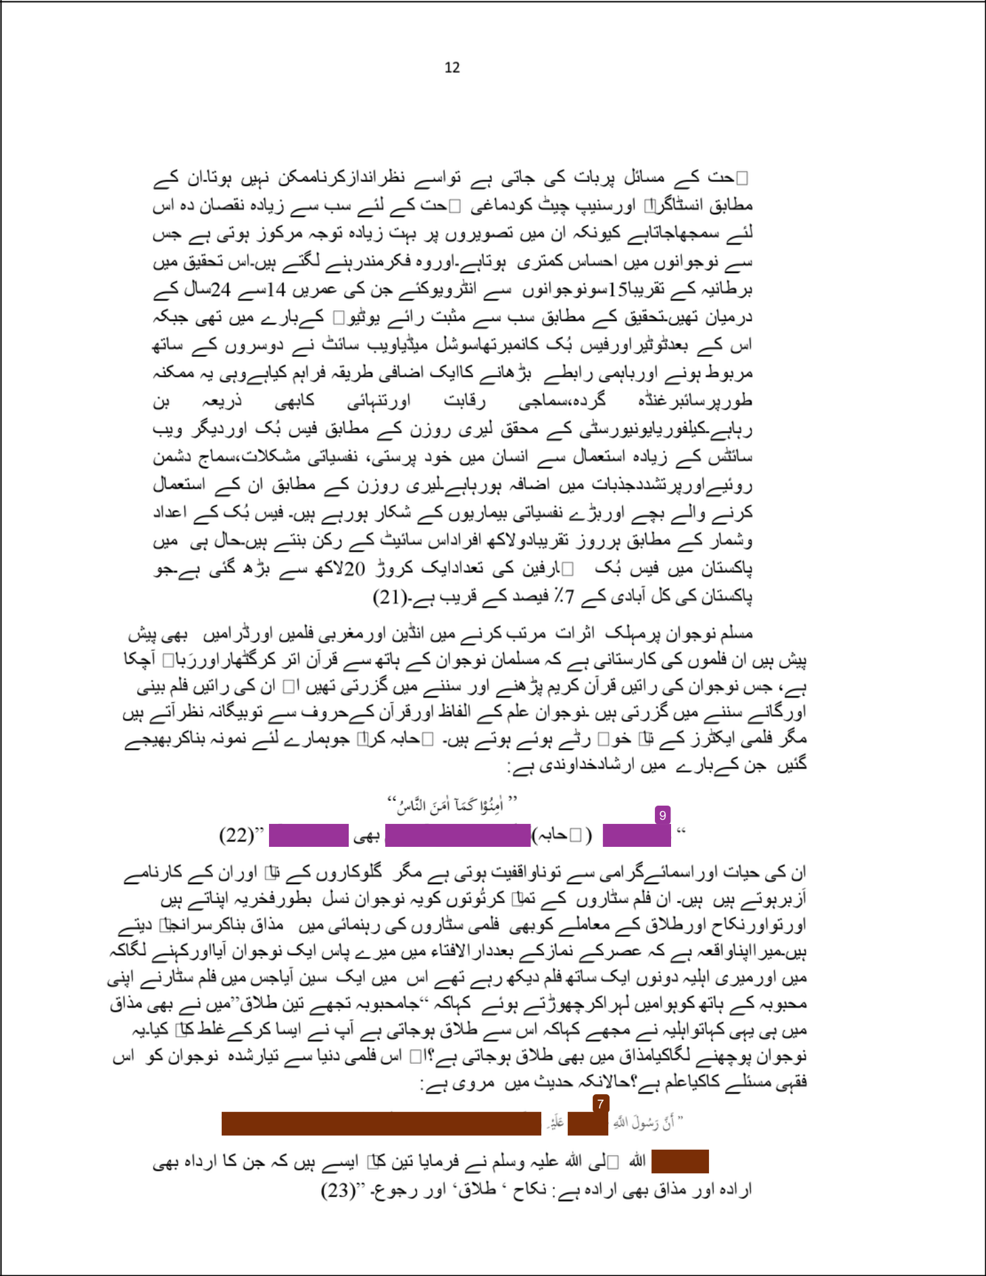

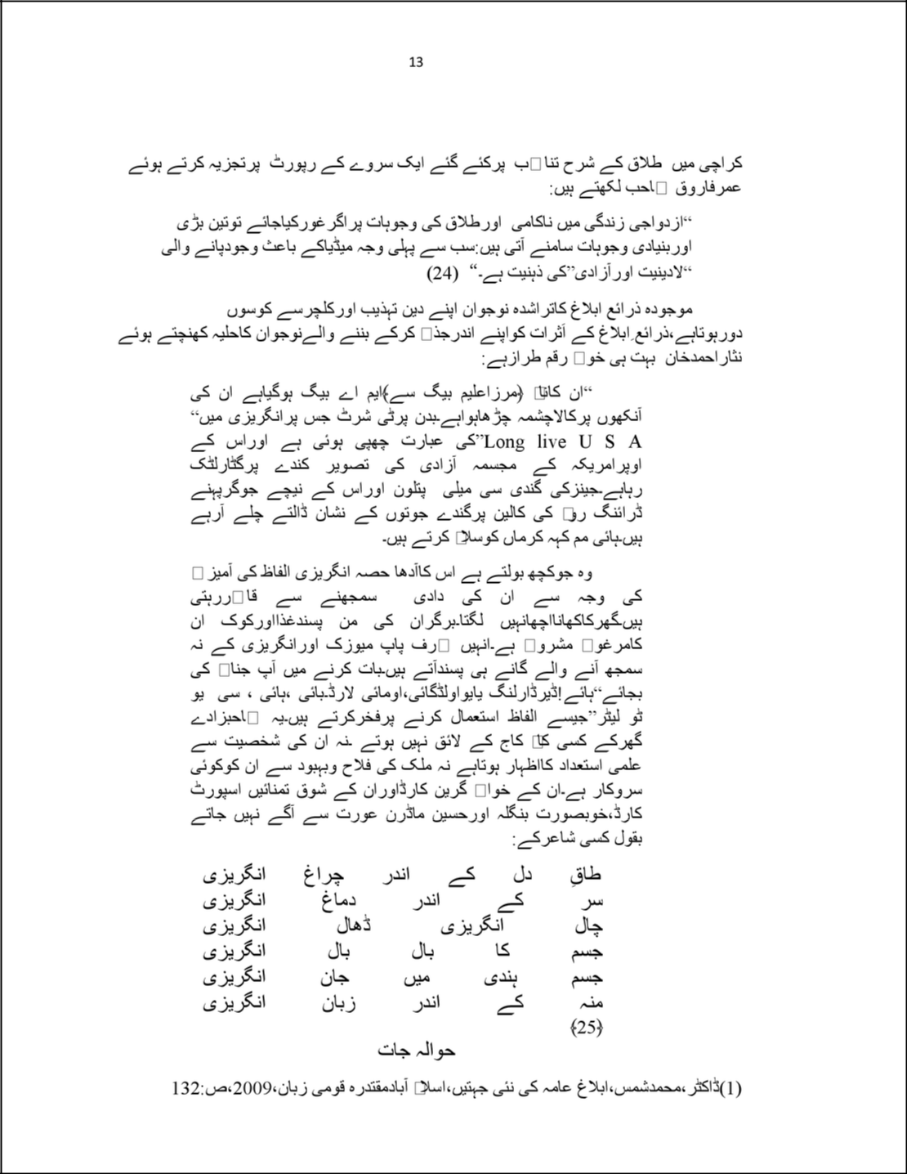

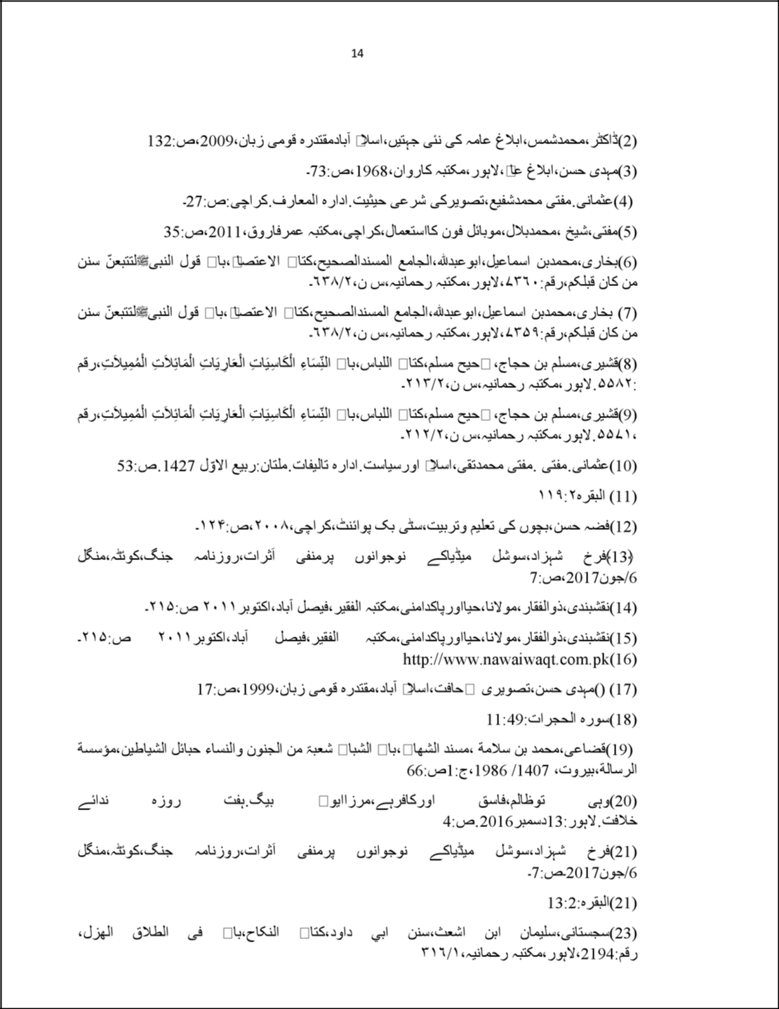

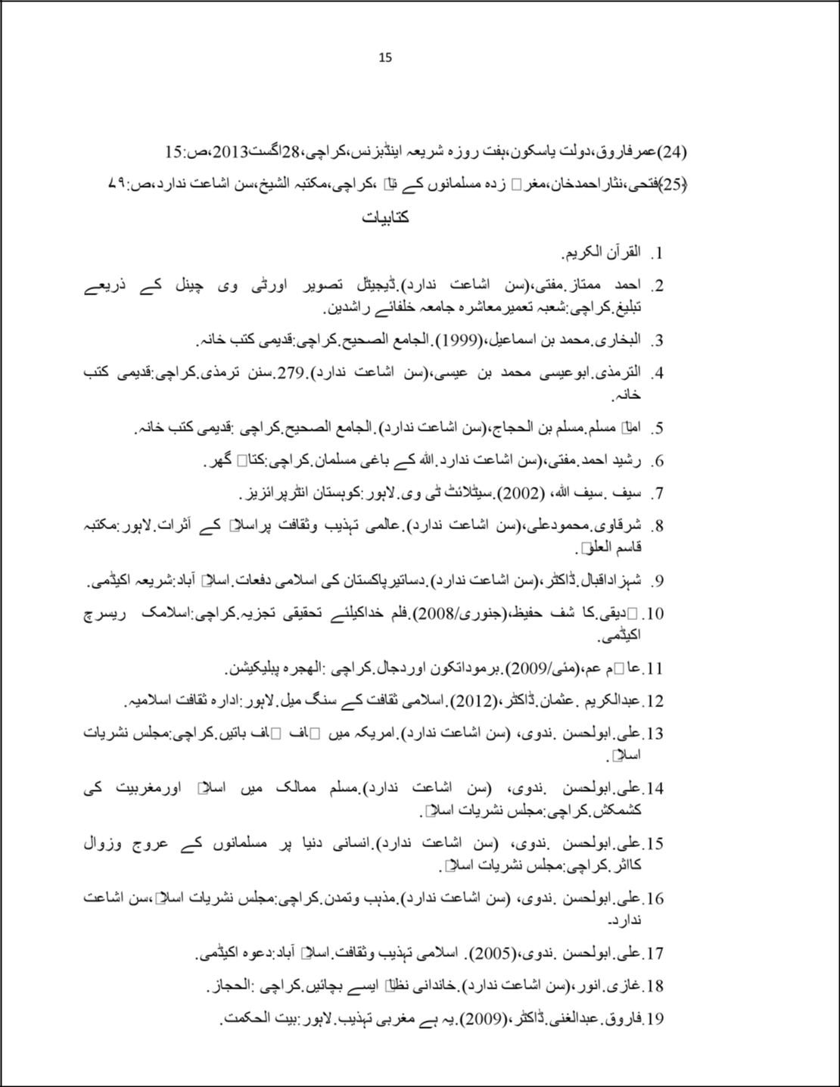

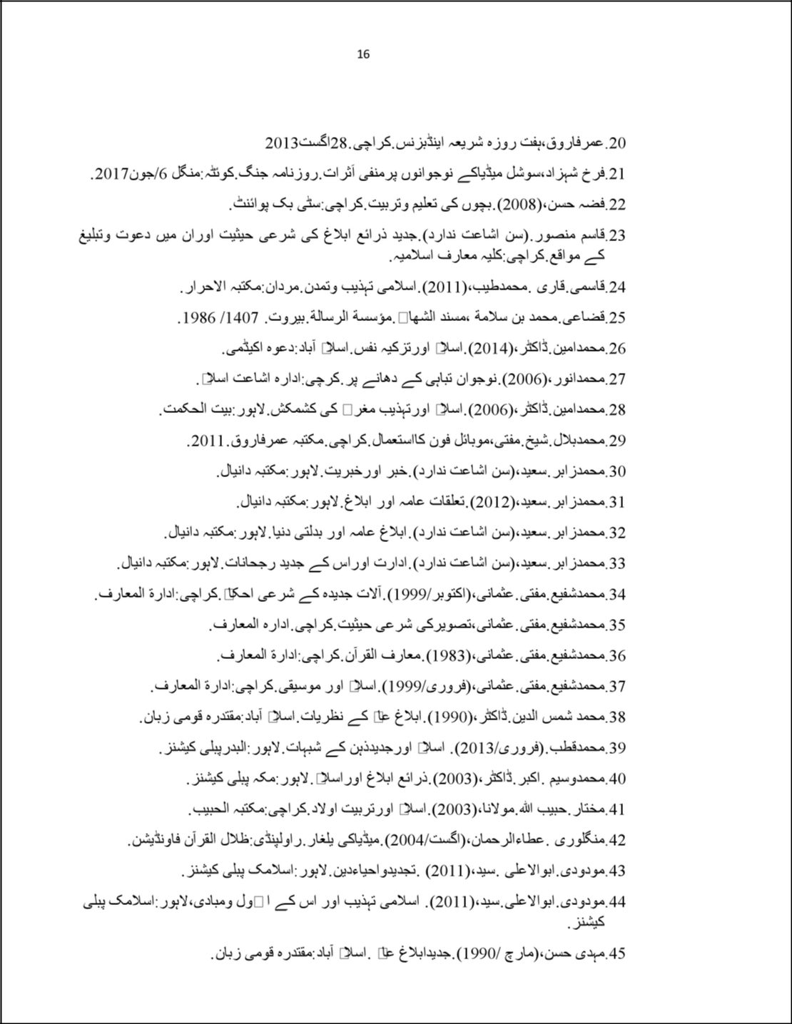

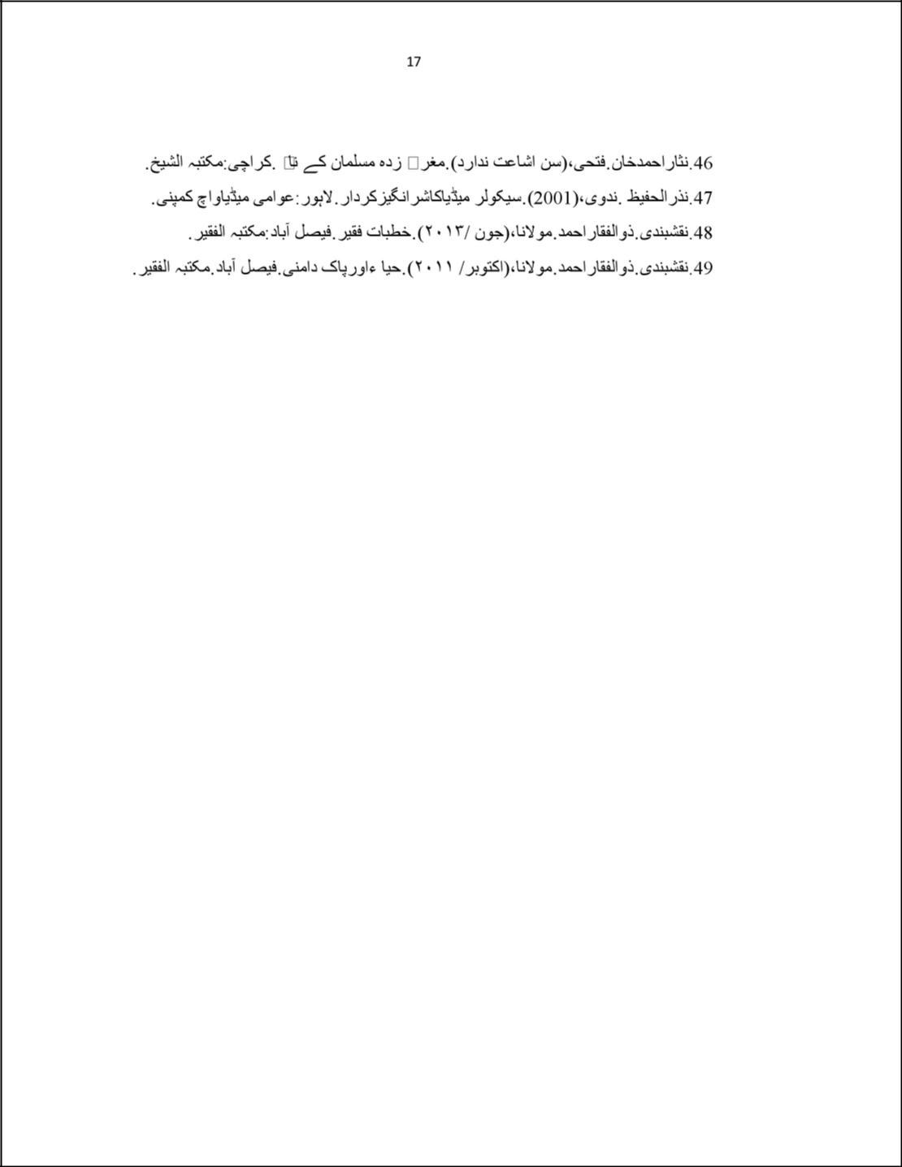

Dr. Abdul Achakzai

ORIGINALITY REPORT

9% | 9% | 1% | 2%
SIMILARITY INDEX | INTERNET SOURCES | PUBLICATIONS | STUDENT PAPERS
PRIMARY SOURCES

₁ raahedaleel.blogspot.com

Internet Source
₂ reviewessays.com

Internet Source
₃ rahbereislam.com

Internet Source
₄ musnijaprie-alpasery.blogspot.com

Internet Source
₅ blogistan.urdusource.com

Internet Source
₆ abumuhammadzz.wordpress.com

Internet Source
₇ sunnah.com

Internet Source
₈ www.mahatroshan.blogspot.com.au

Internet Source
₉ qurango.com

Internet Source

4%

1%

1%

1%

1%

<1%

<1%

<1%

<1%

<1%

<1%

<1%

www.darululoom-deoband.com

Internet Source

fridayspecial.com.pk

Internet Source

,"اﻟطﻌﯾﻣﺎت ، ھﺎﻧﻲ. "ﻓﻘﮫ اﻷﺣوال اﻟﺷﺧﺻﯾﺔ ﻓﻲ اﻟﻣﯾراث واﻟوﺻﯾﺔ Dar Al-Shorouk for Publishing & Distribution, 2007.
Publication

10

11

12

Exclude quotes Of f Exclude matches Of f

Exclude bibliography Of f

