Hafiz Ubaid Ullah Sb 1

by Salman ahmed

Submission date: 16-May-2018 10:03AM (UTC+0500)

Submission ID: 952604546

File name: Muf ti_Haf iz_Ubaid_Ullah.docx (26.51K)

Word count: 3454

Character count: 15484

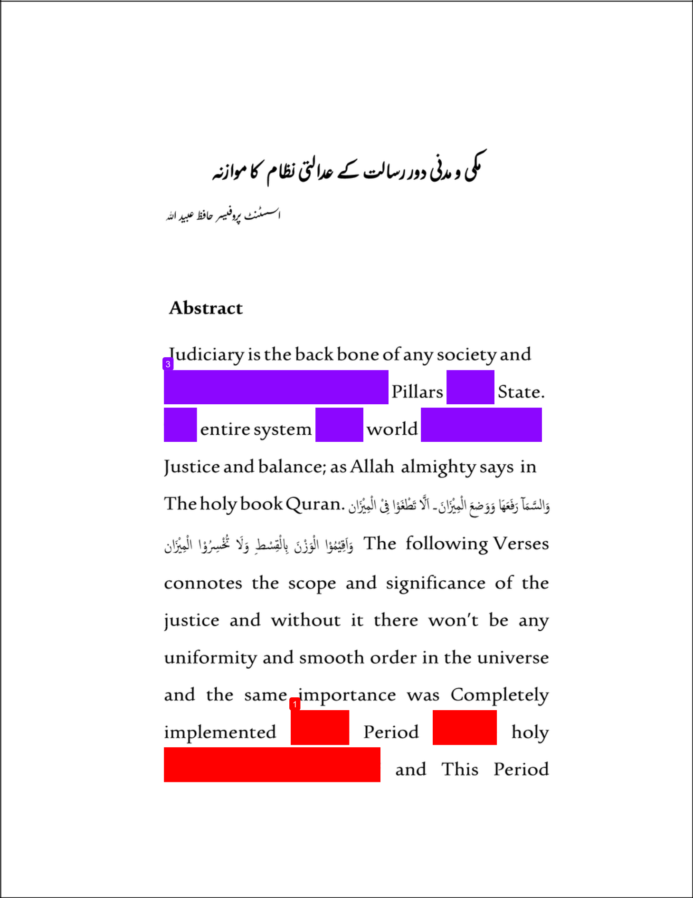

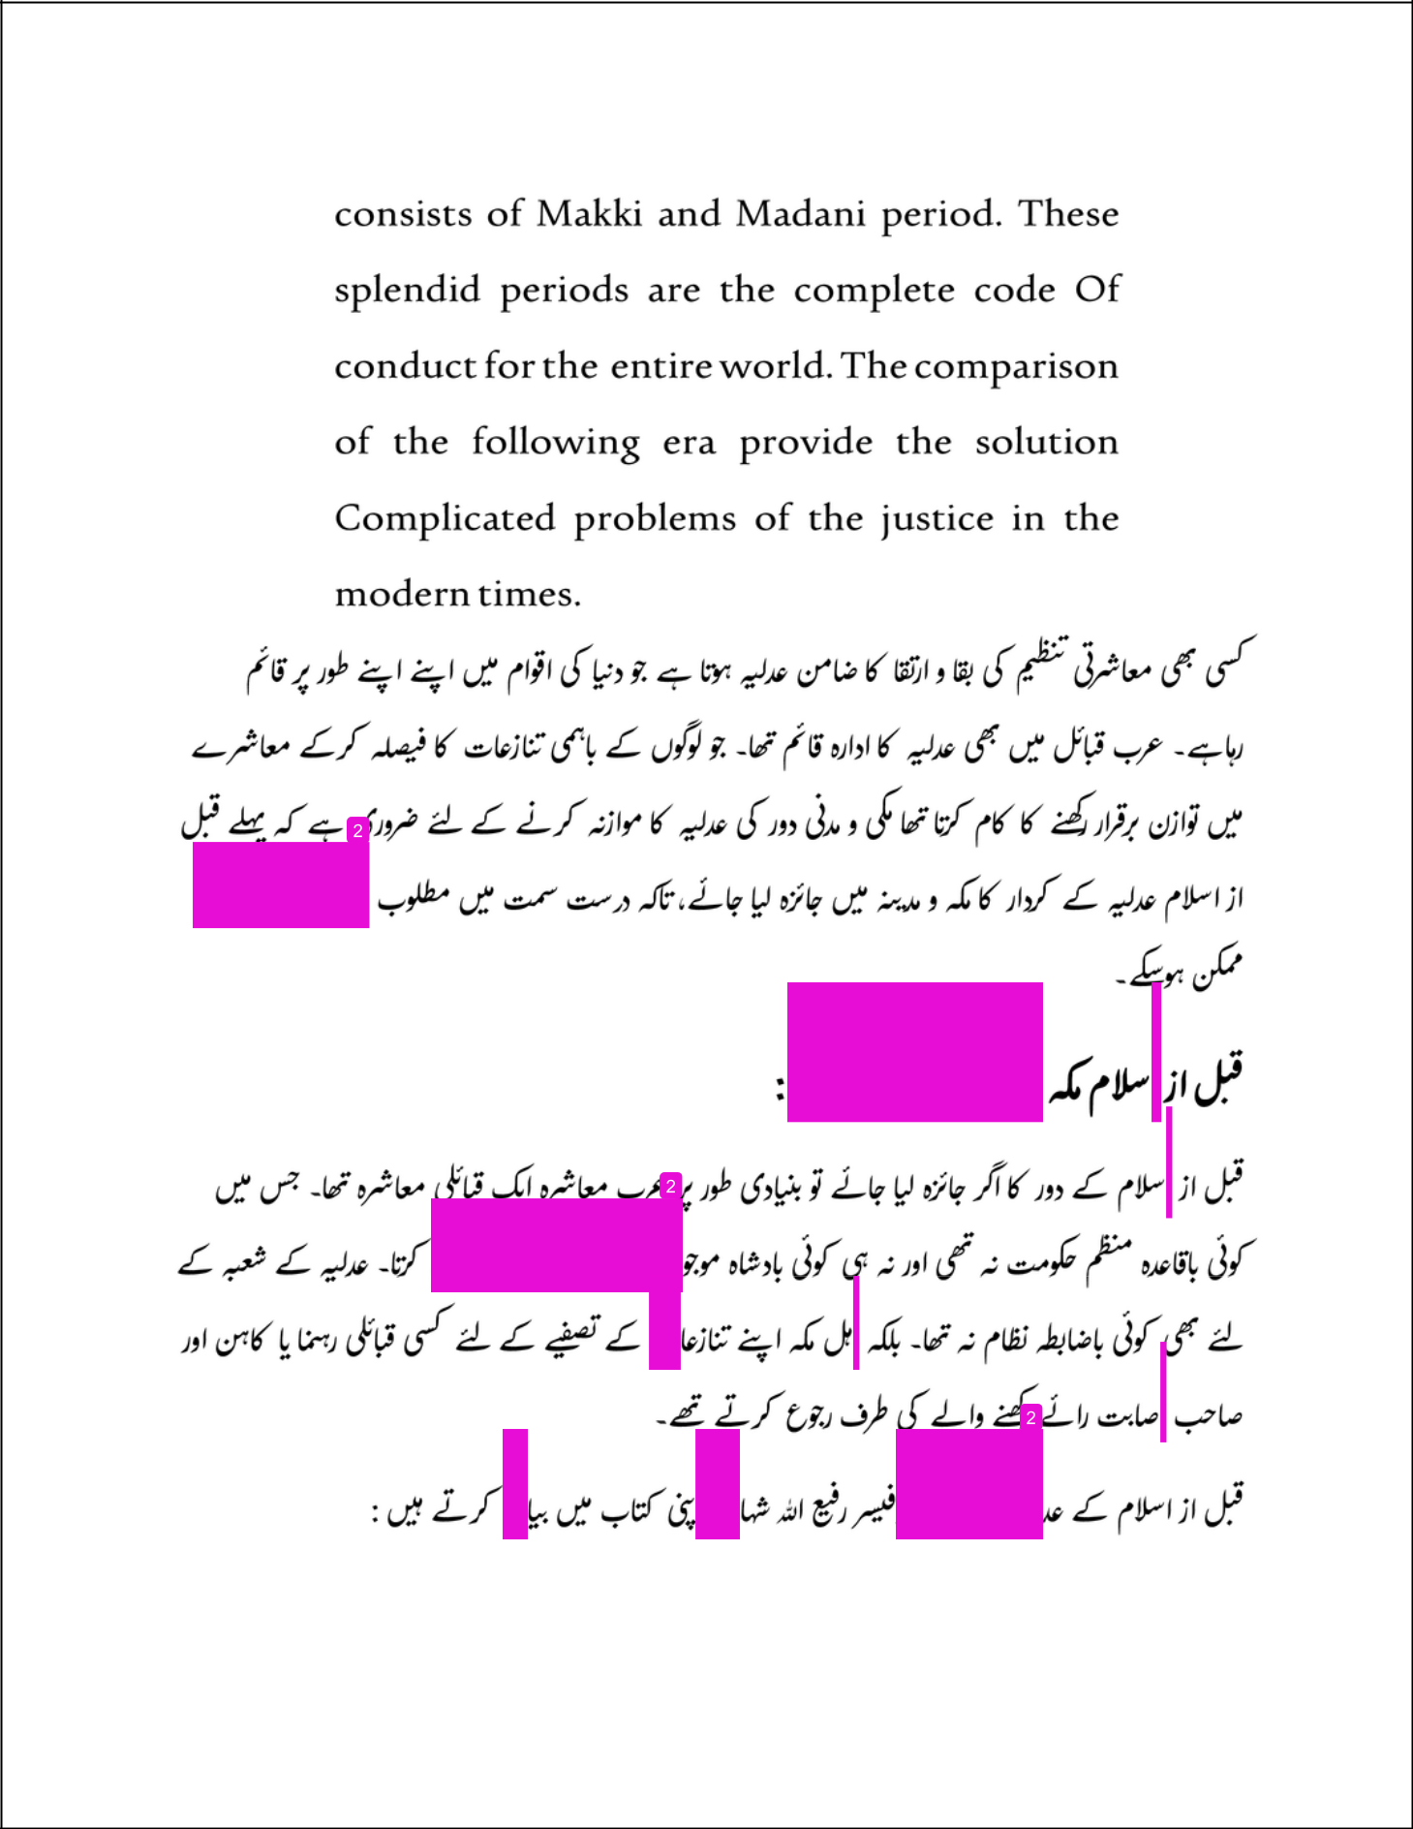

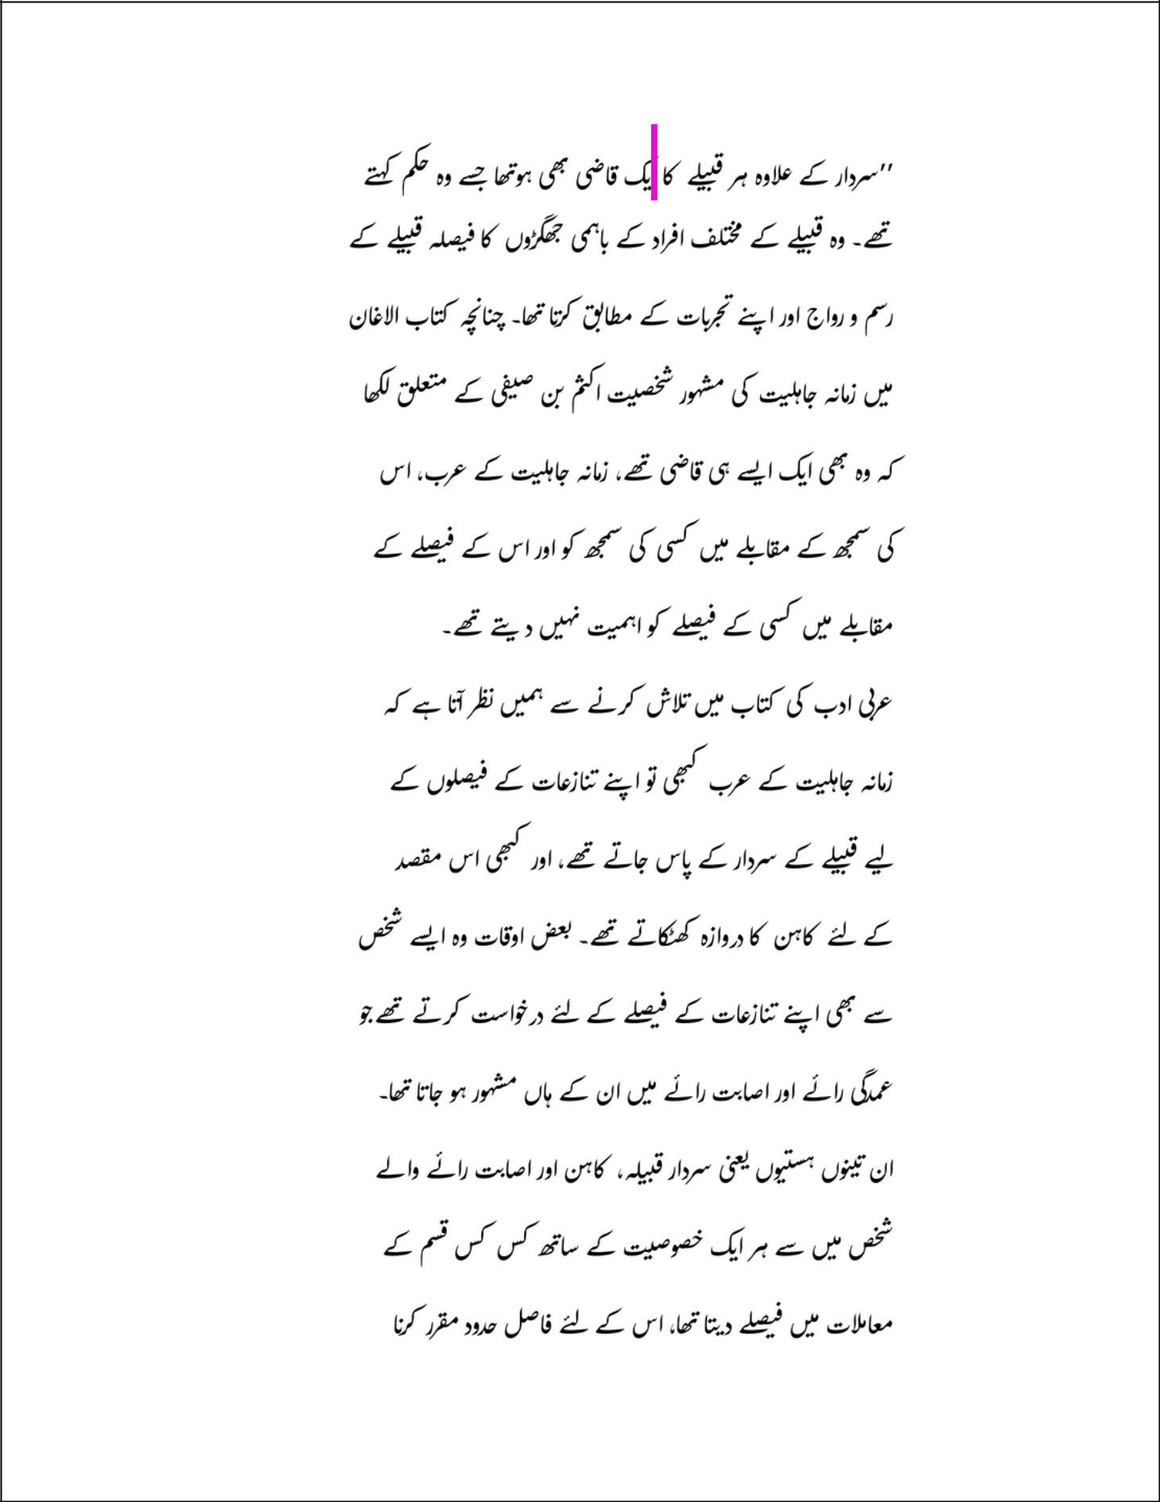

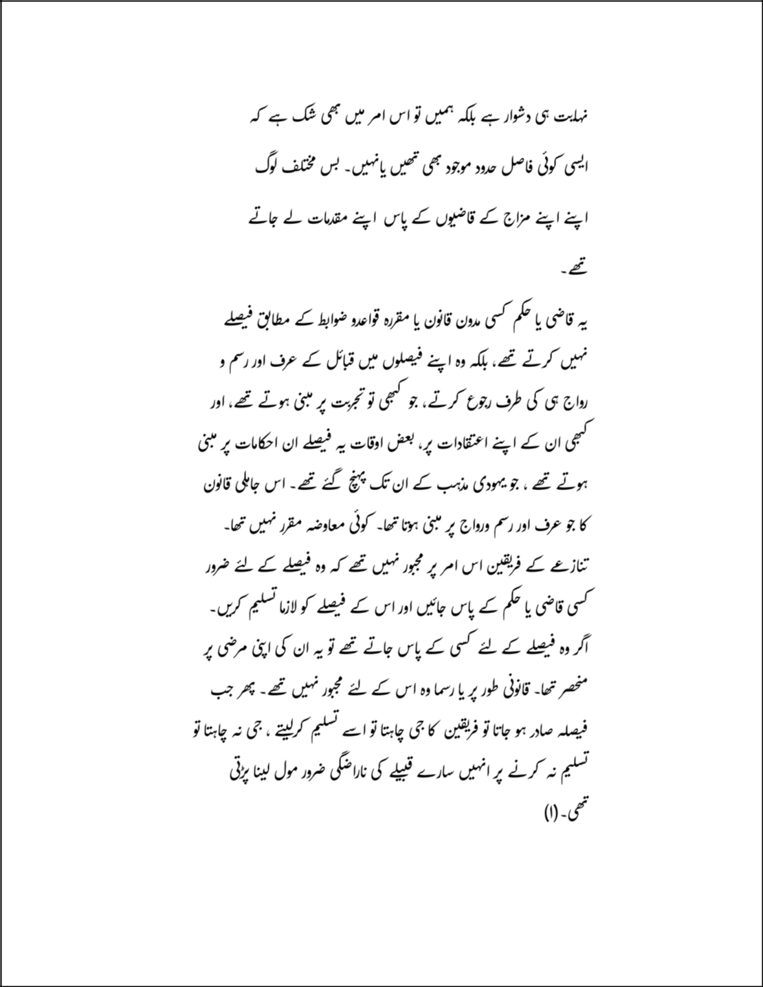

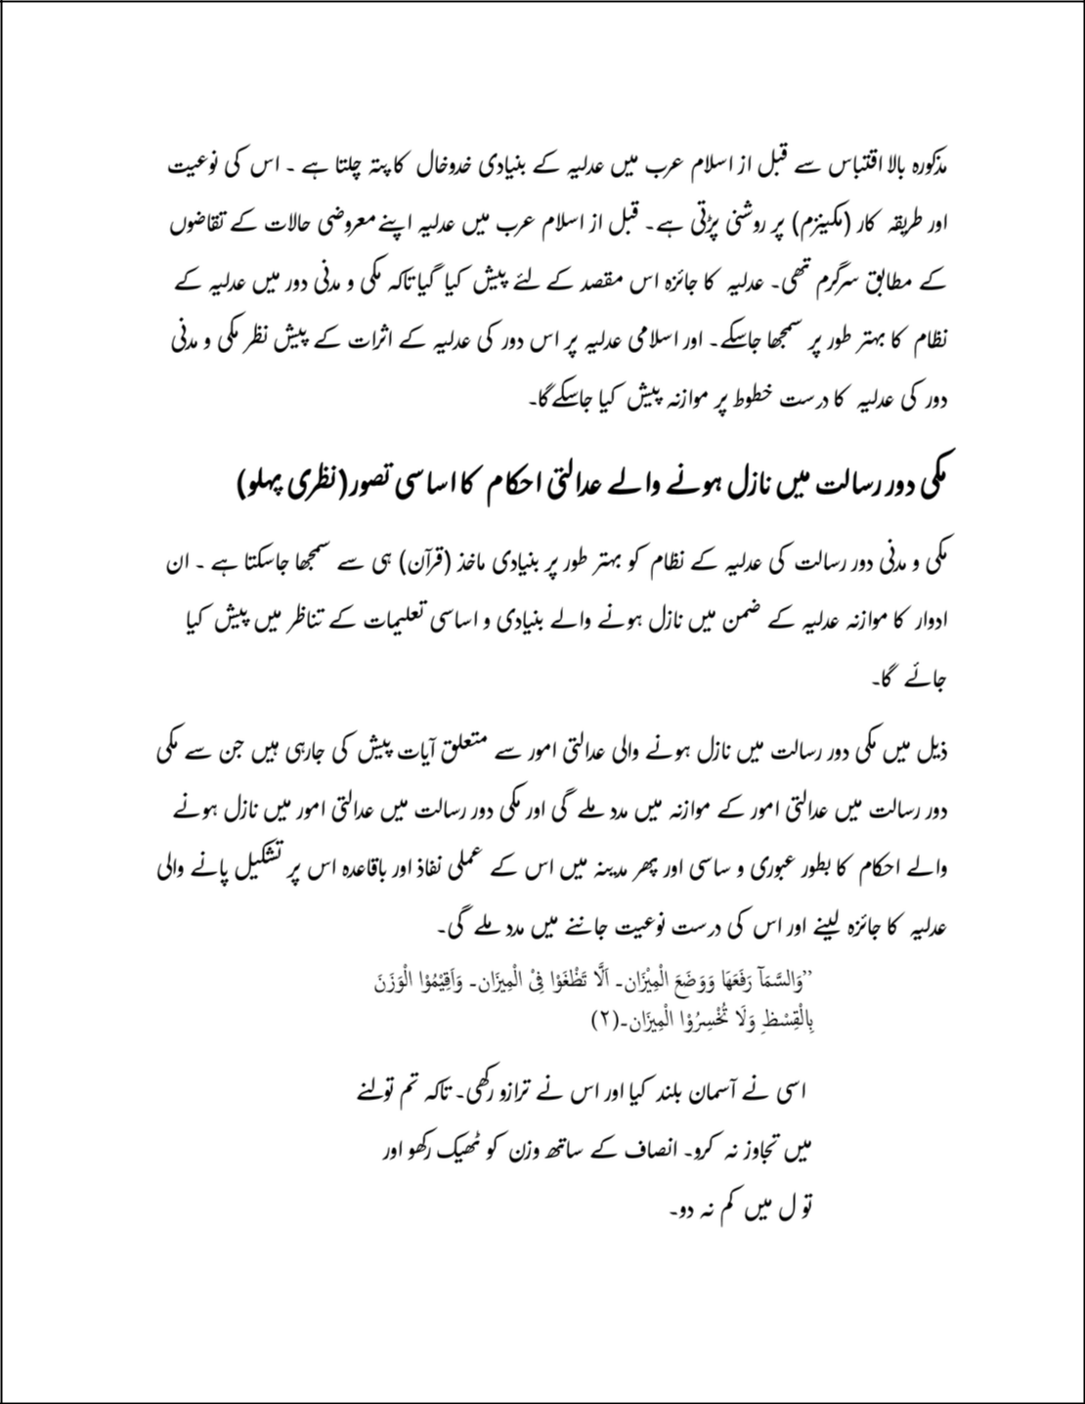

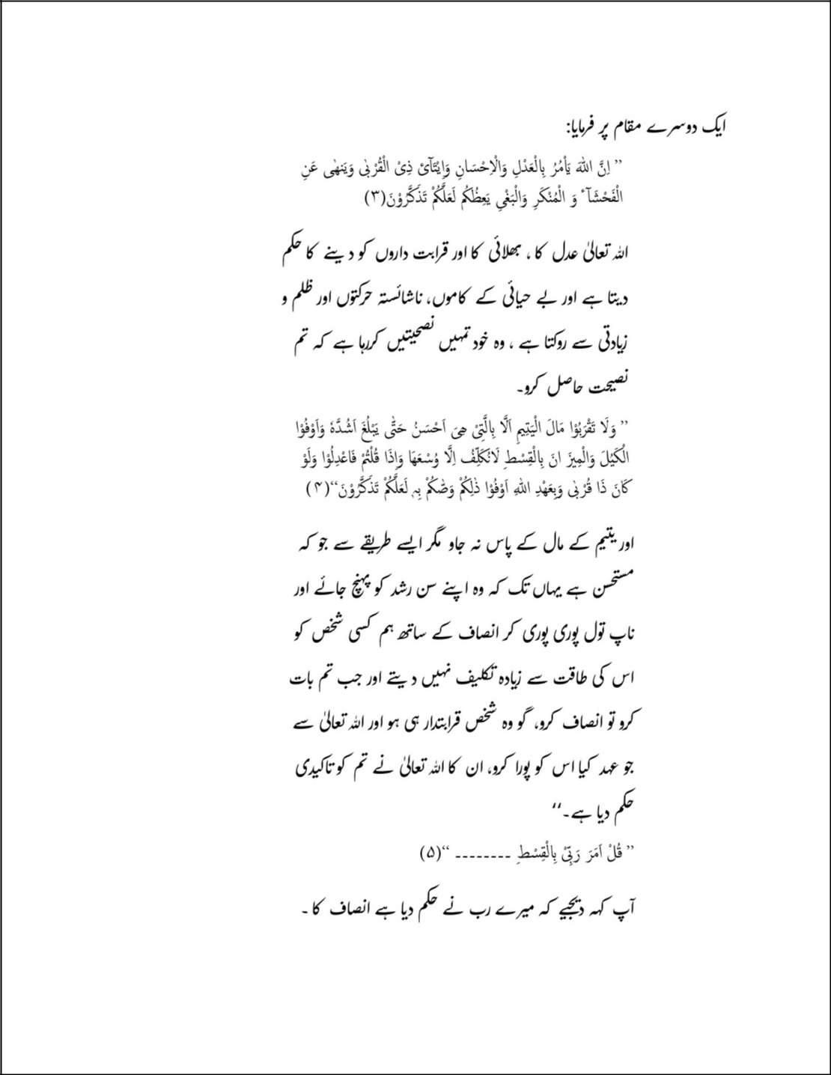

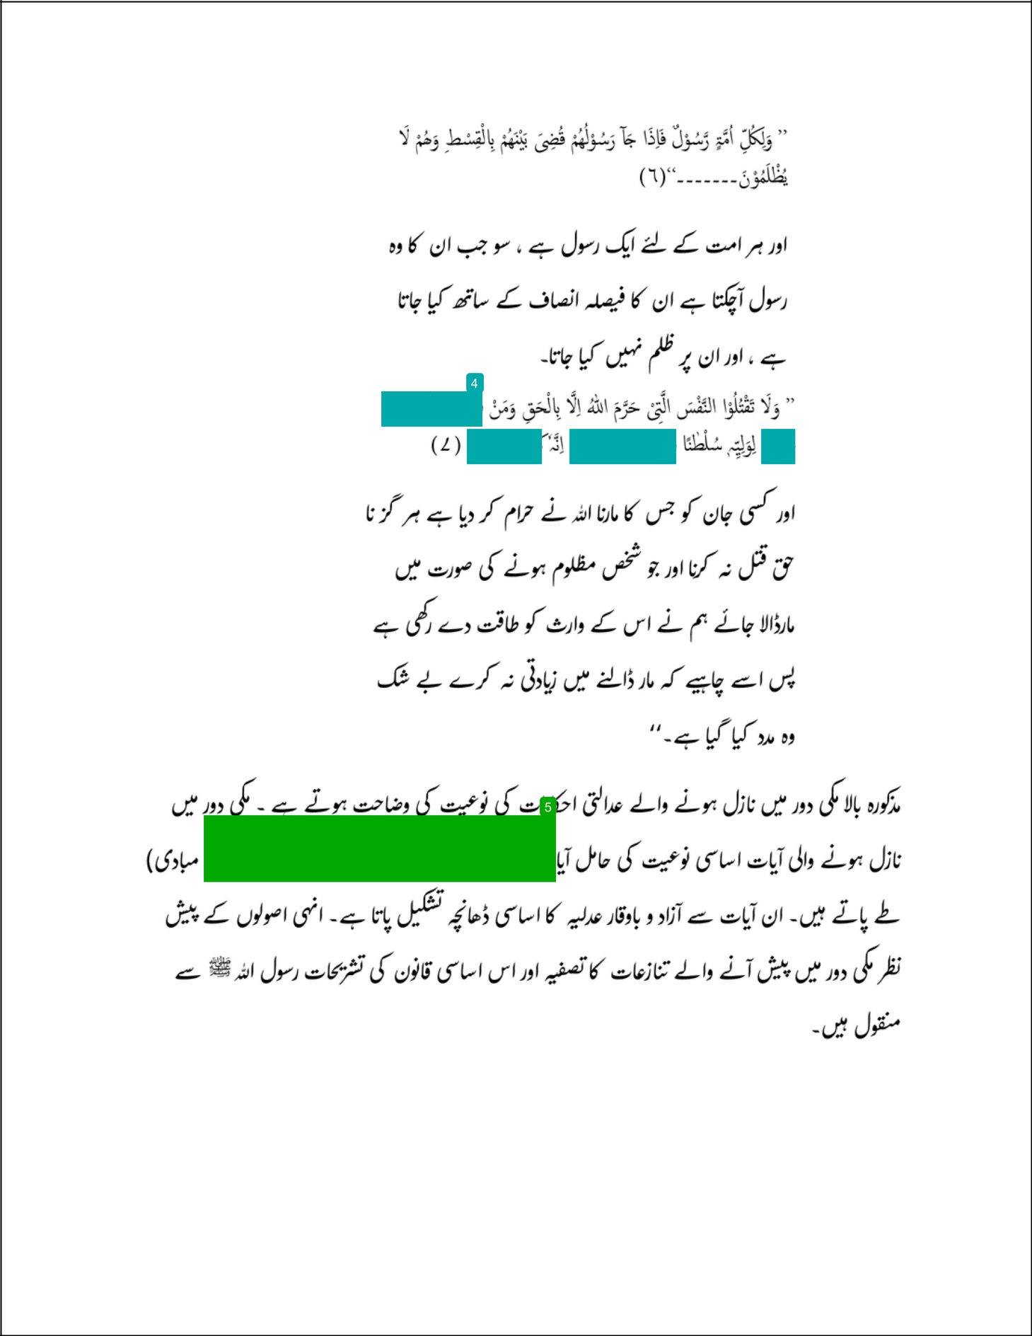

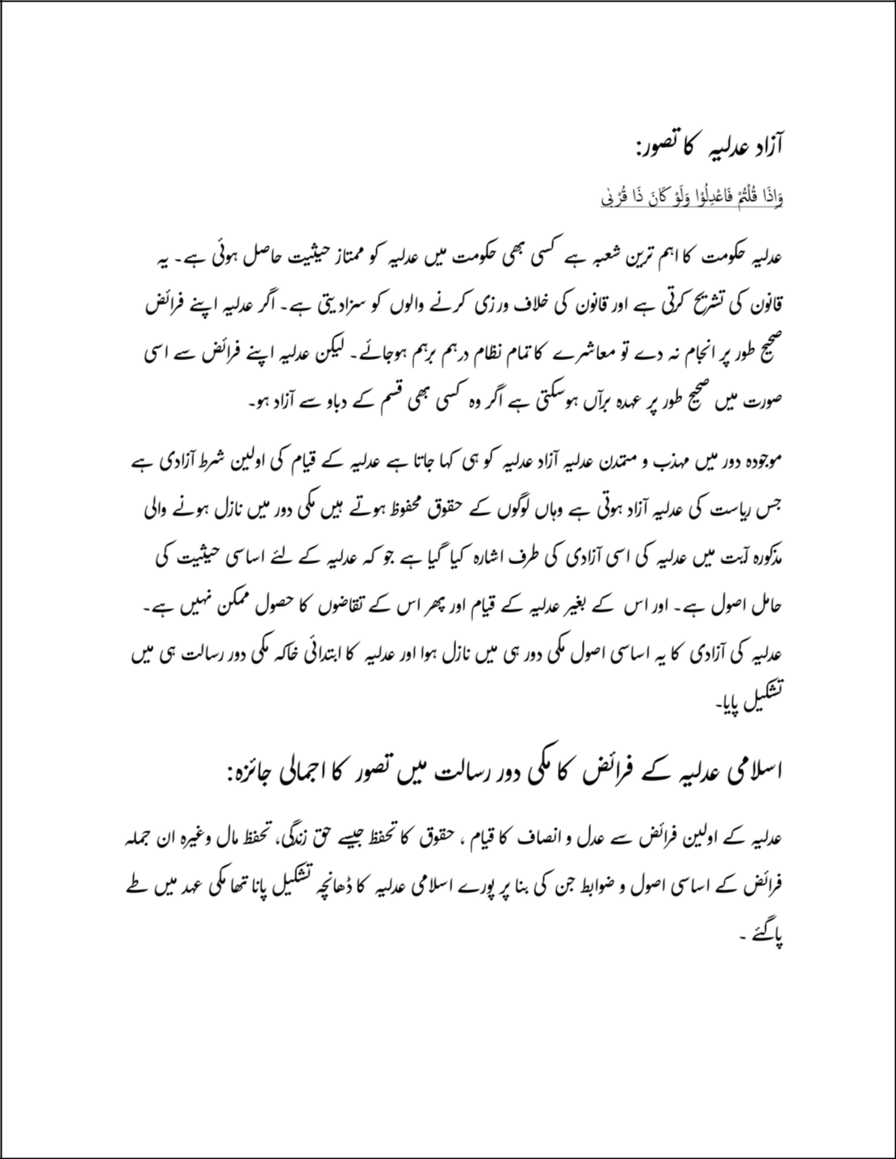

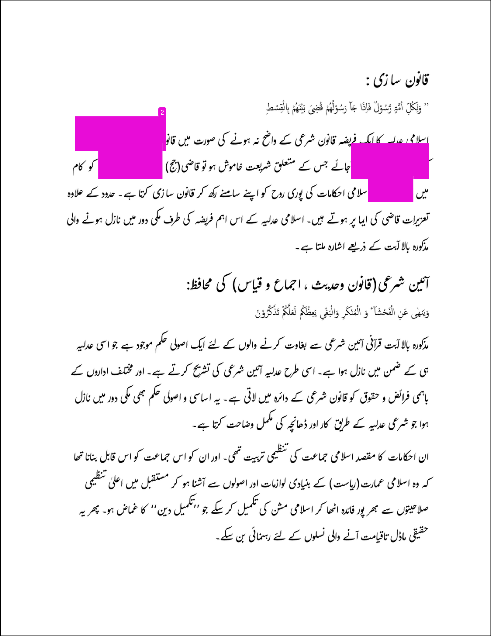

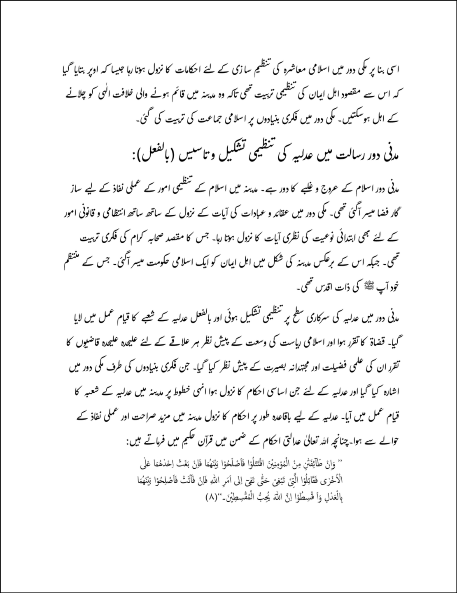

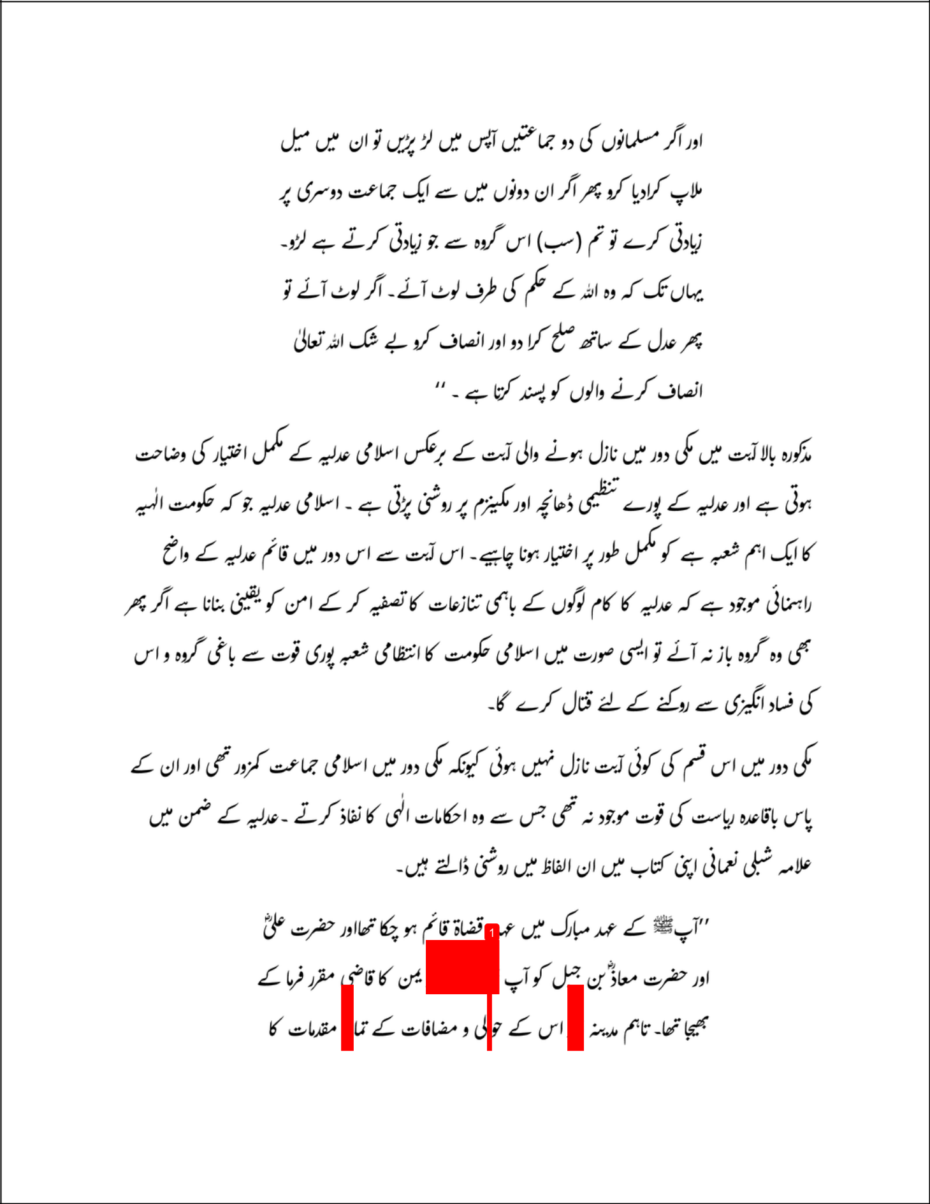

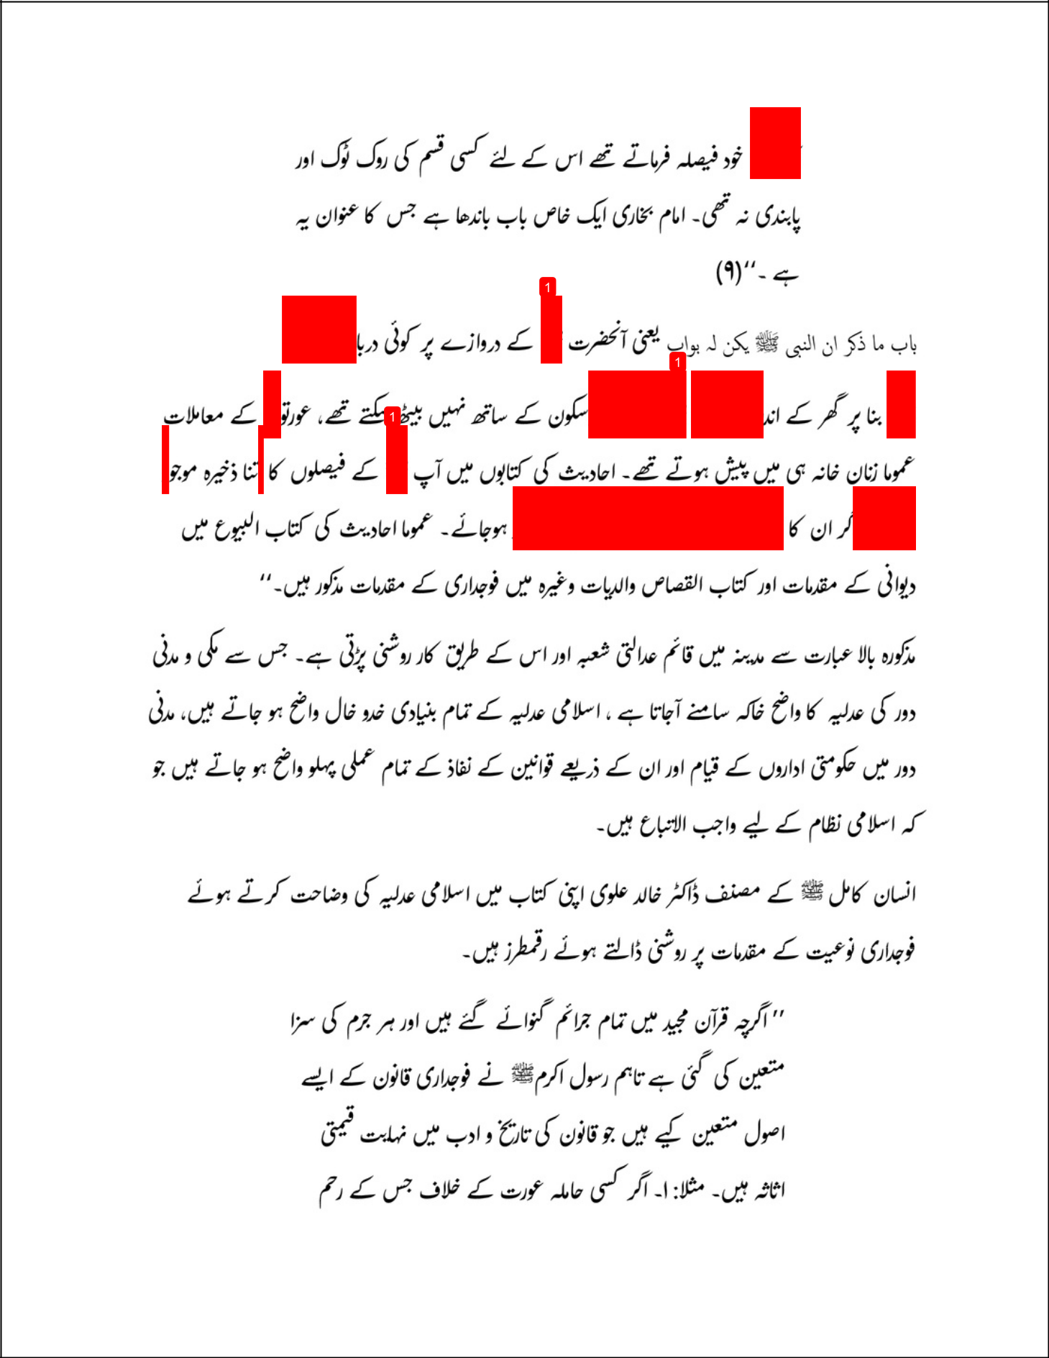

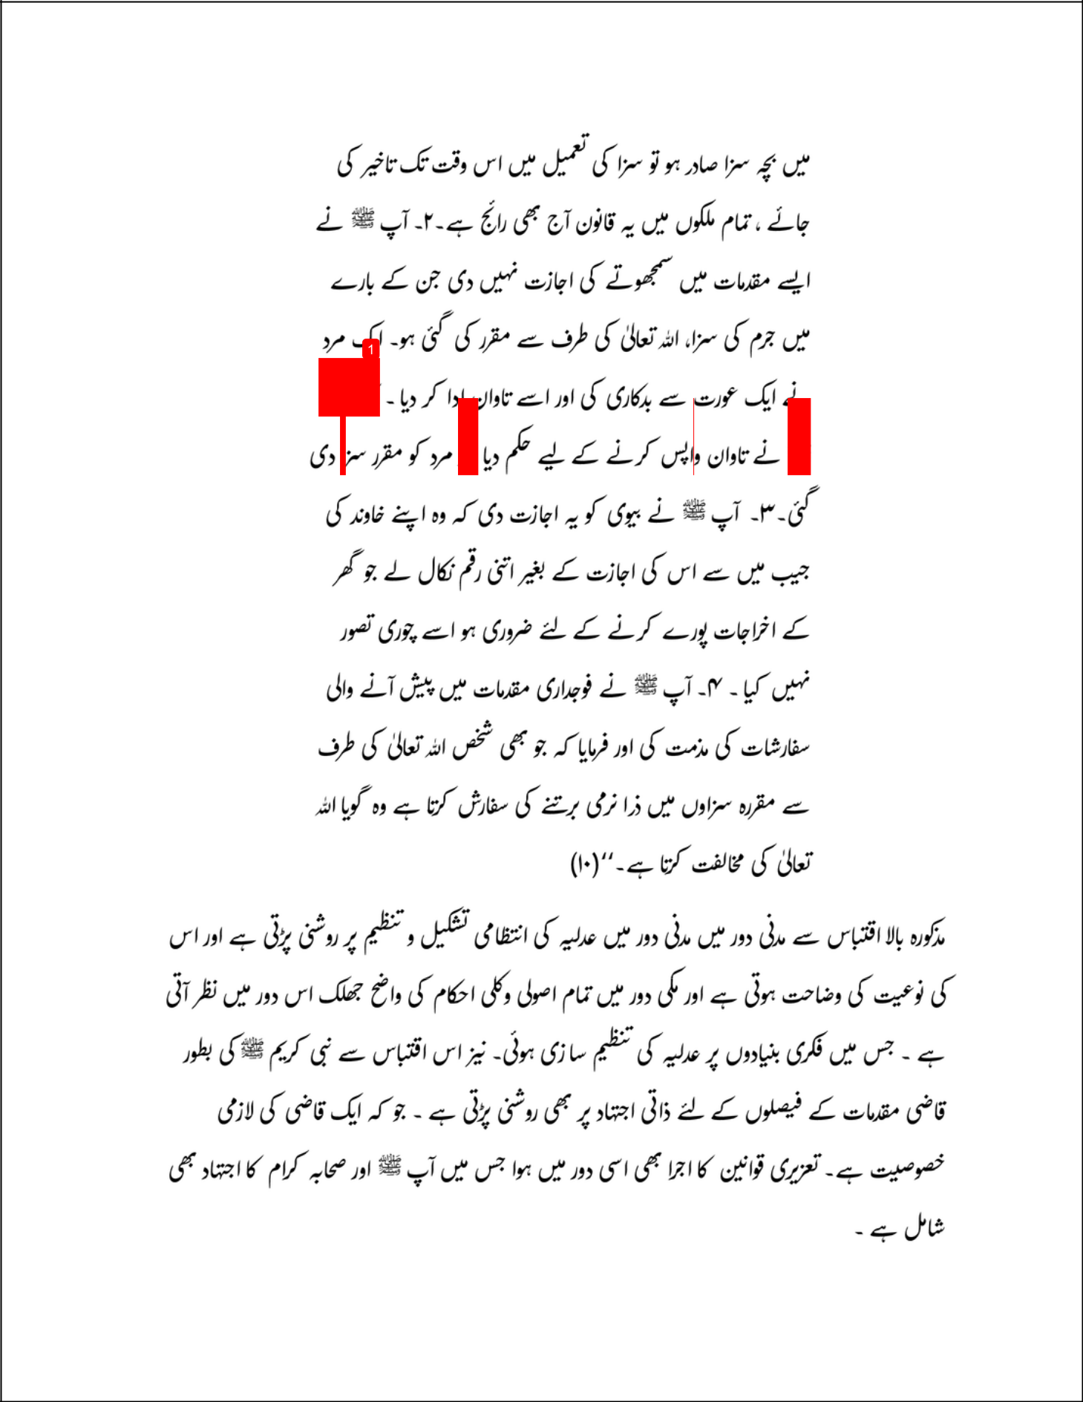

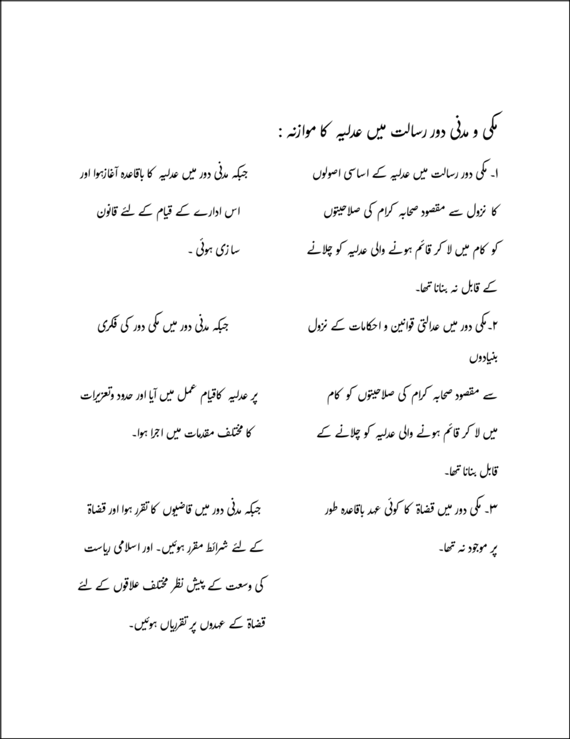

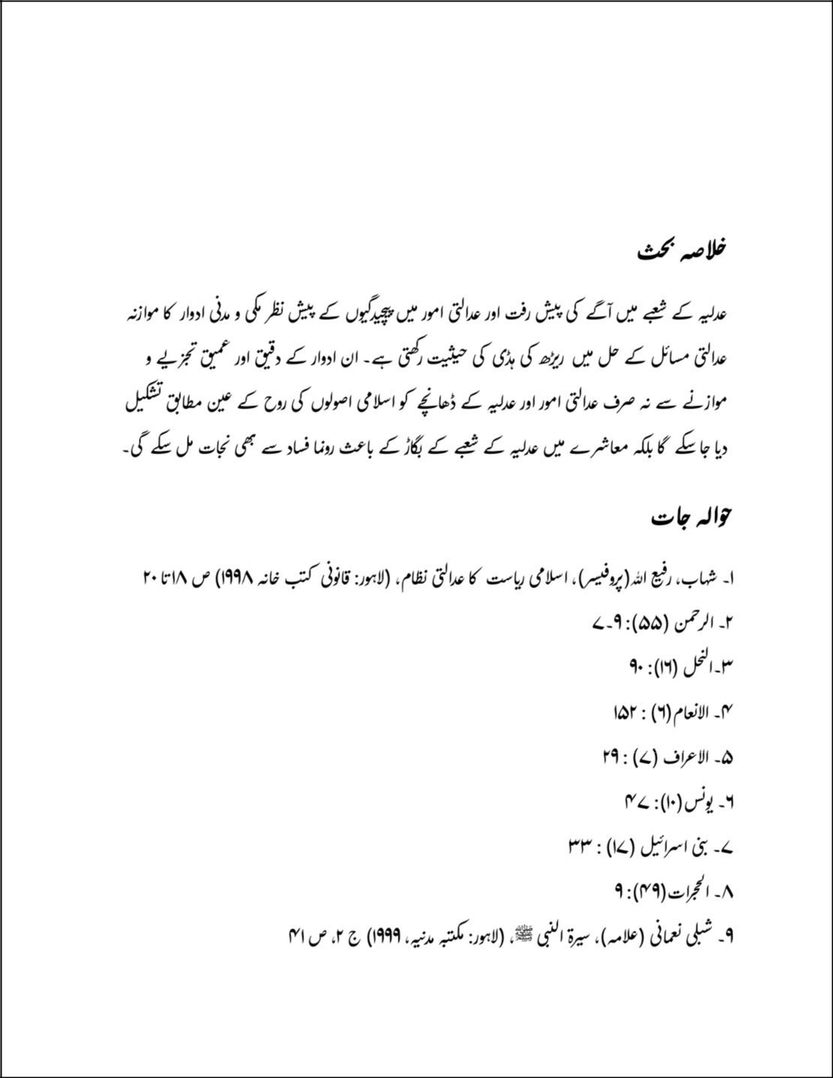

Hafiz Ubaid Ullah Sb 1

ORIGINALITY REPORT

6% |  |  | 1% | 2% | 4%
 | SIMILARITY INDEX |  | INTERNET SOURCES | PUBLICATIONS | STUDENT PAPERS
 | PRIMARY SOURCES
 |  | Submitted to Higher Education Commission |  |  |  | 3%
 | 1
 |  | Pakistan
 |  | Student Paper
 |  | "Interview with Chadli Bendjedid the former |  |  |  | 2%
 | 2
 |  | president of Algeria and its historical
 |  | significance", , 2009.
 |  | Publication
 |  | www.isguvenligivecalisansagligidergisi.com |  |  |  | 1%
 | 3
 |  | Internet Source
 |  | Submitted to Al Falah University |  |  |  | 1%
 | 4
 |  | Student Paper
 |  | "Abstracts in Spanish, French, Chinese, Arabic, |  |  |  | <1%
 | 5
 |  | and Russian", Comparative Education Review,
 |  | 2014.
 |  | Publication

Exclude quotes

Of f

Exclude matches

Of f

Exclude bibliography

Of f

