Mufti Abdul Haq Haqani

by Salman ahmed

Submission date: 12-May-2018 01:49PM (UTC+0500)

Submission ID: 952604546

File name: 2_l.docx (81.36K)

Word count: 6641

Character count: 33827

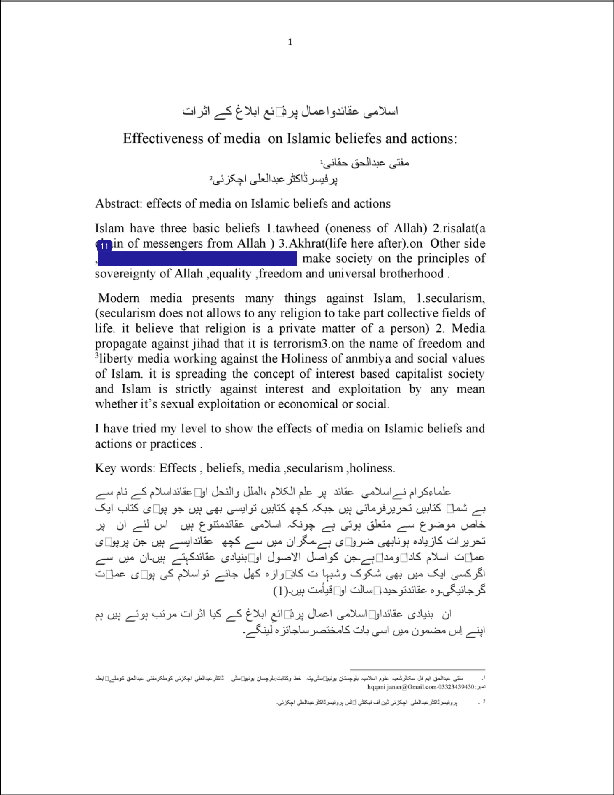

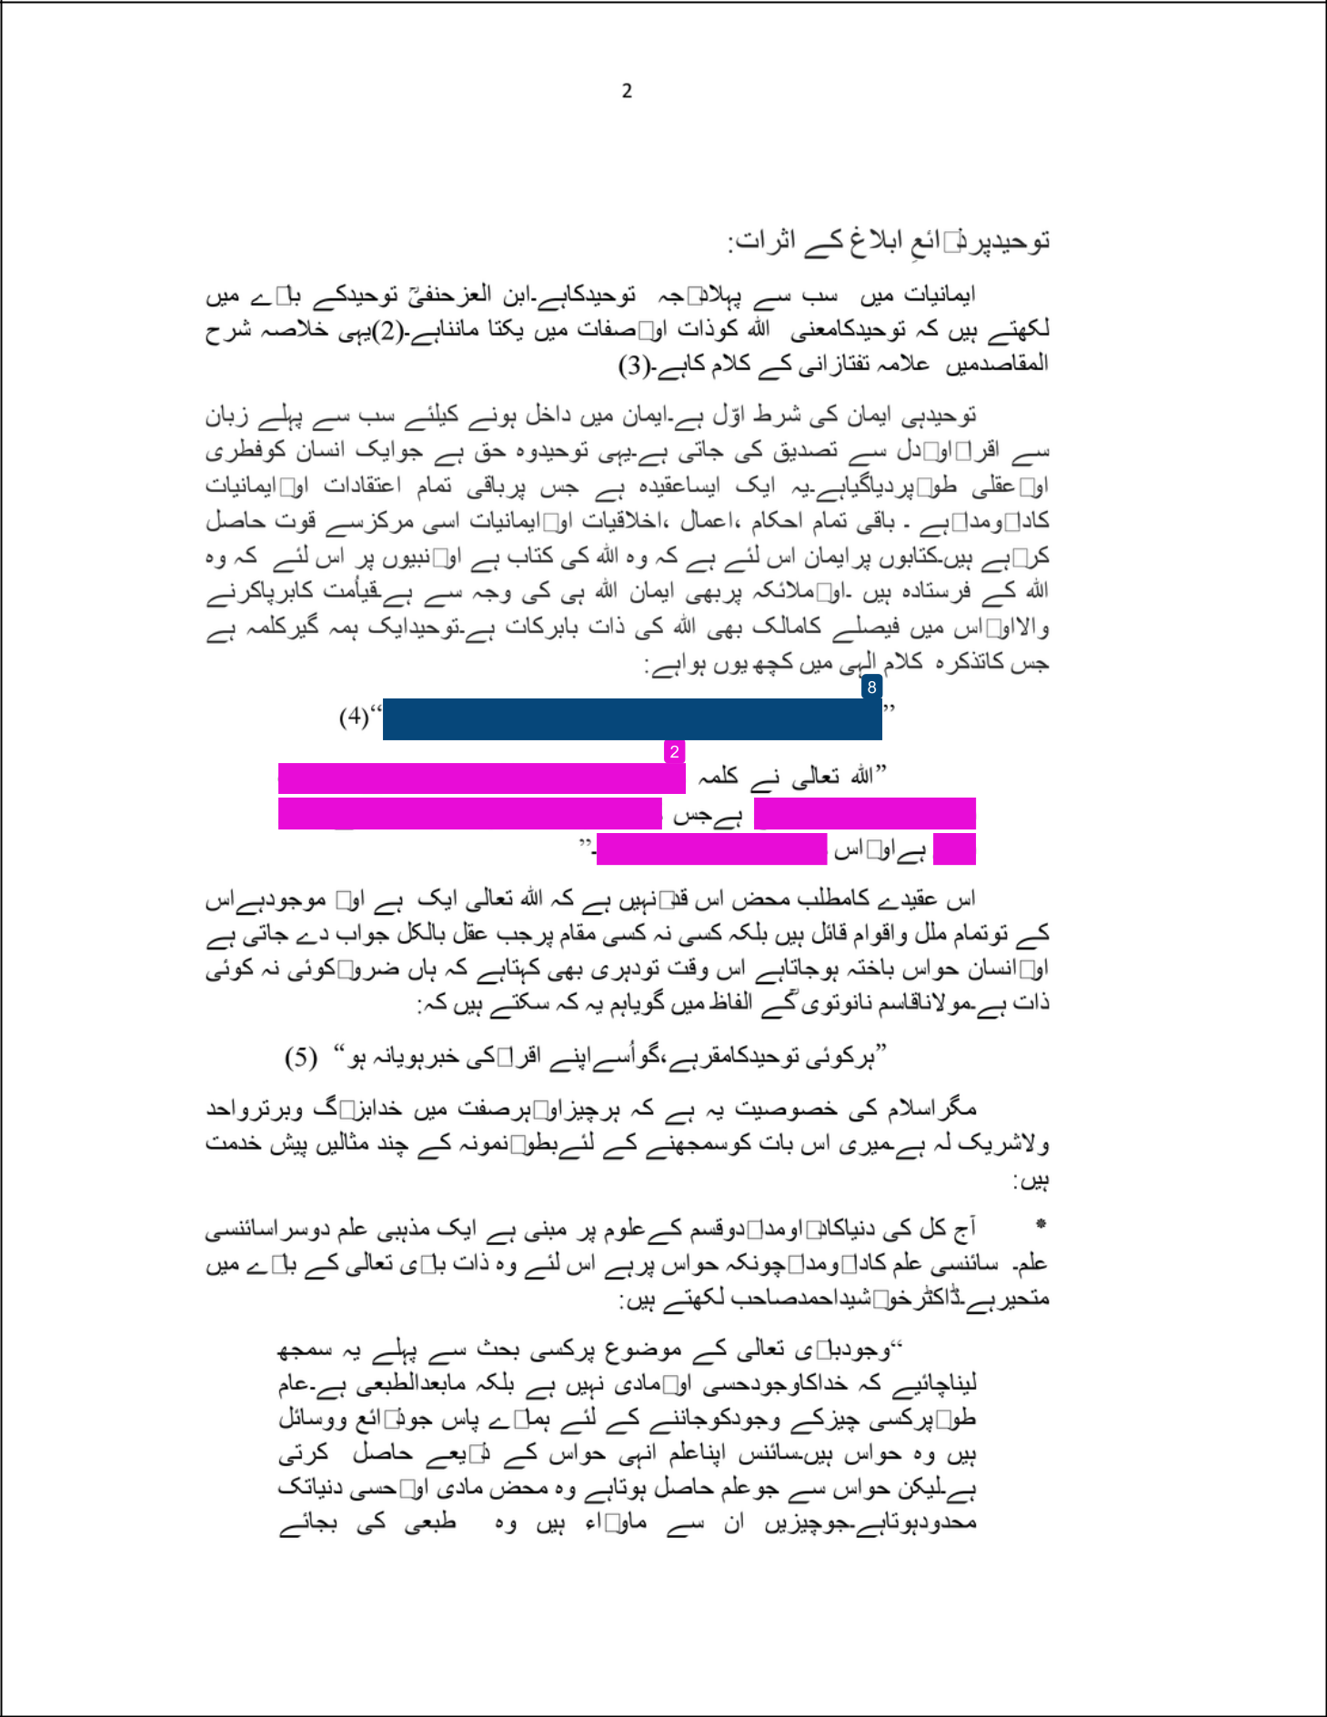

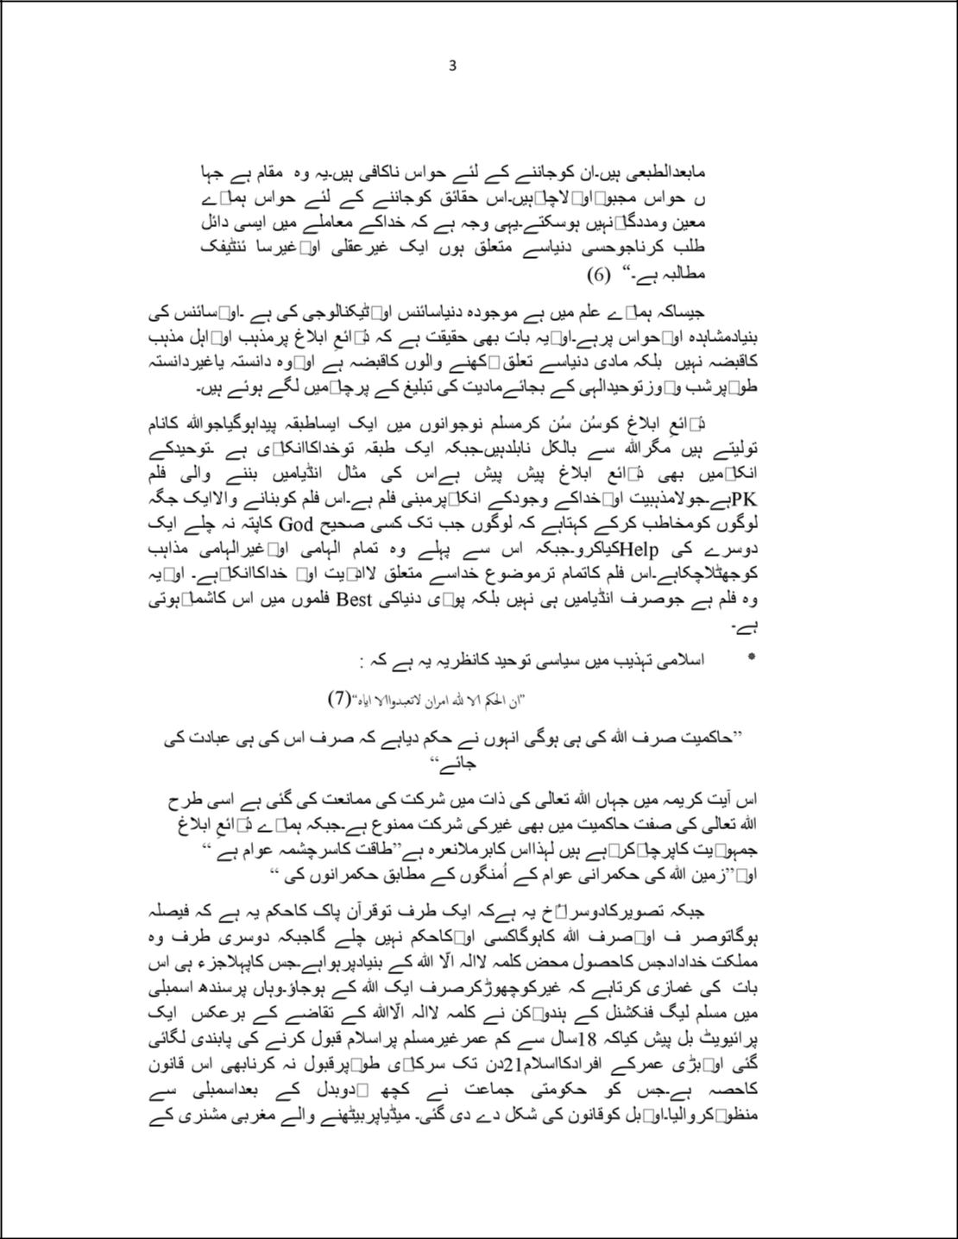

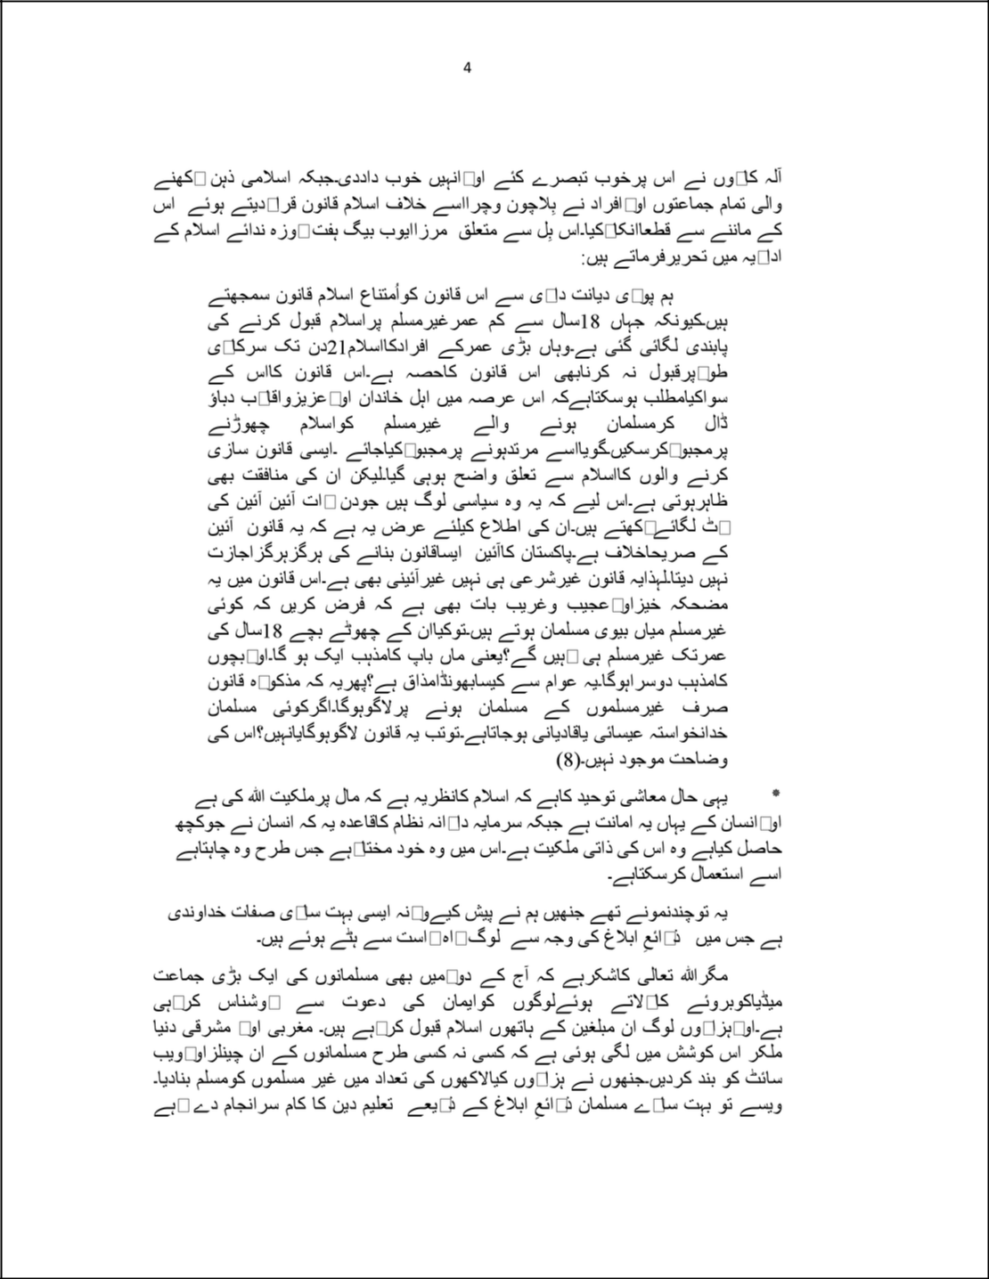

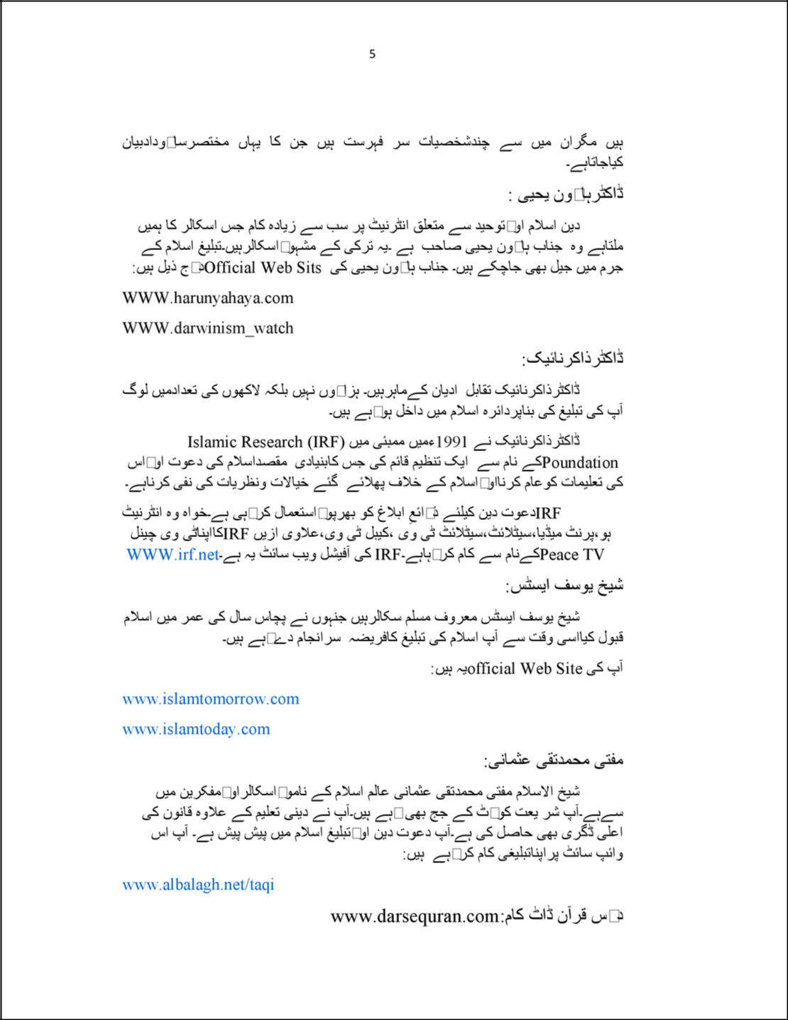

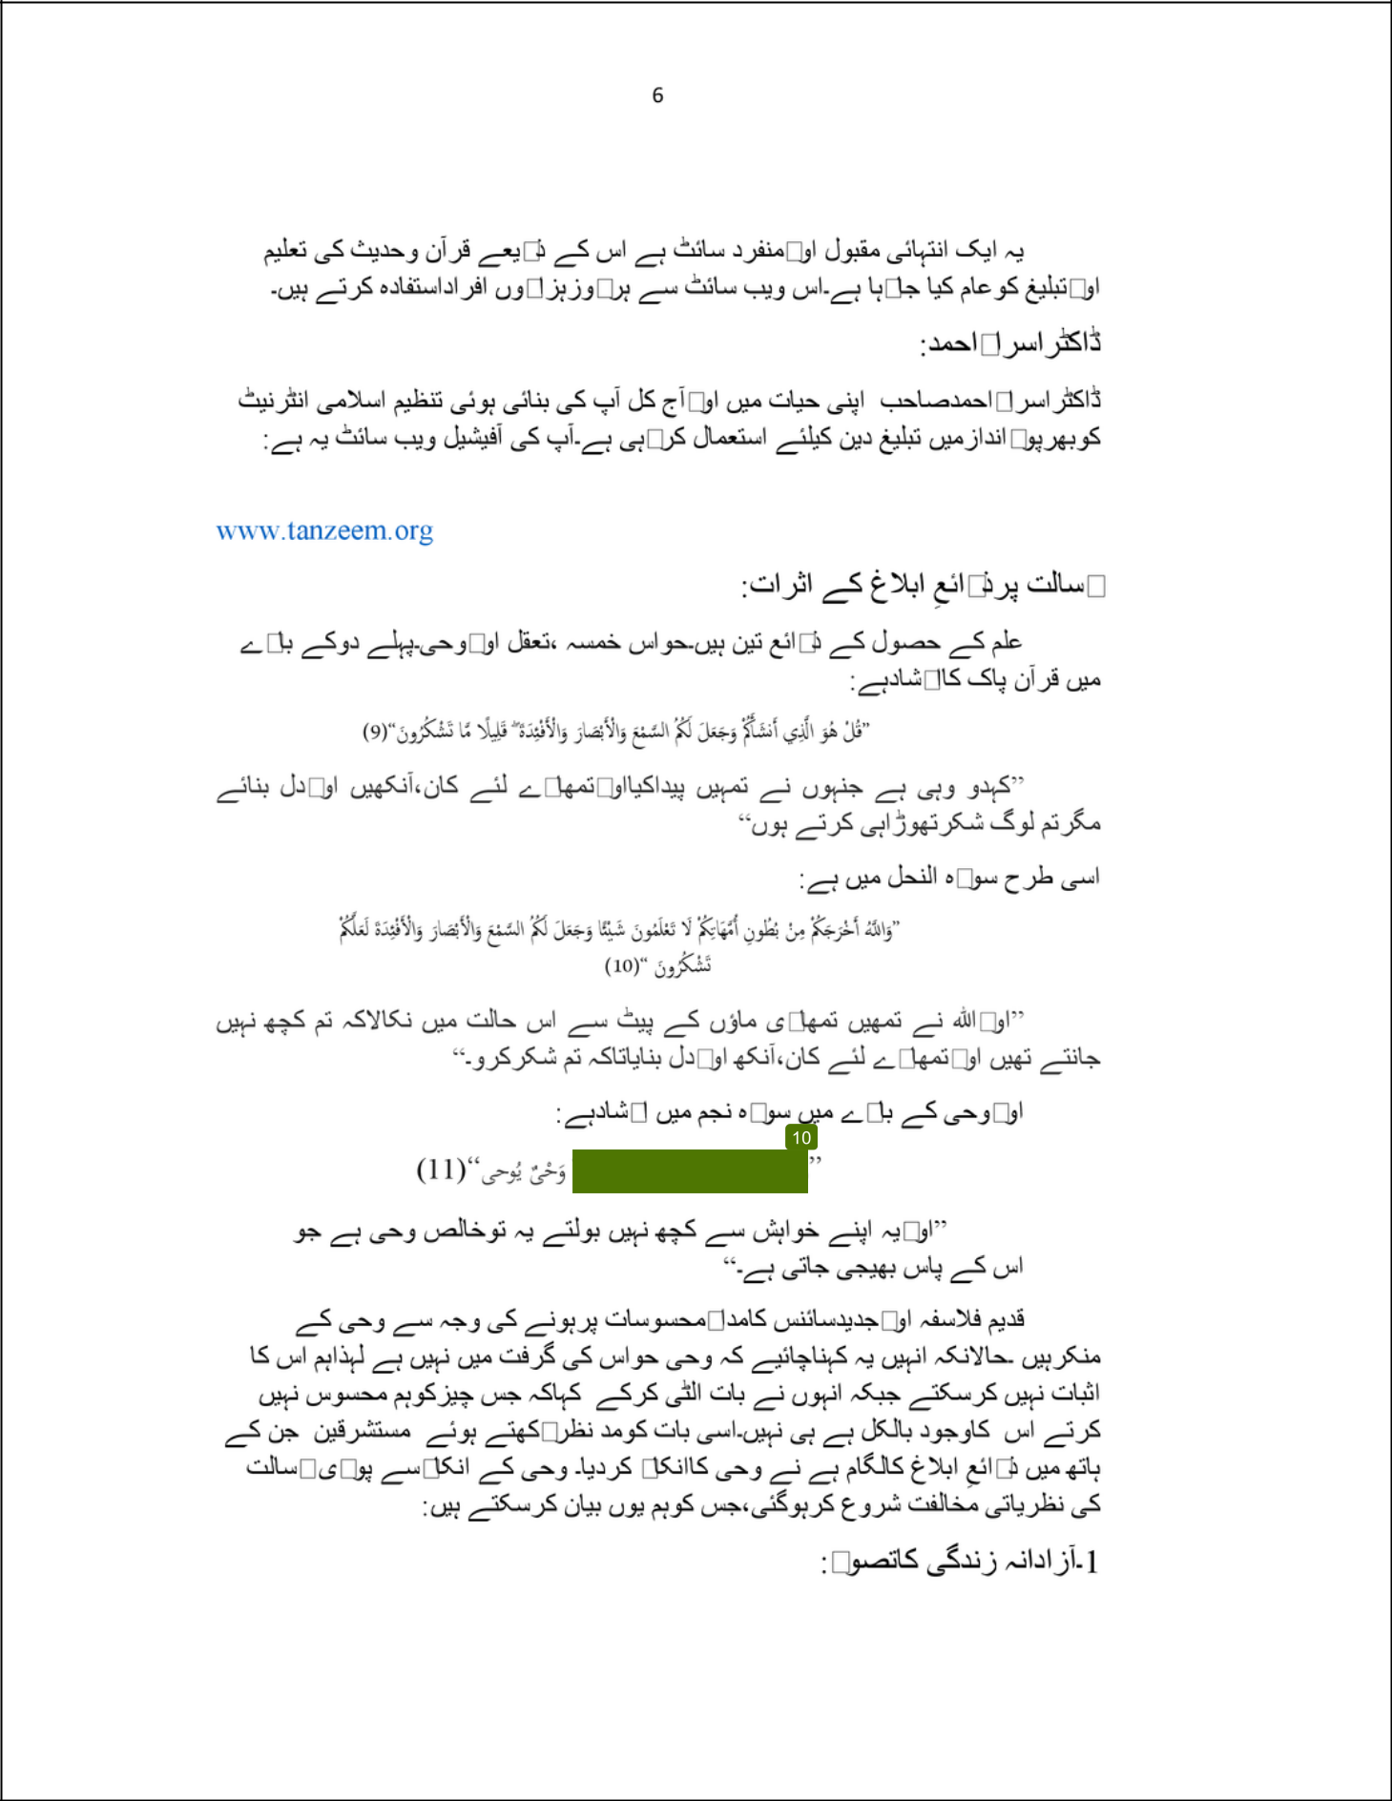

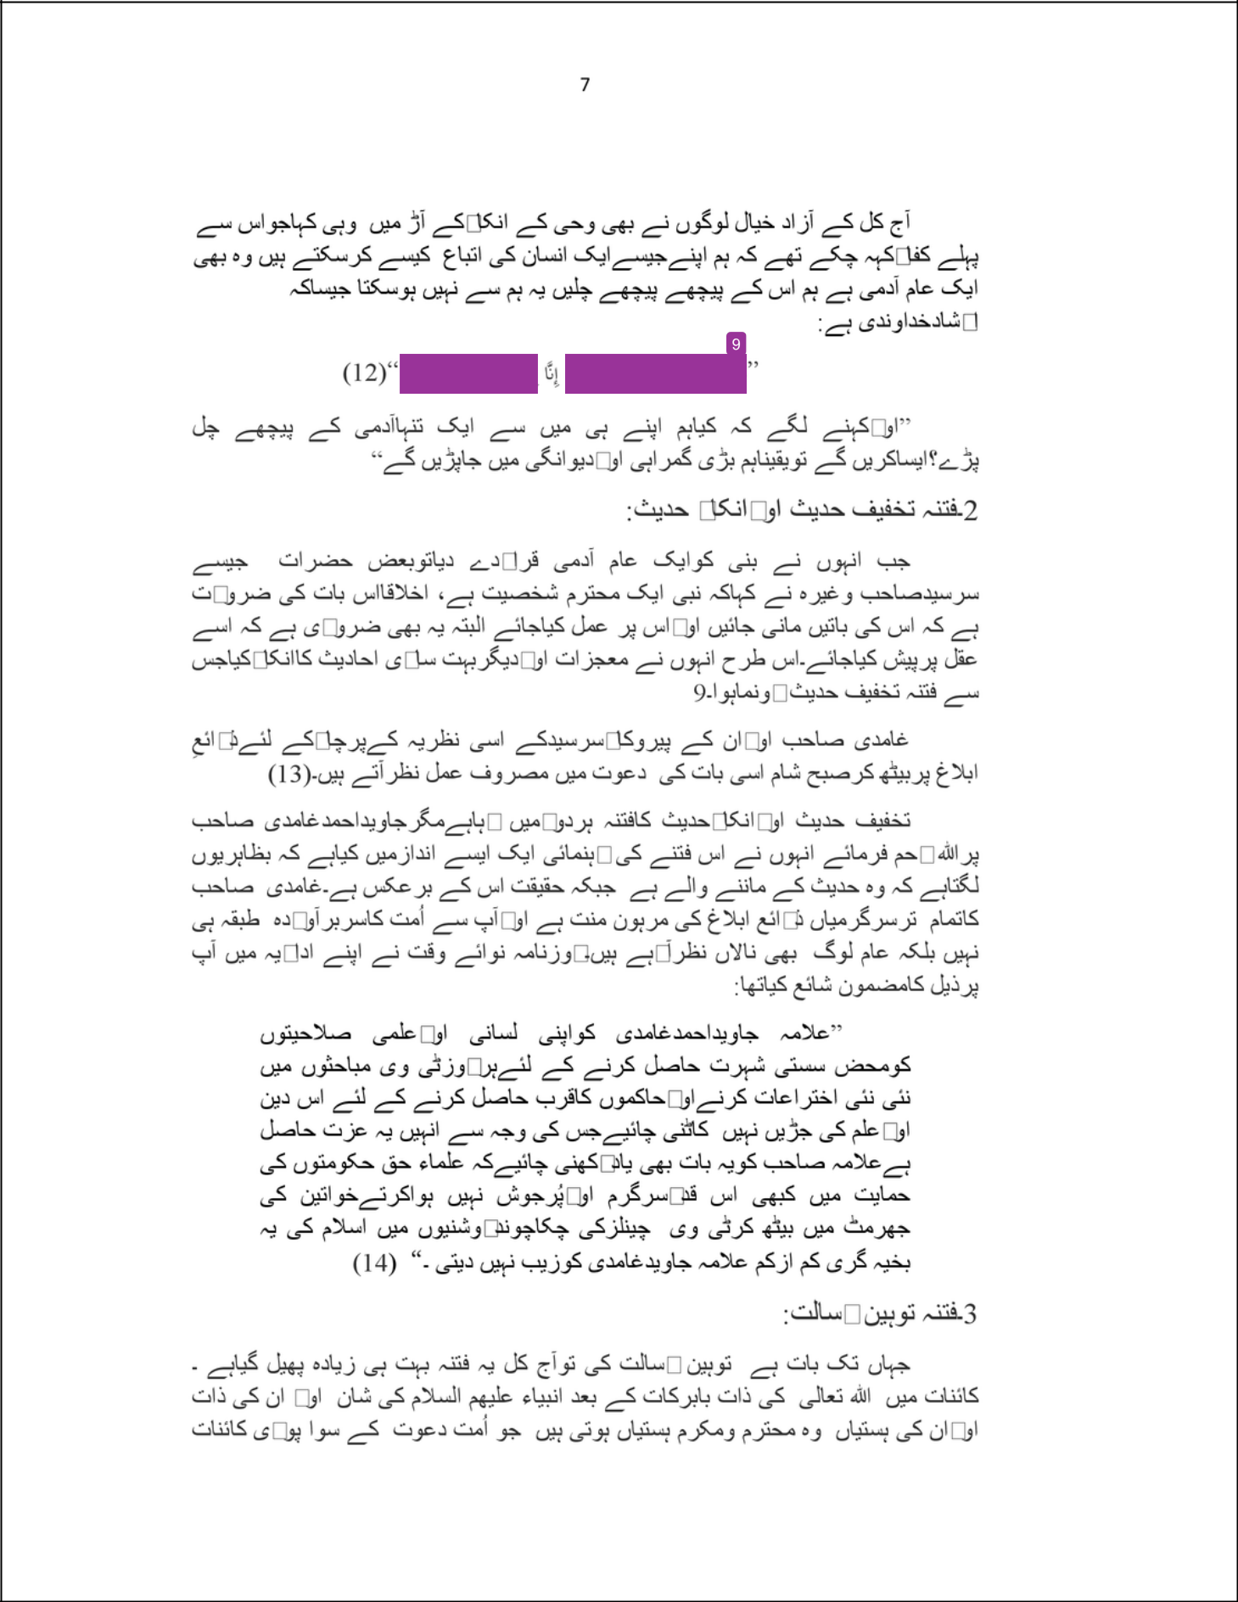

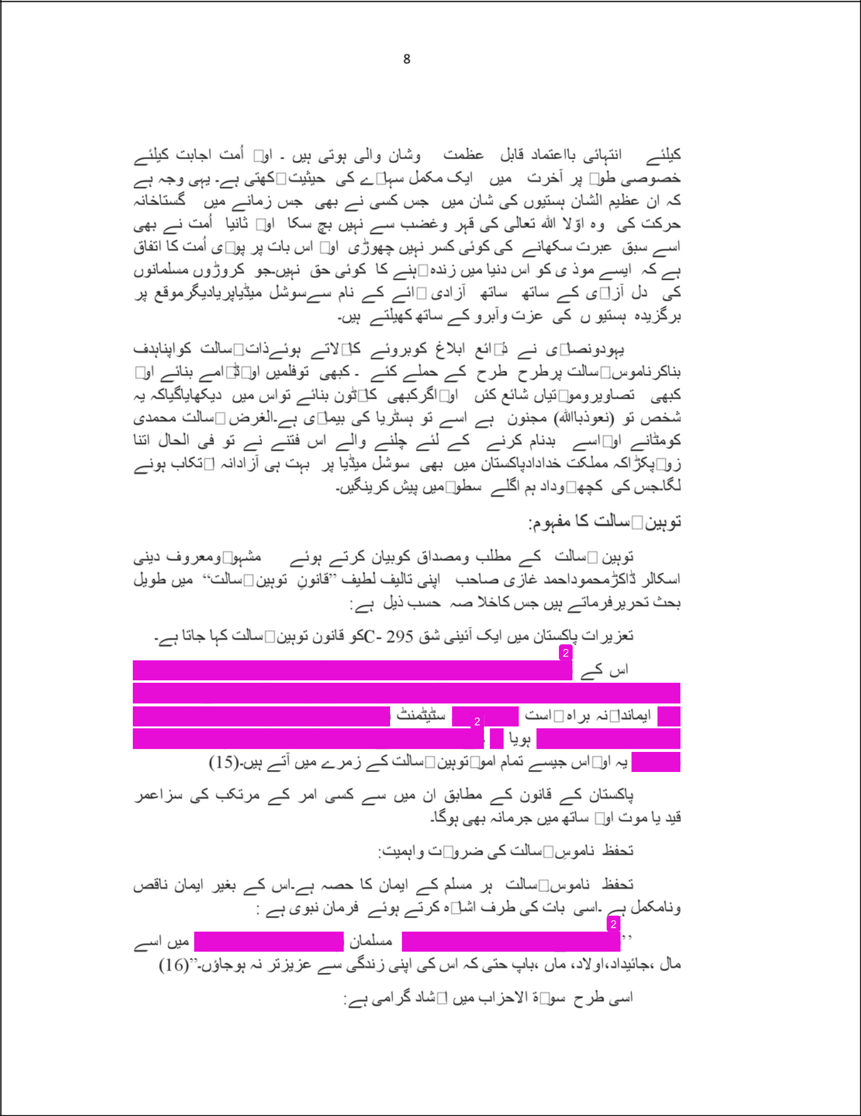

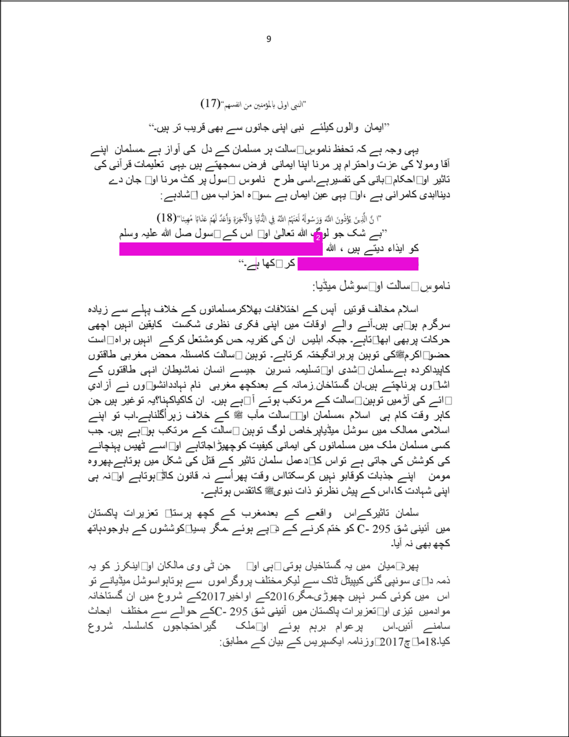

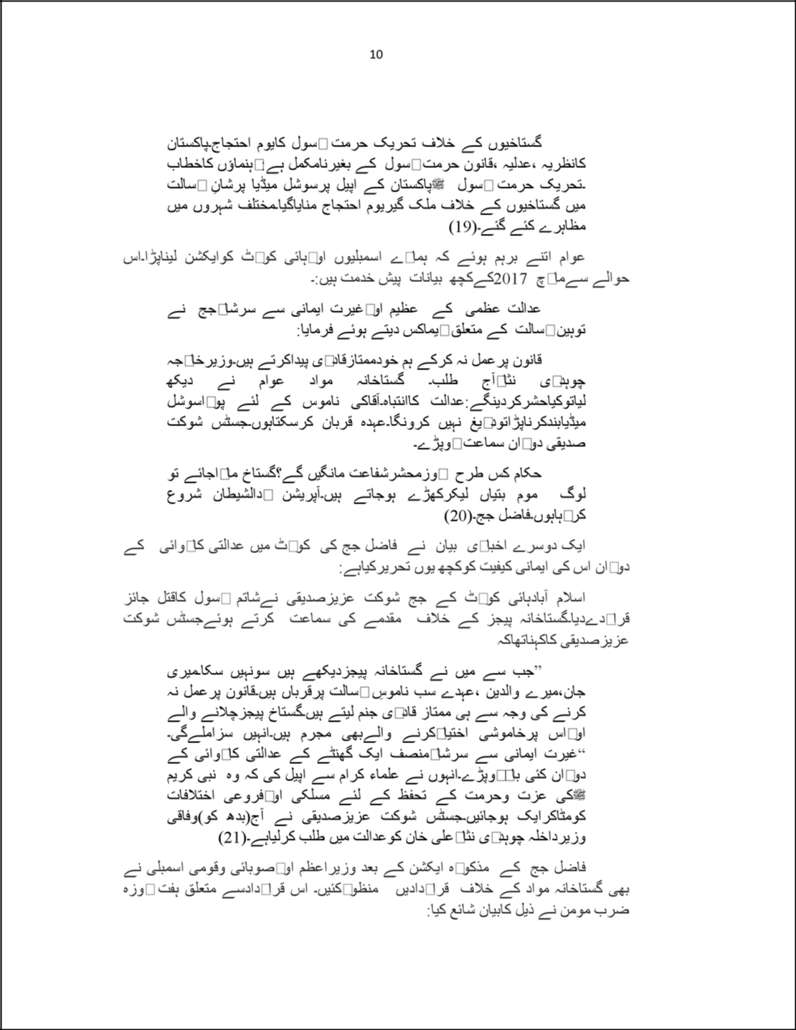

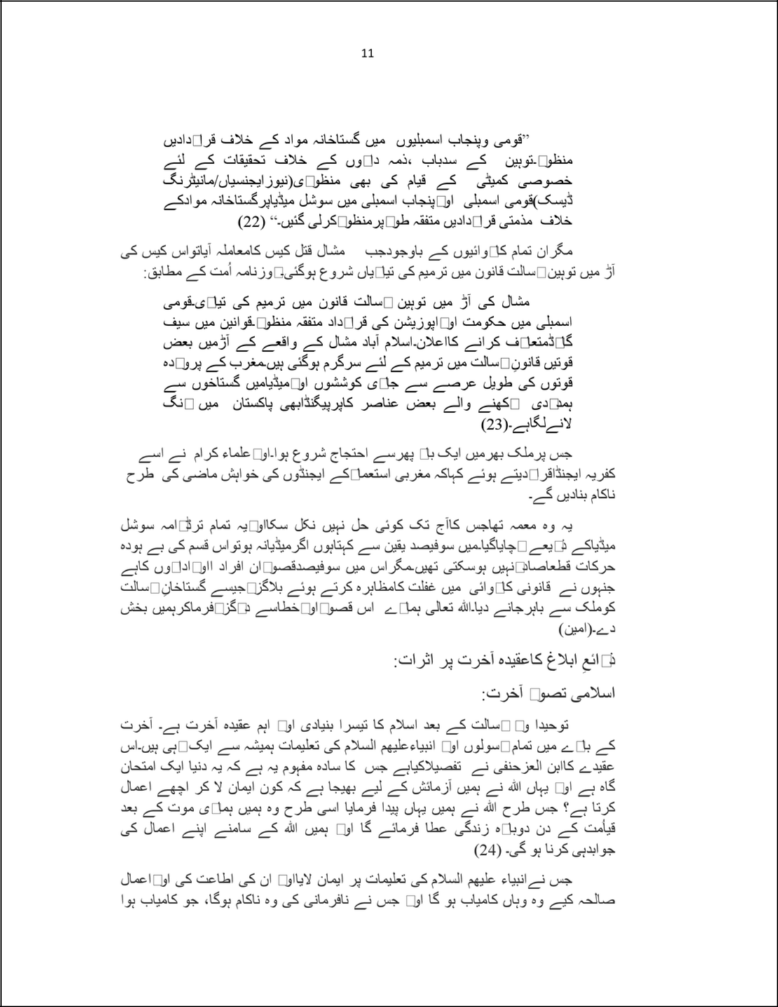

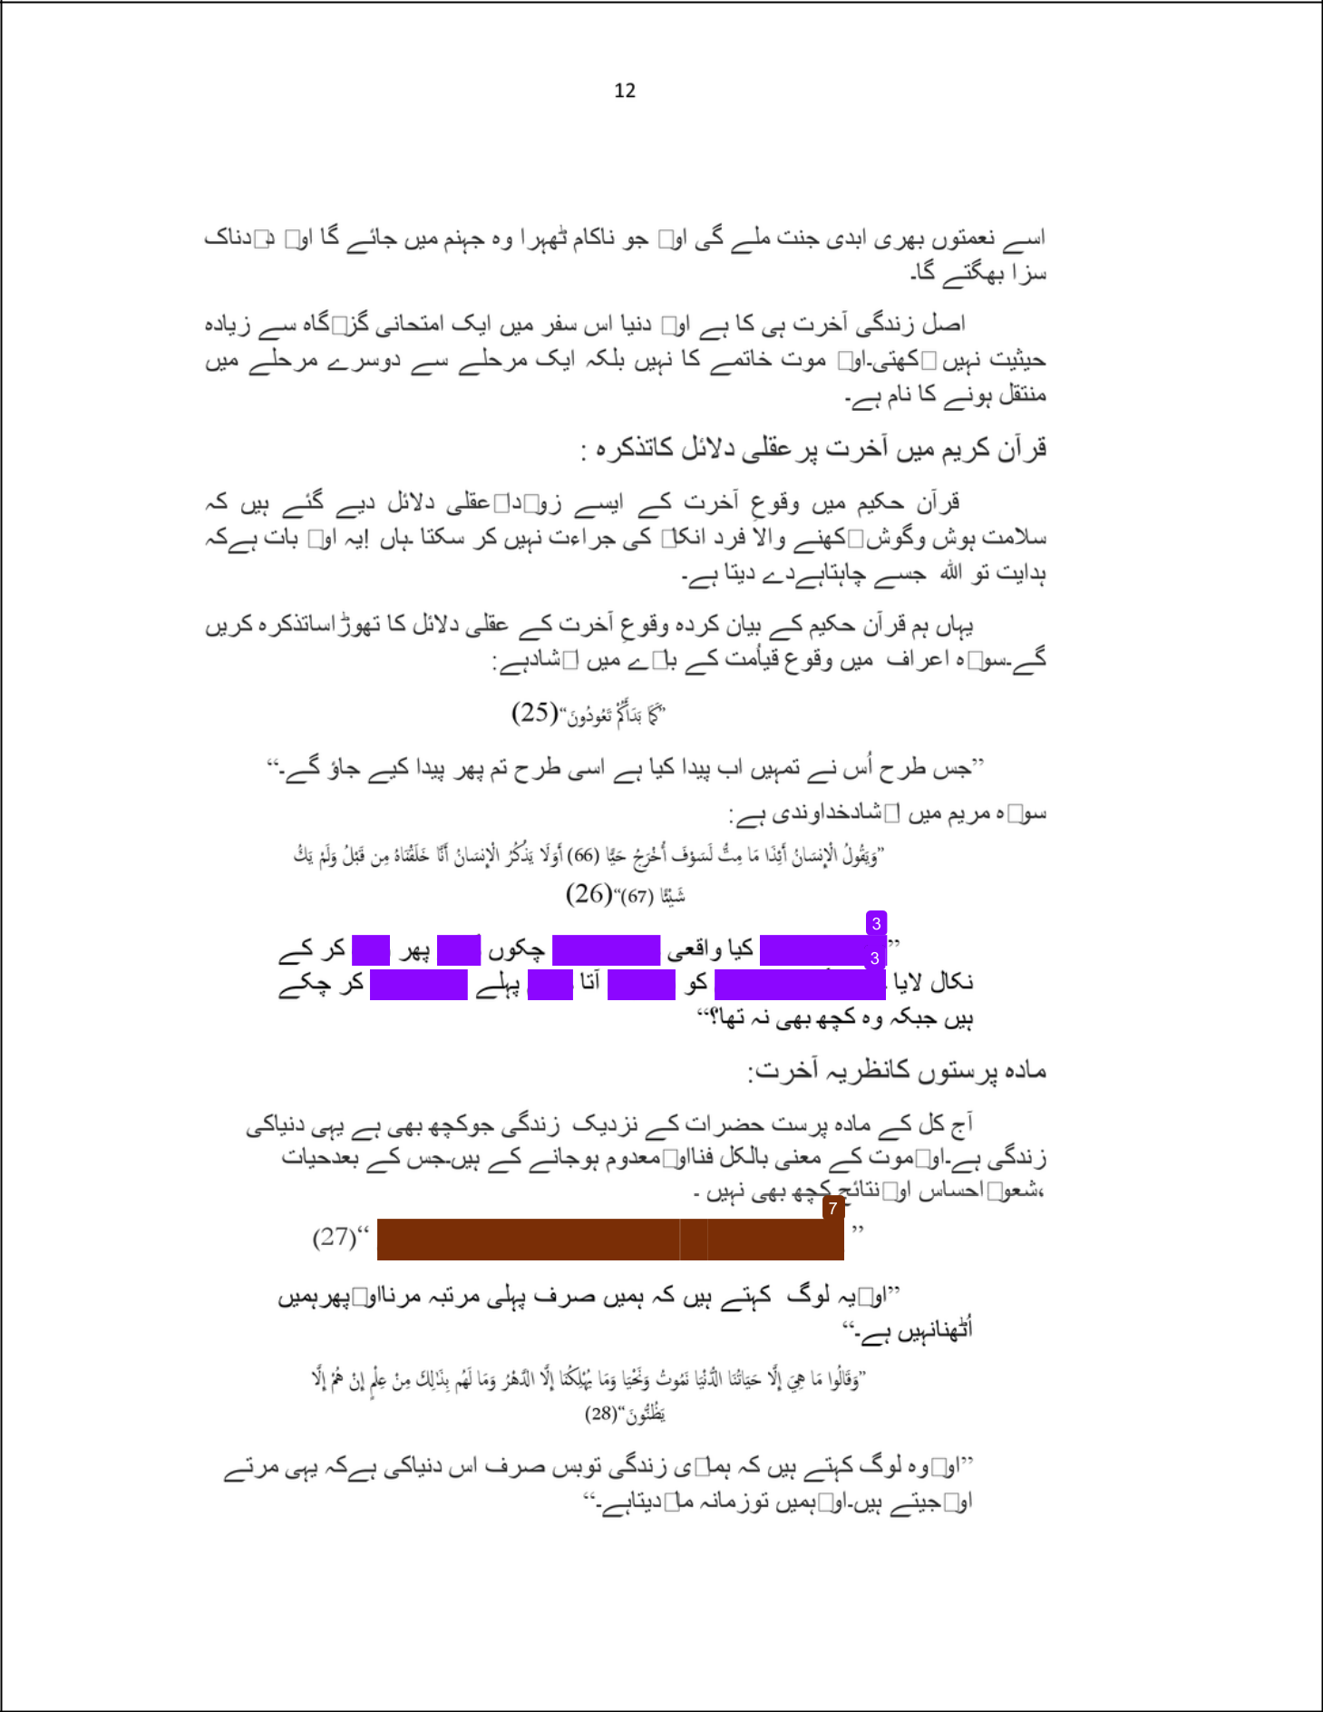

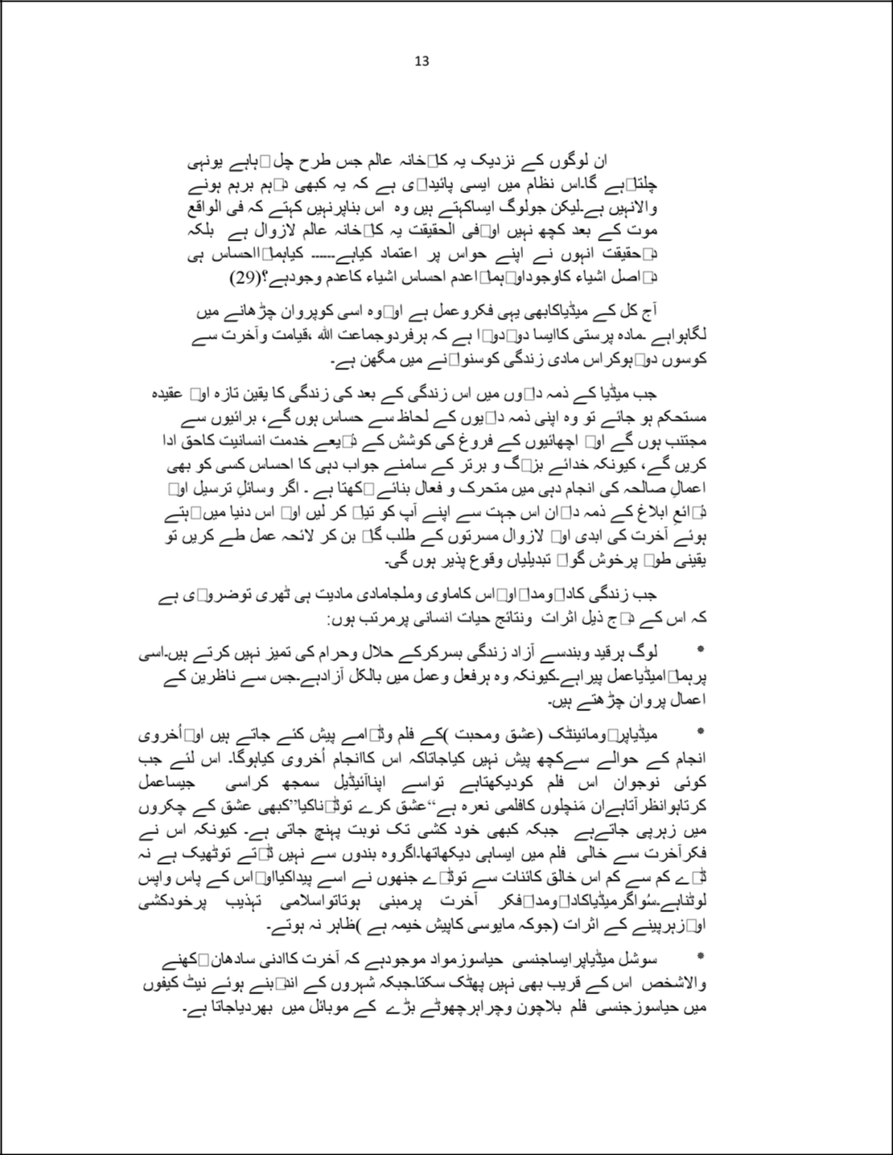

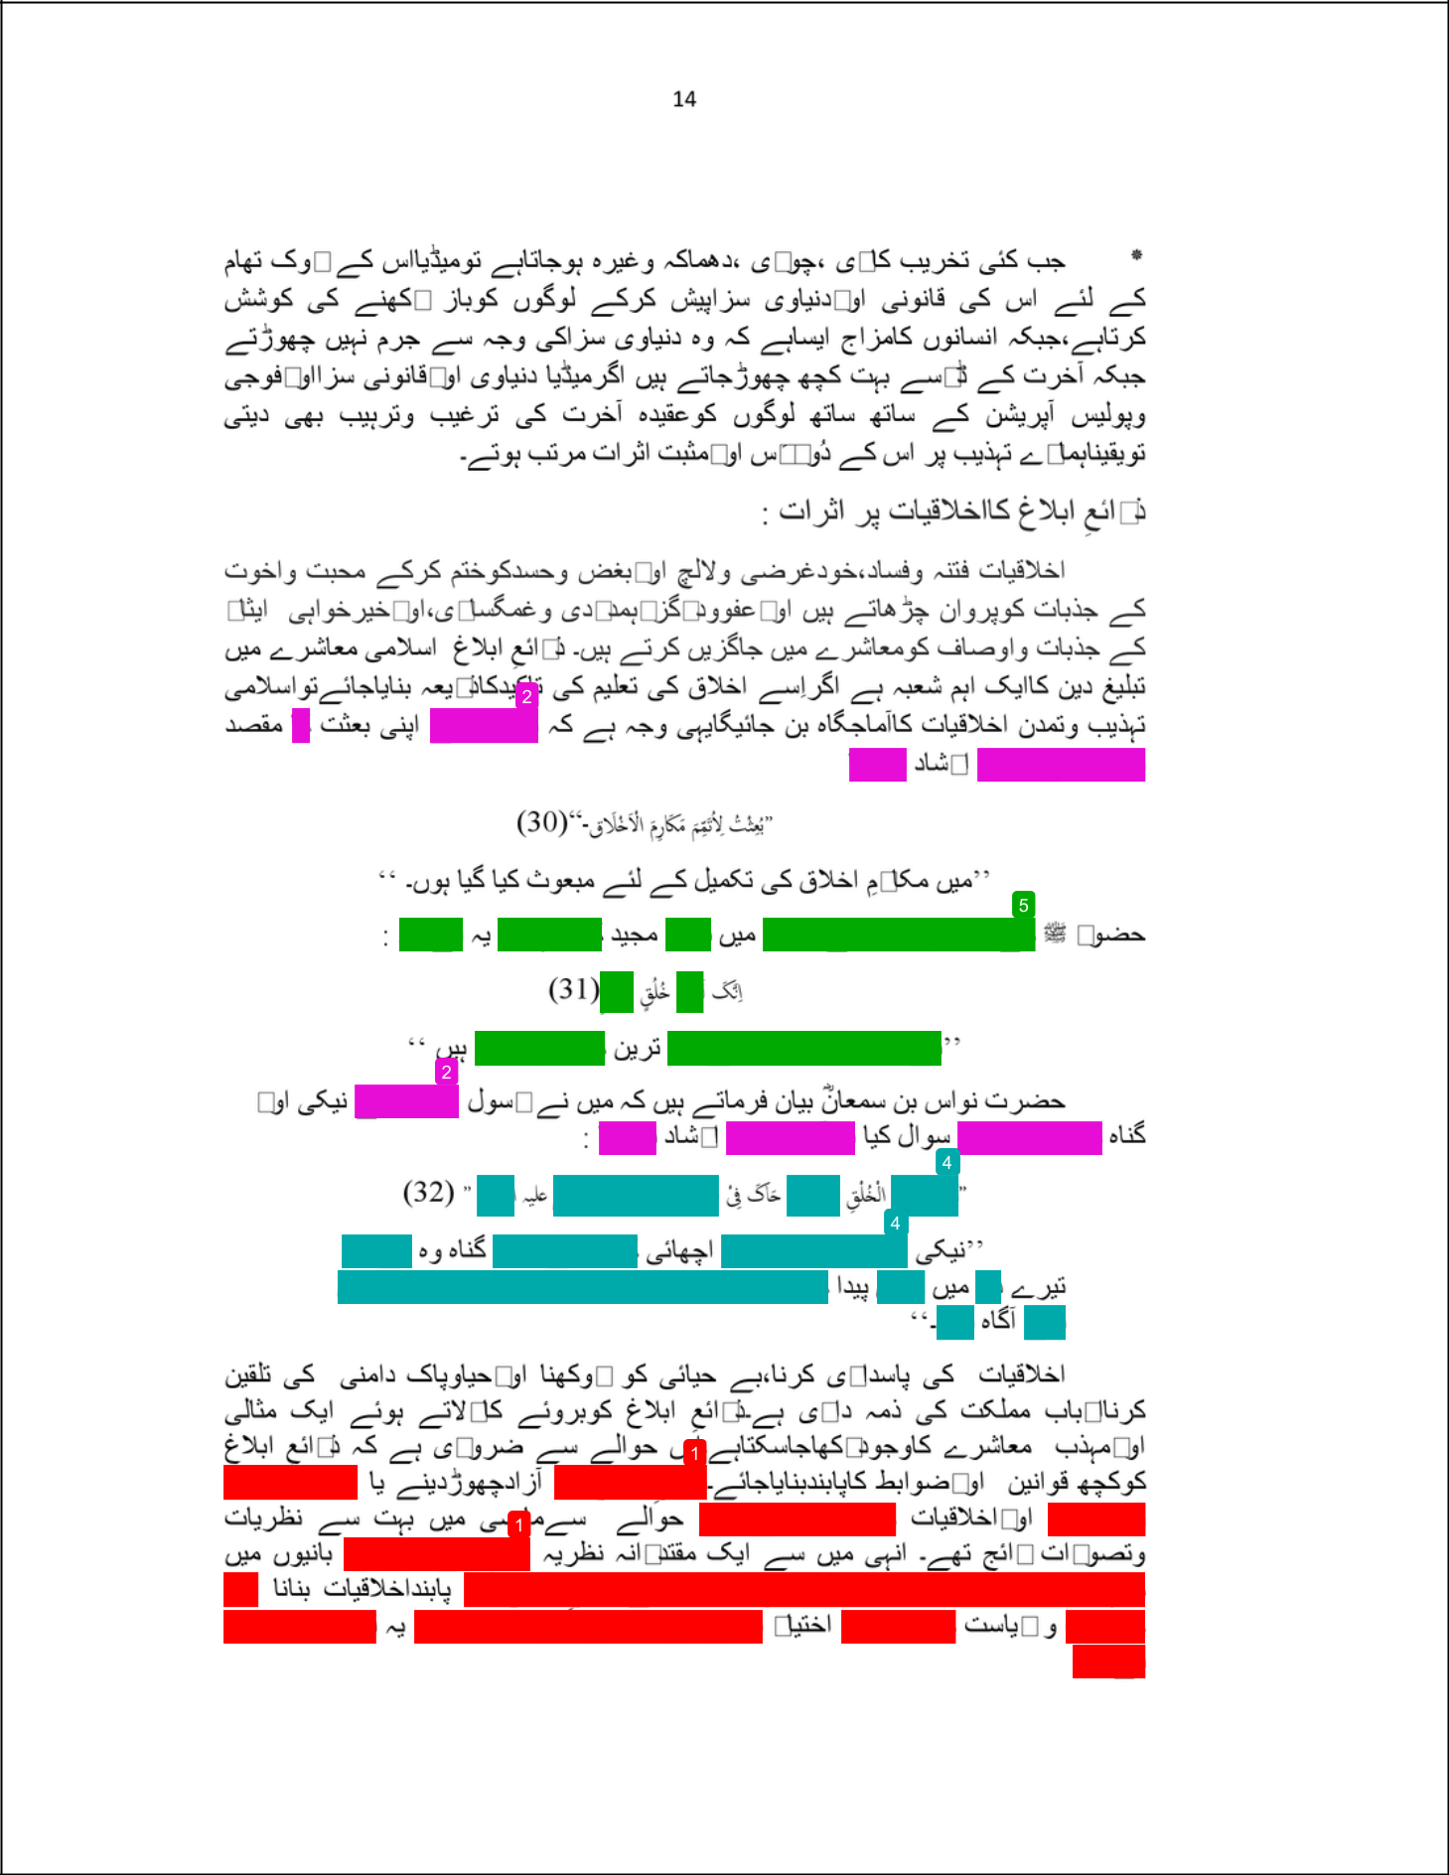

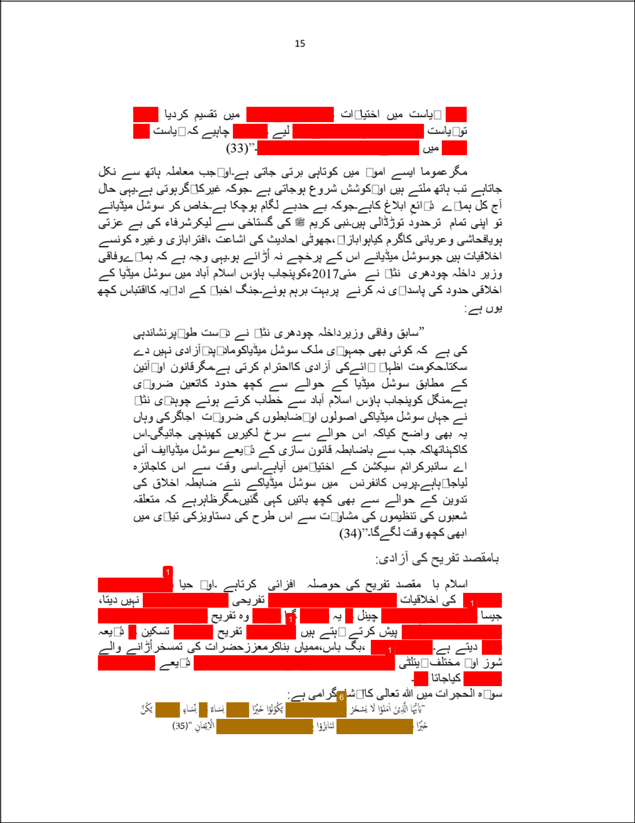

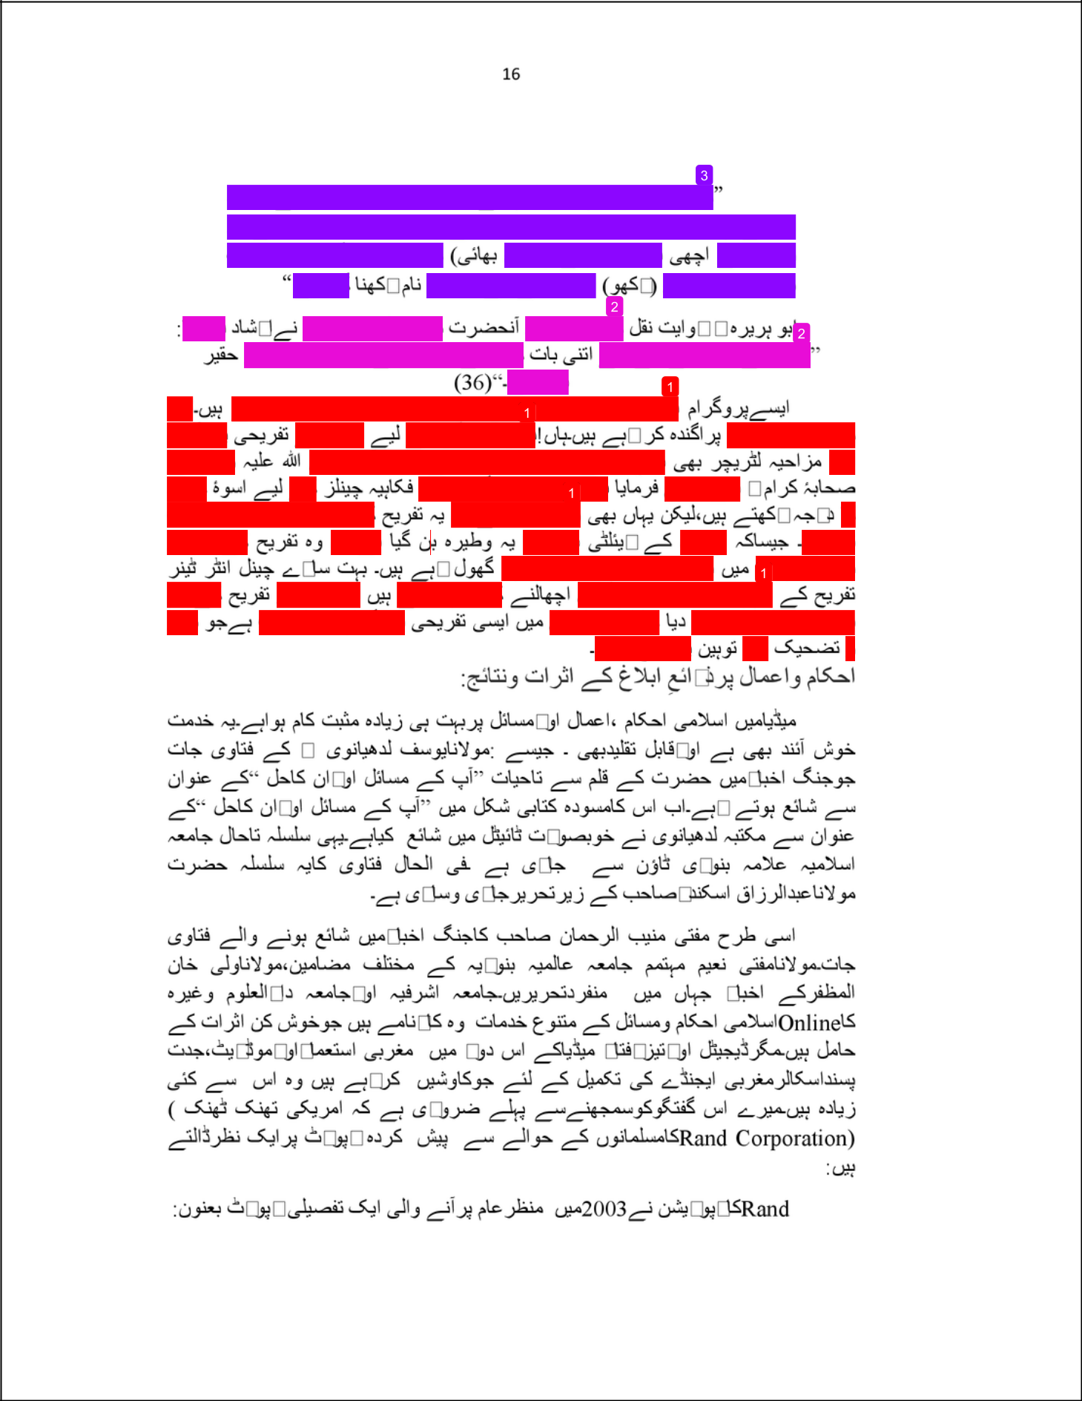

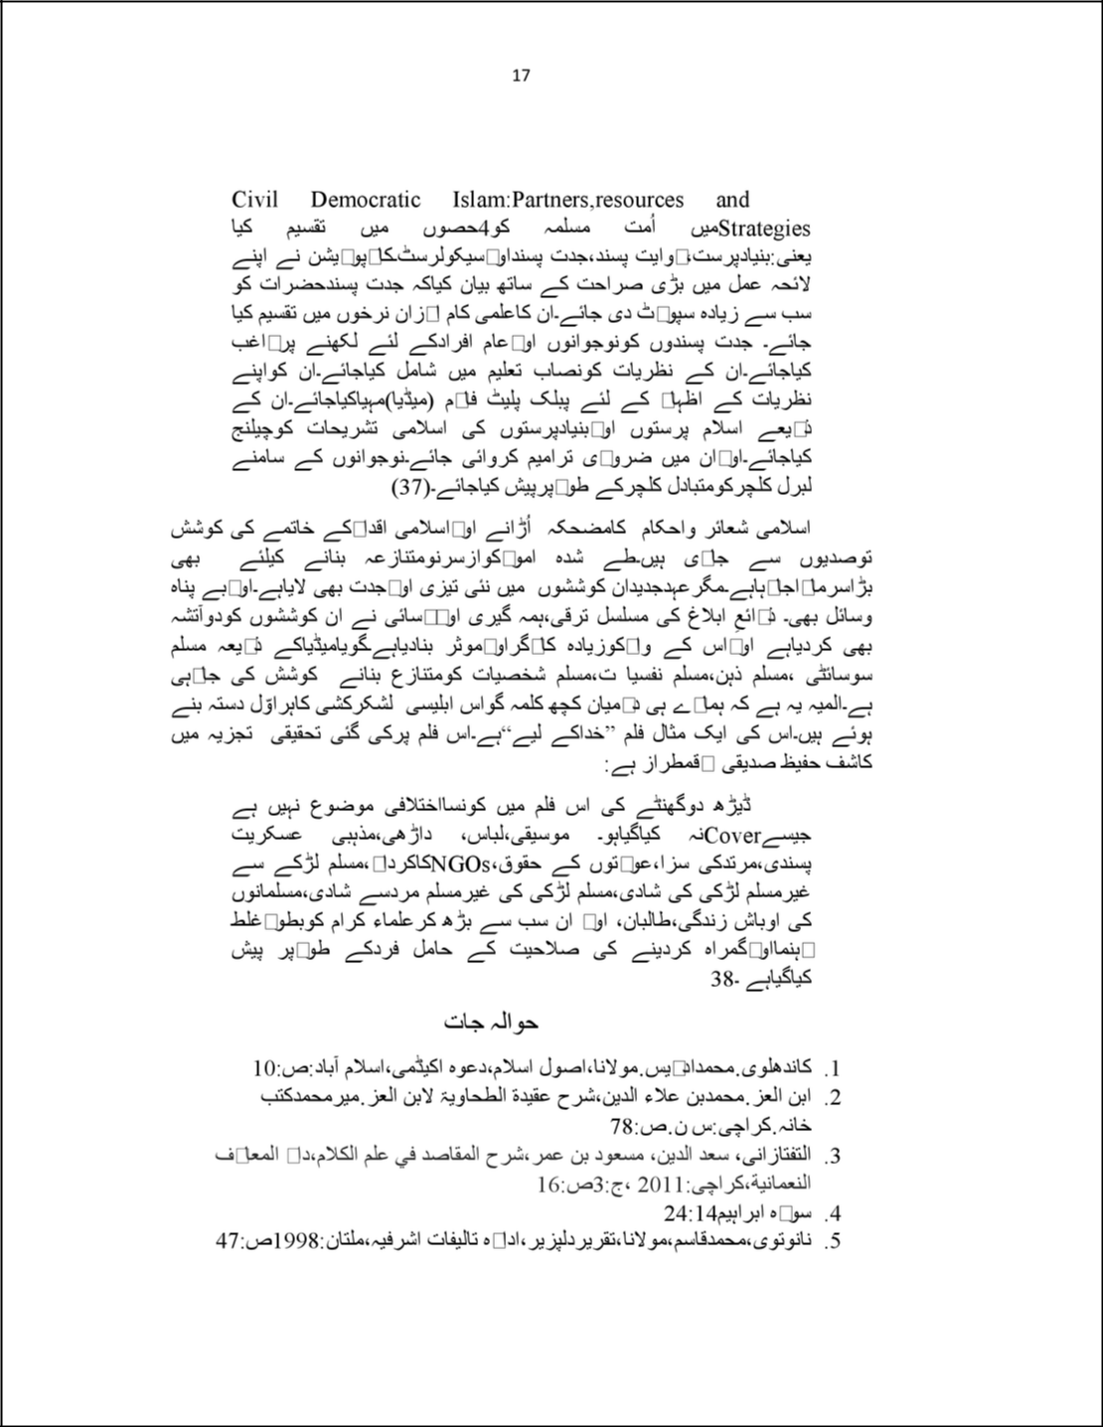

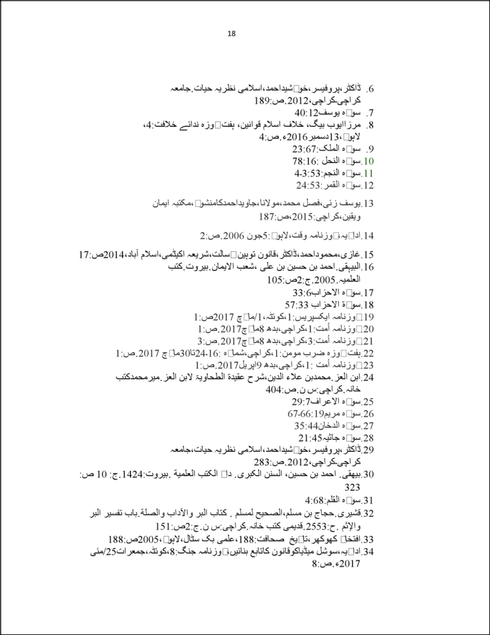

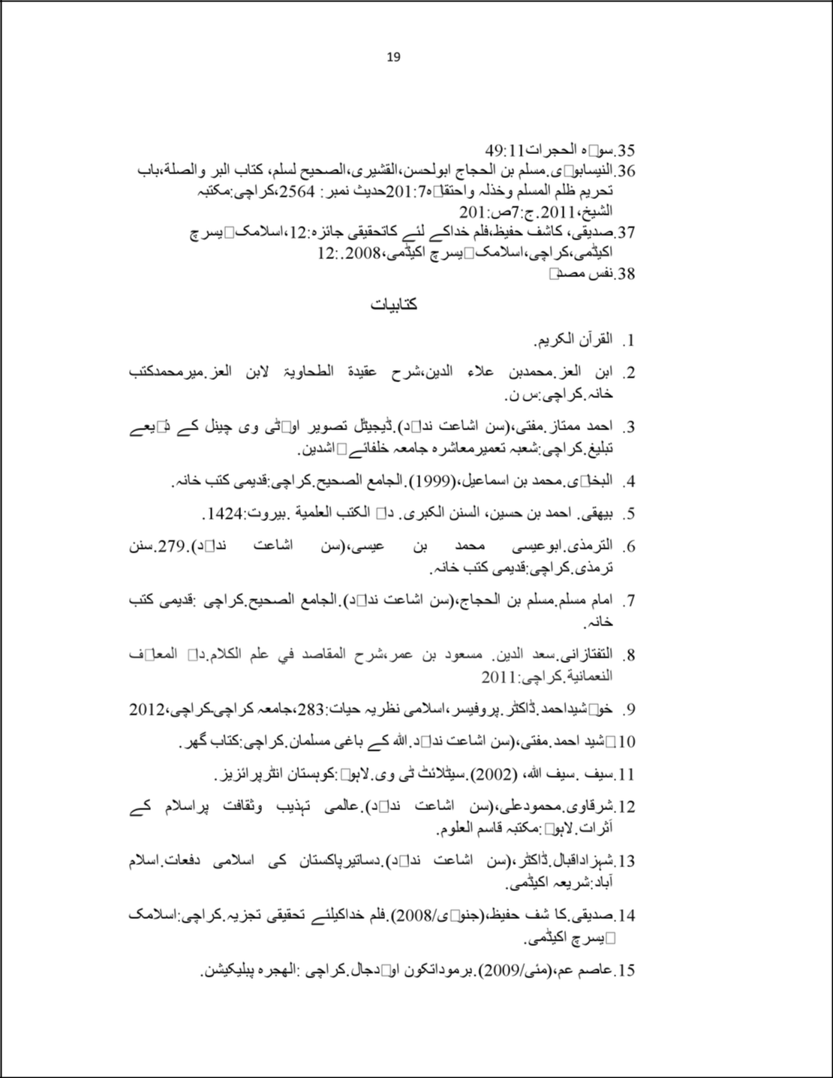

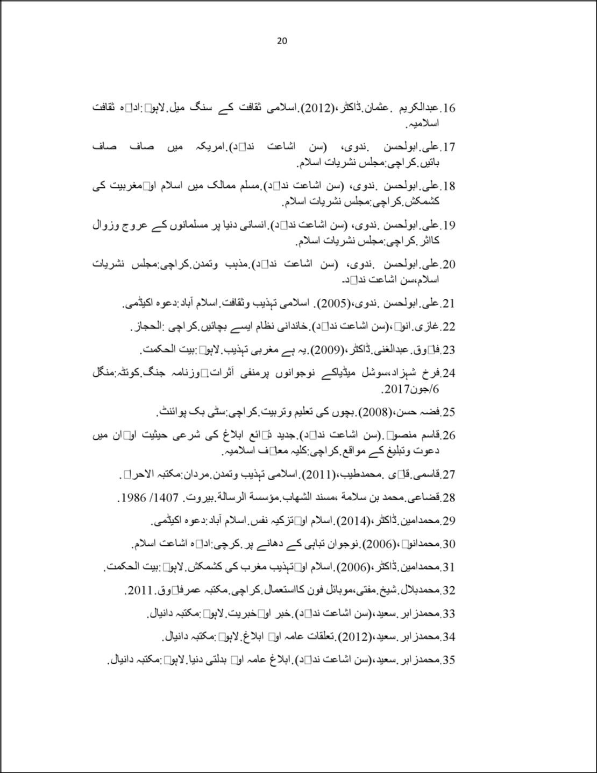

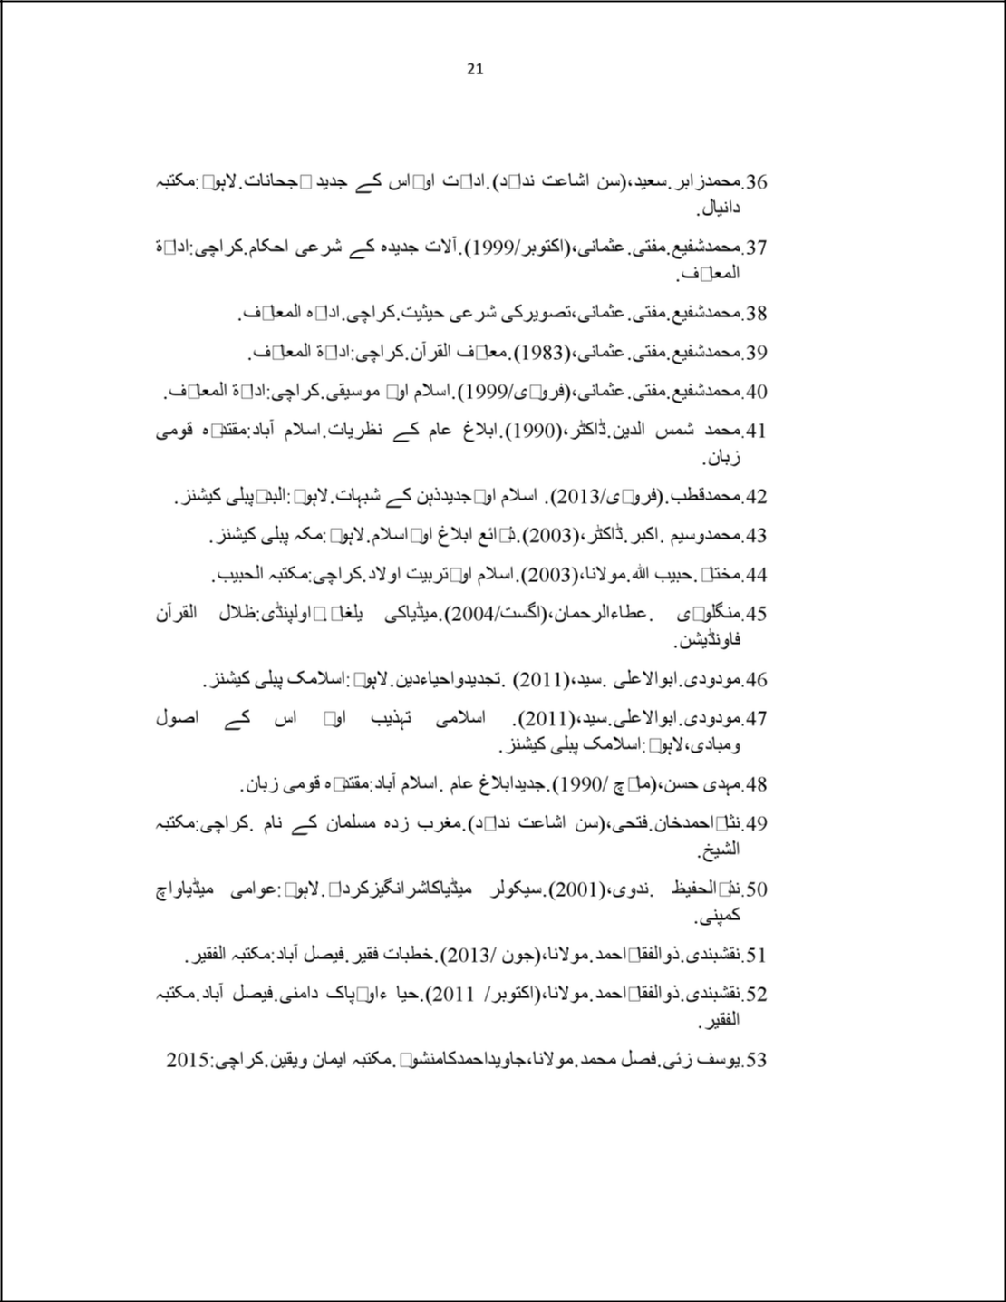

Mufti Abdul Haq Haqani

ORIGINALITY REPORT

8% |  |  | 7% | 1% | 4%
 | SIMILARITY INDEX |  | INTERNET SOURCES | PUBLICATIONS | STUDENT PAPERS
 | PRIMARY SOURCES
 |  | raahedaleel.blogspot.com |  |  |  | 3%
 | 1
 |  | Internet Source
 |  | Submitted to Higher Education Commission |  |  |  | 2%
 | 2
 |  | Pakistan
Student Paper

- qurango.com

Internet Source

- albisharah.com

Internet Source

- magazine.mohaddis.com

Internet Source

- www.quran7m.com

Internet Source

- www.al-mawrid.org

Internet Source

- Submitted to Tikrit University

Student Paper

- www.muhammad.com

1%

<1%

<1%

<1%

<1%

<1%

 |  | Internet Source | <1%
 |  | t-tarikh.persianblog.ir | <1%
 | 10
 |  | Internet Source
 |  | mandens.dk | <1%
 | 11
 |  | Internet Source

Exclude quotes

Of f

Exclude matches

Of f

Exclude bibliography

Of f

