Mufti Abdul Waris Sb

by Salman ahmed

Submission date: 11-May-2018 09:01AM (UTC+0500)

Submission ID: 952611056

File name: 1.docx (43.36K)

Word count: 7202

Character count: 30016

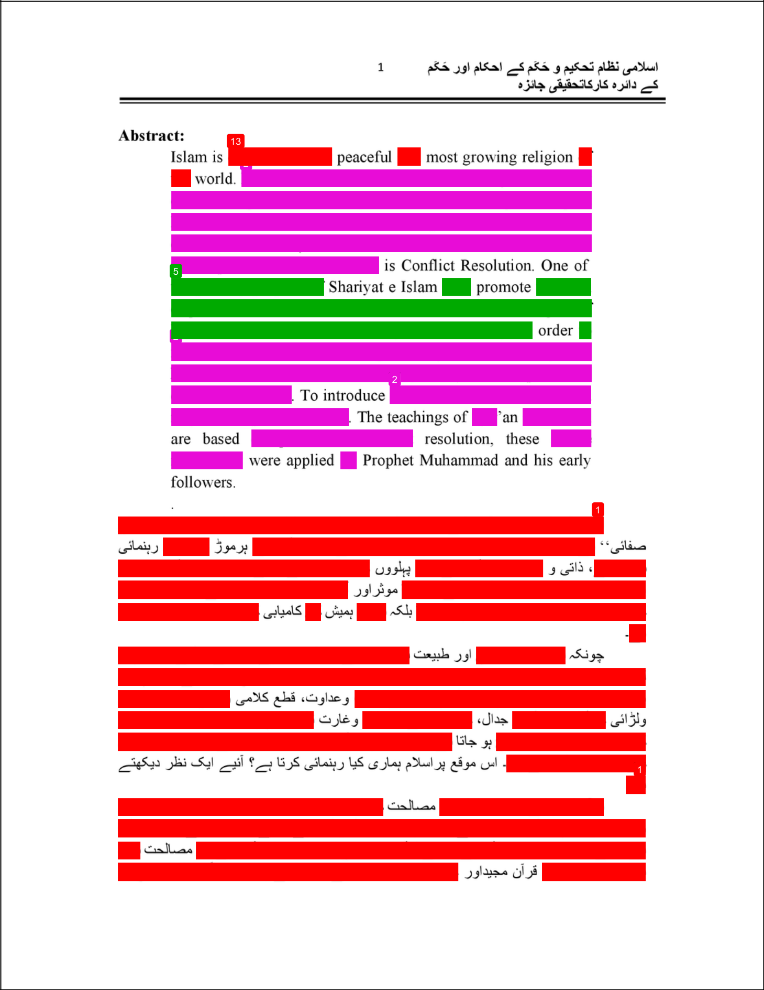

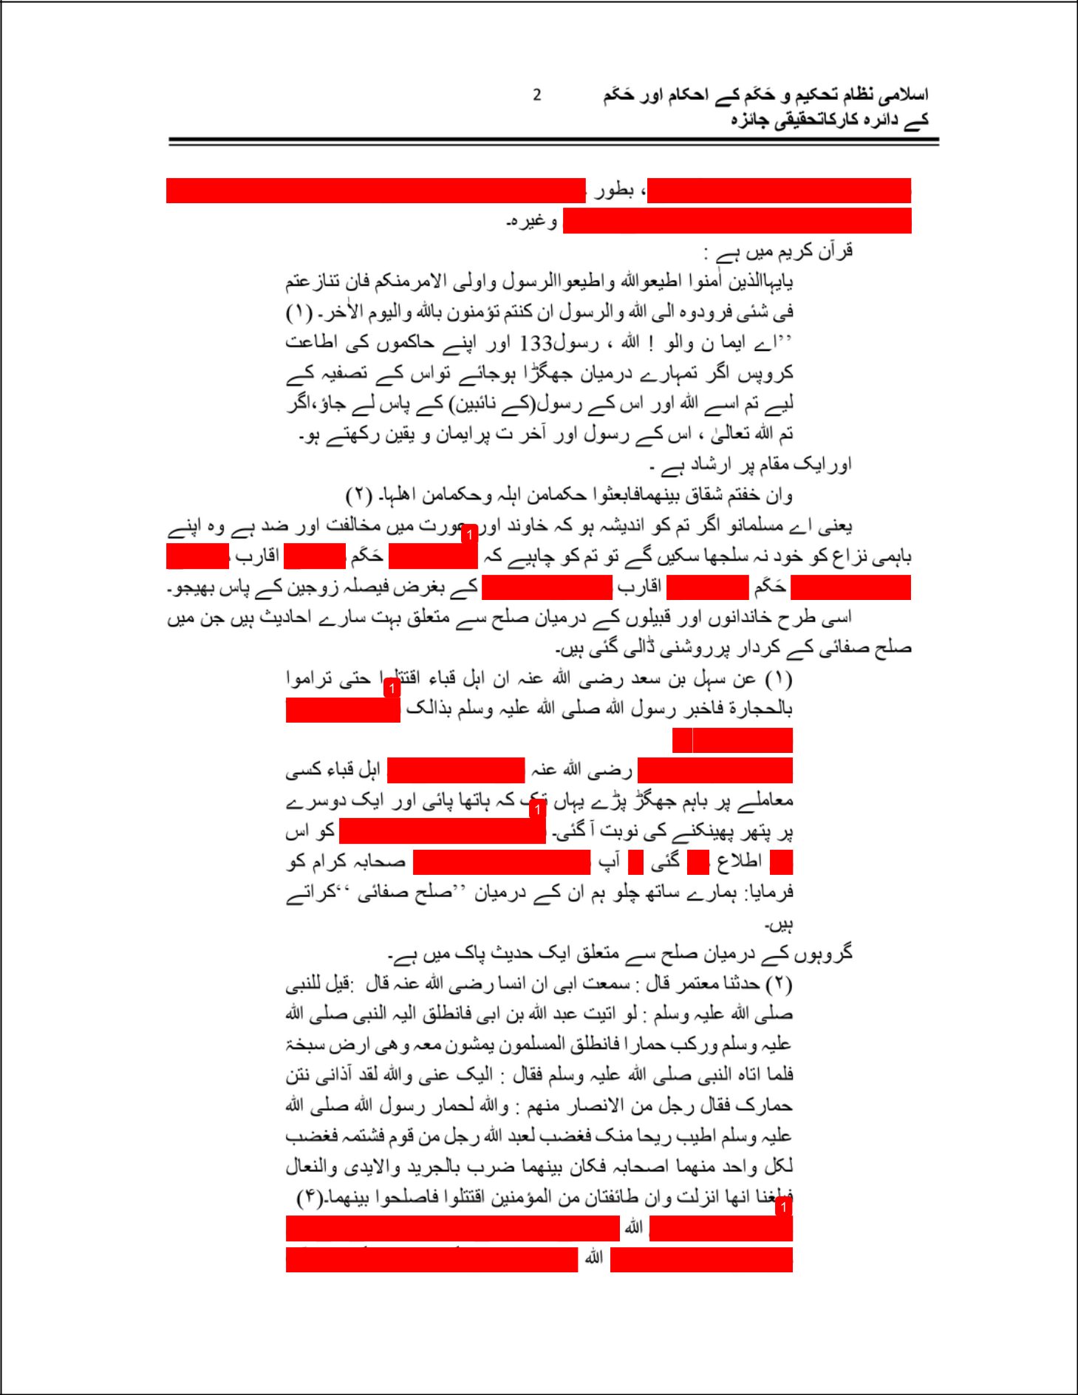

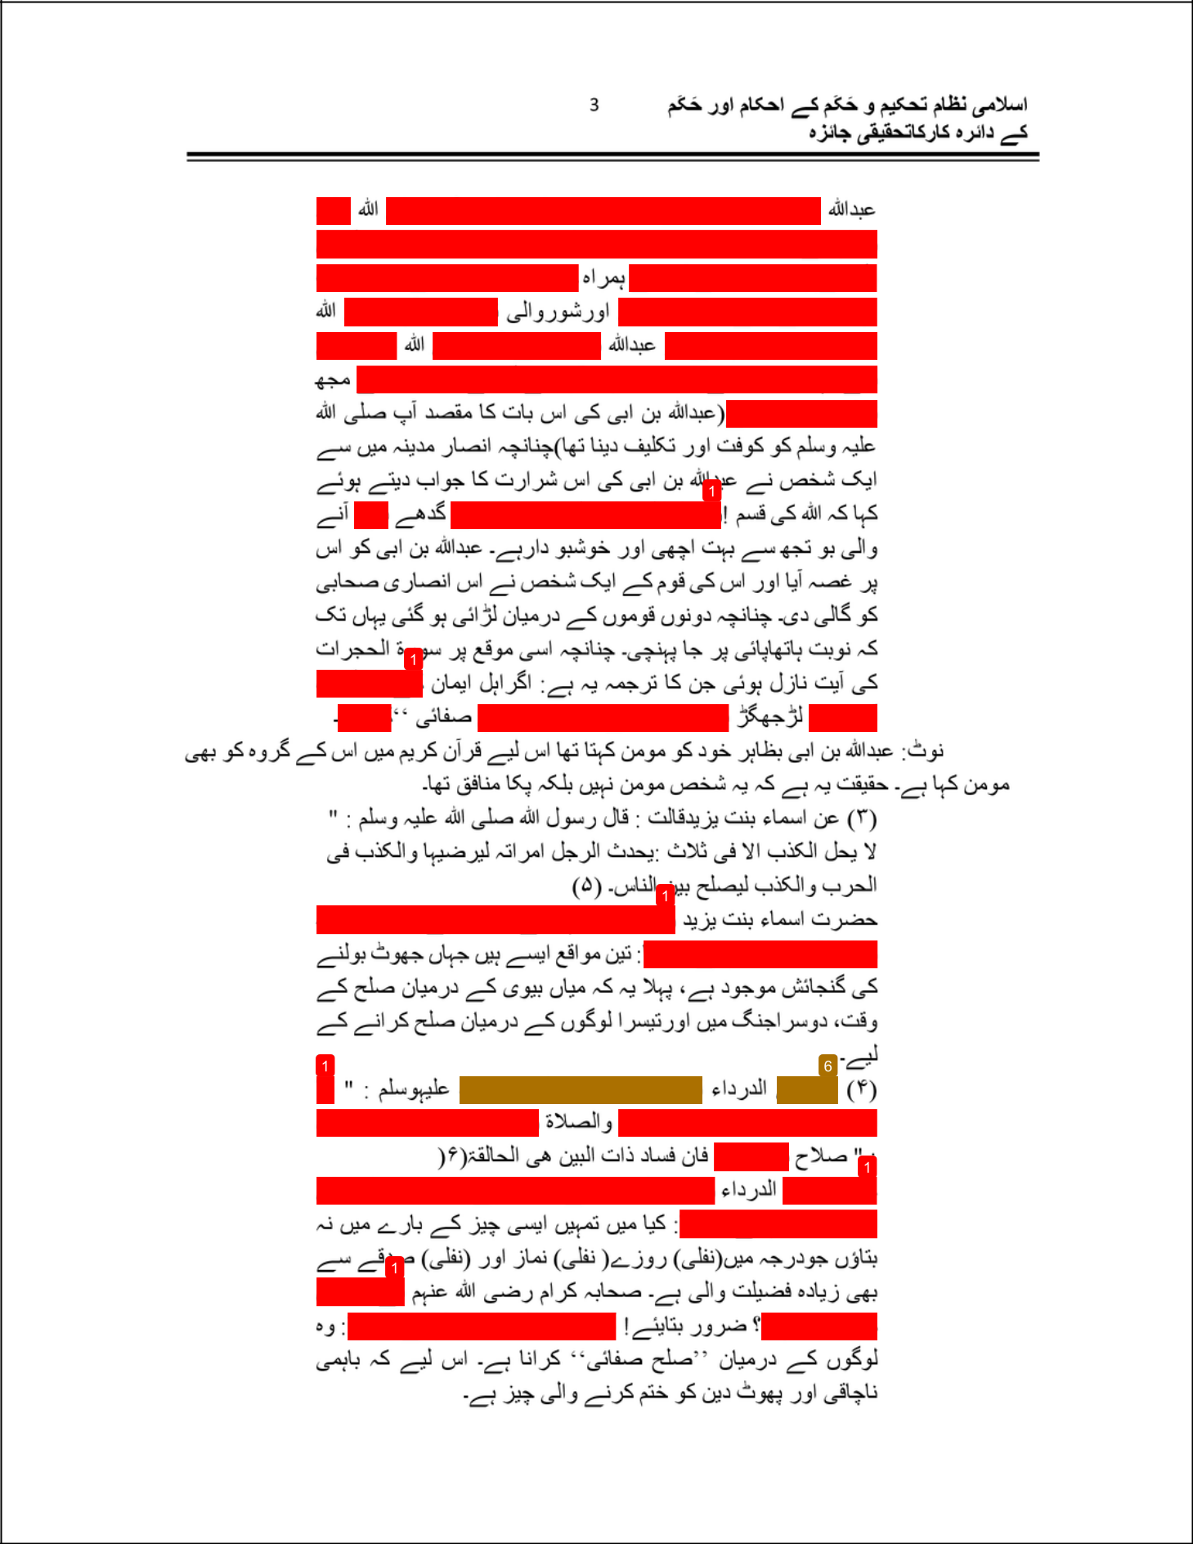

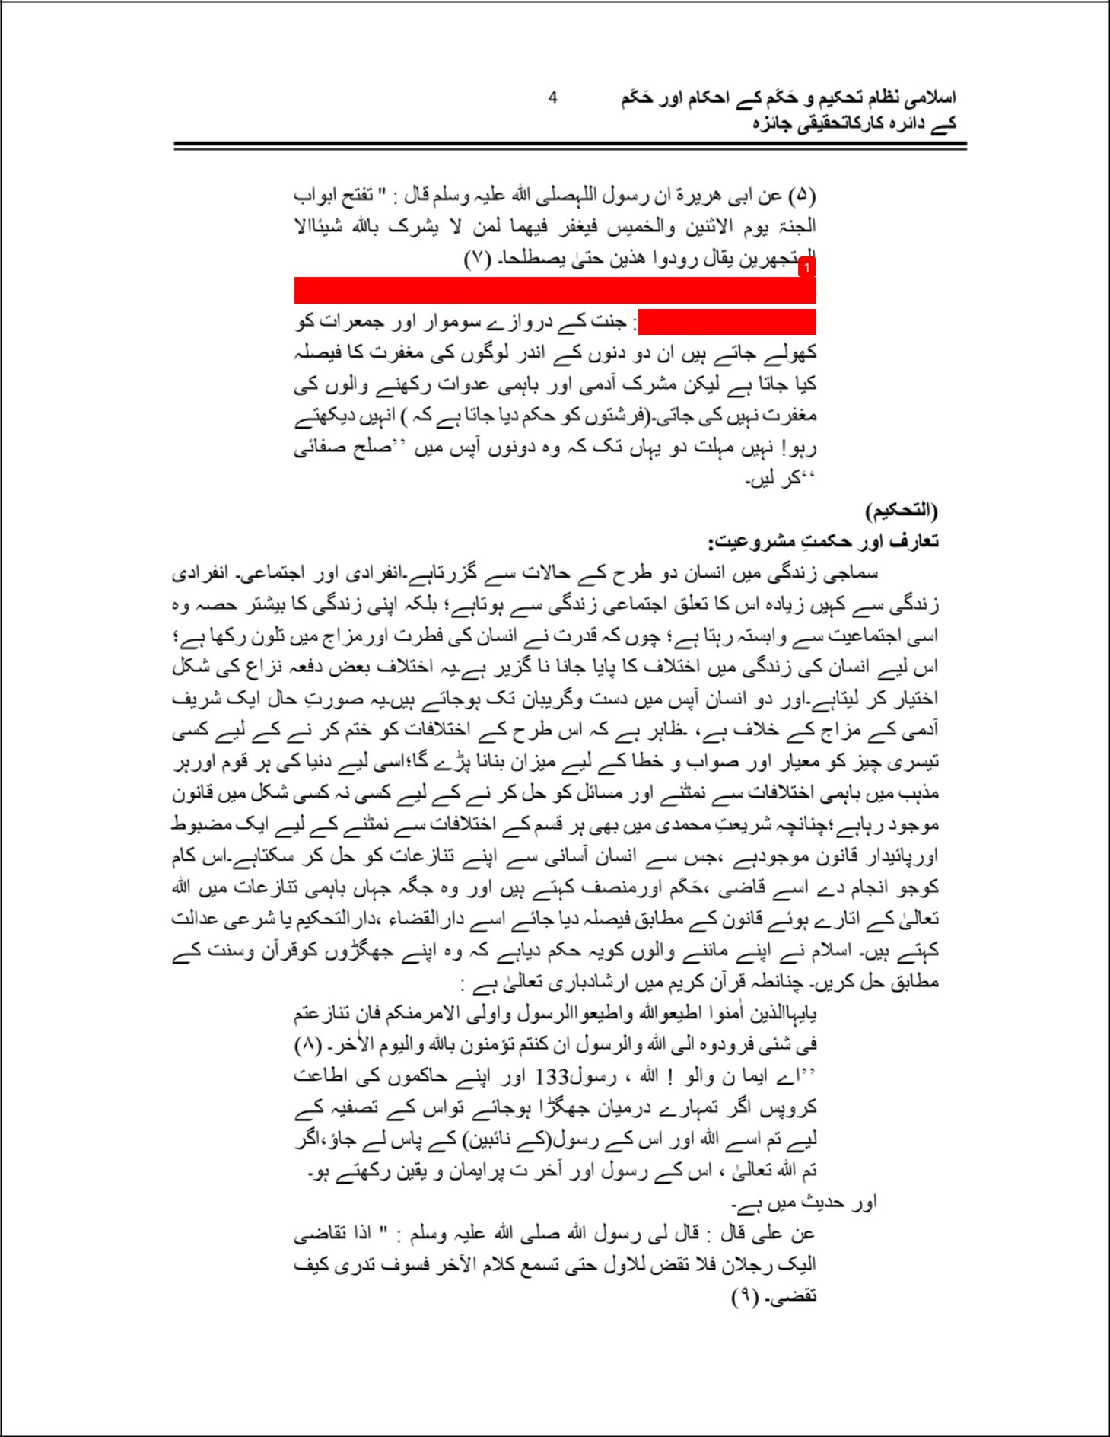

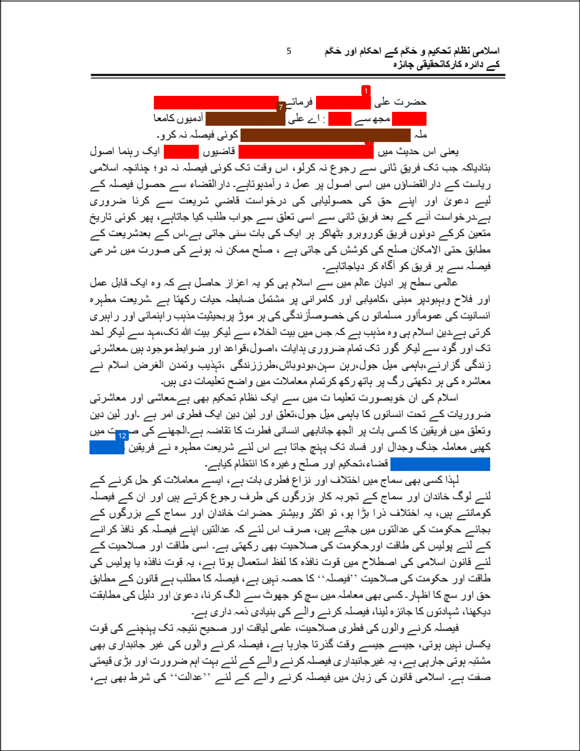

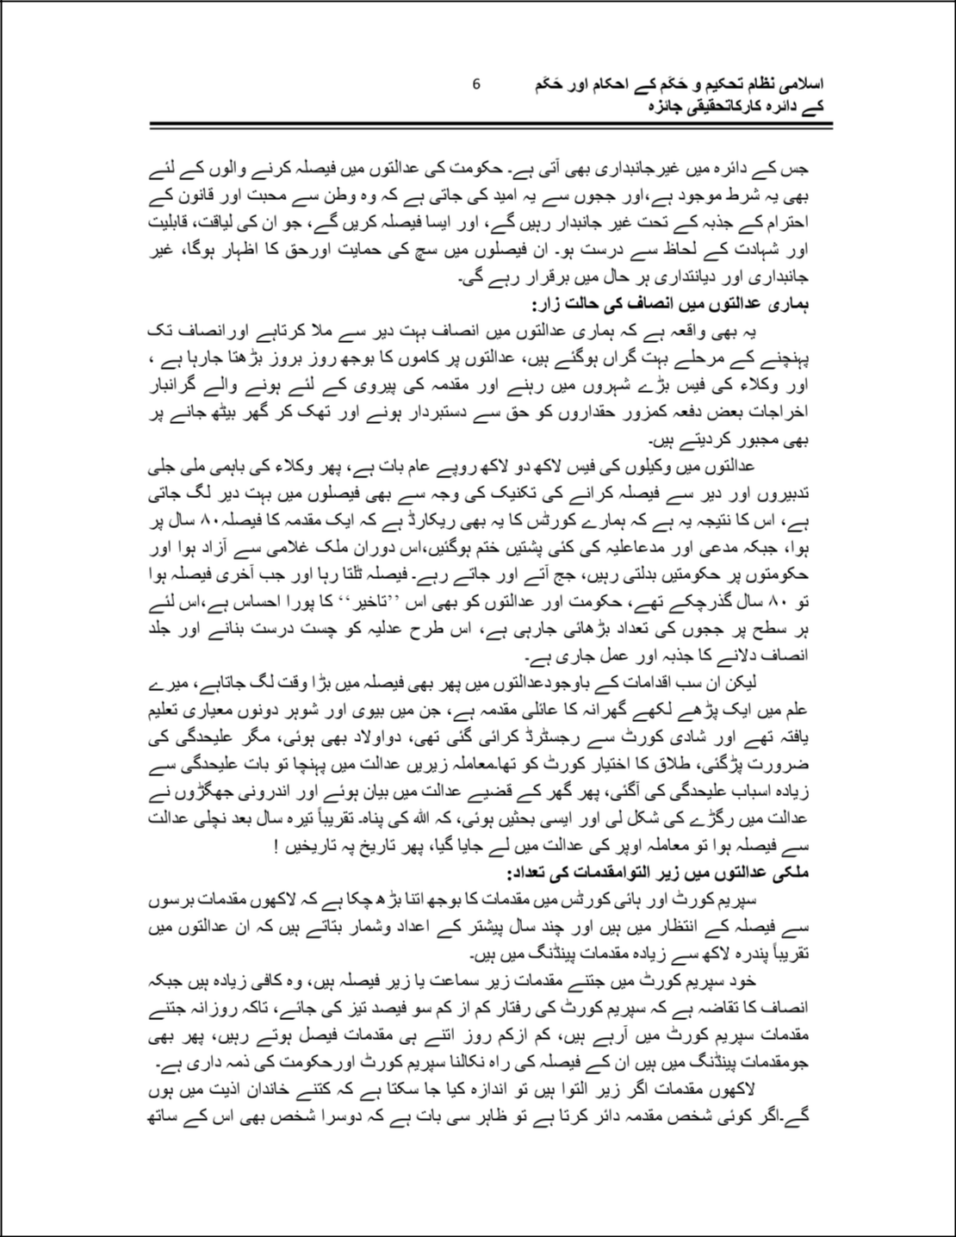

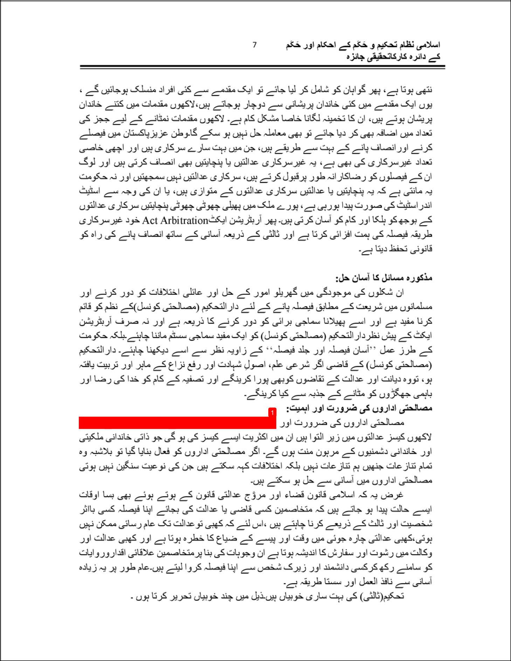

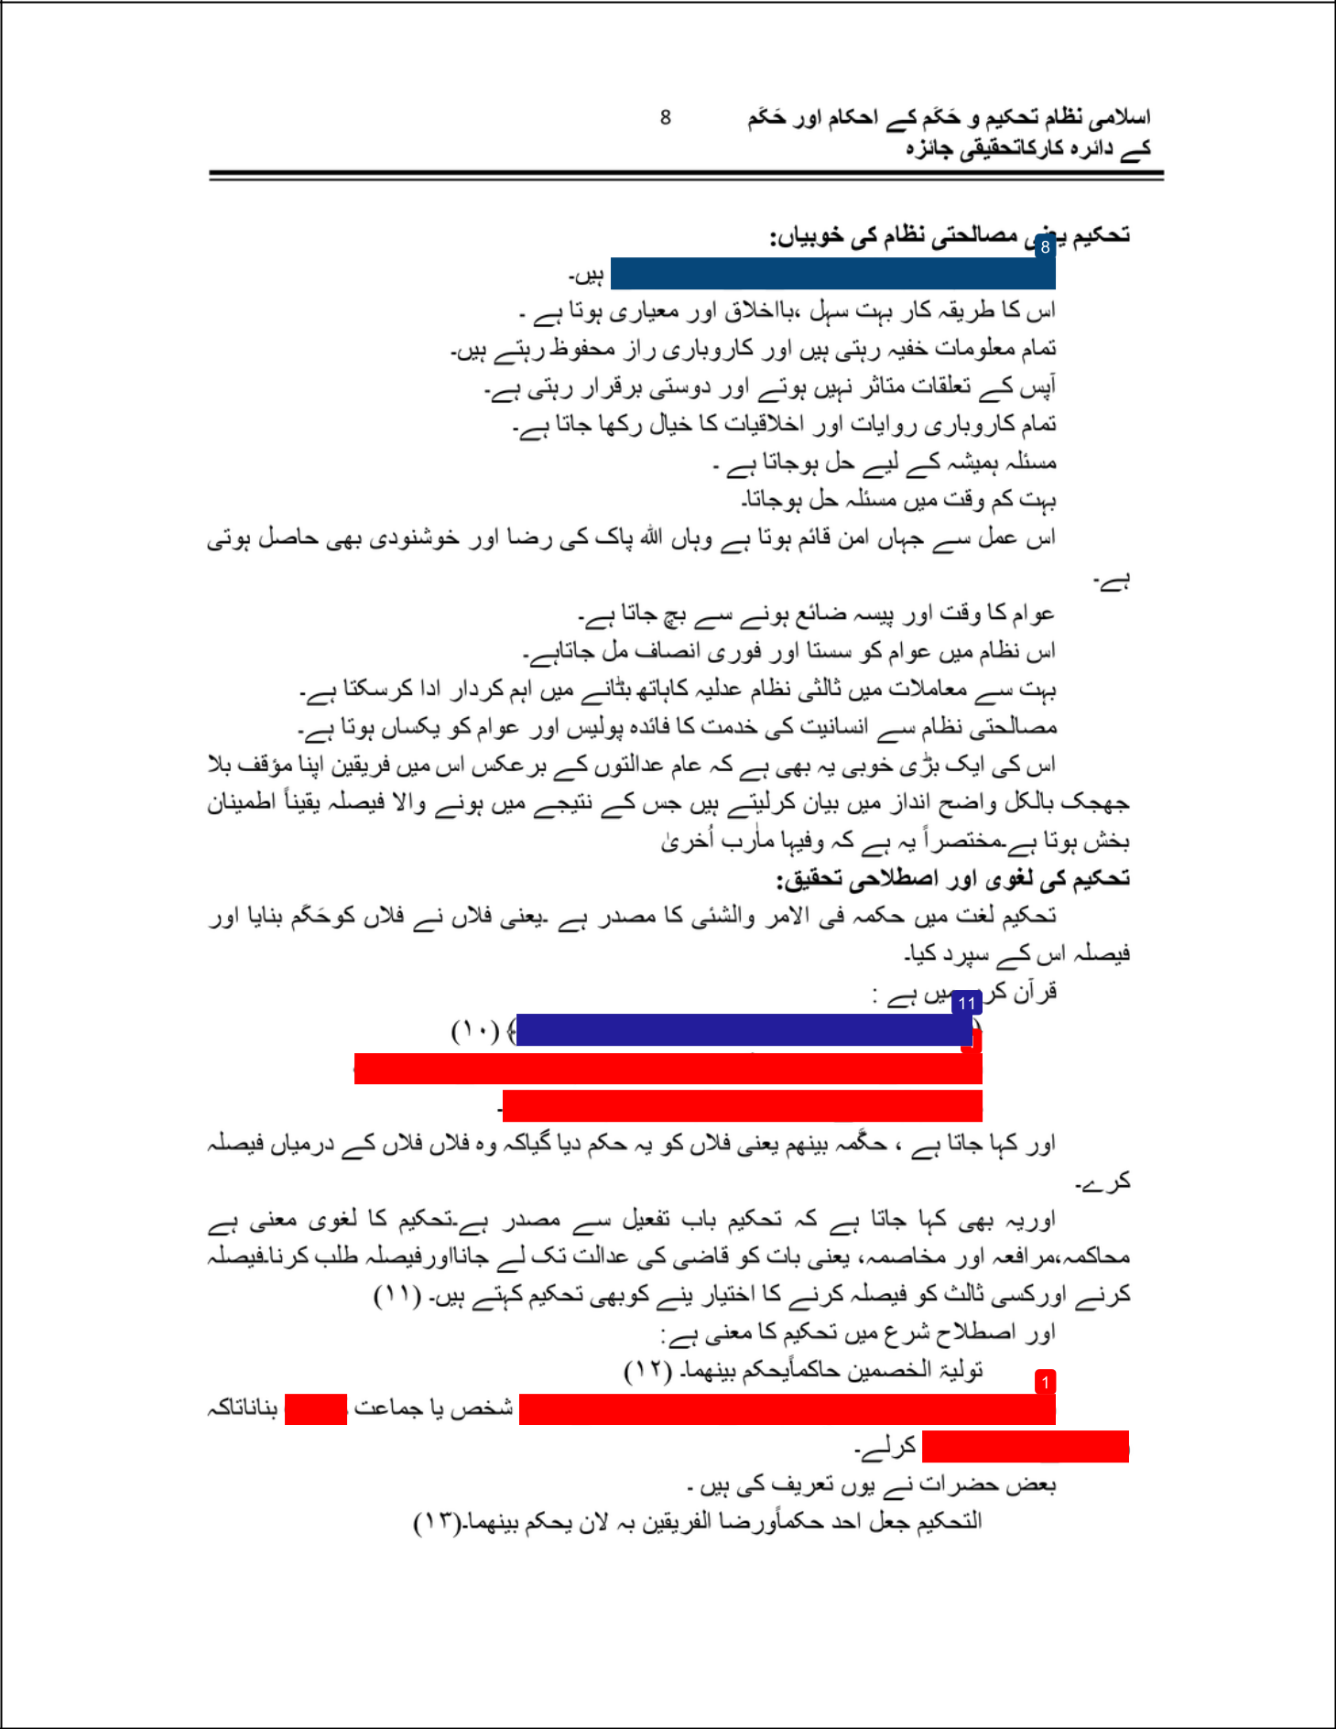

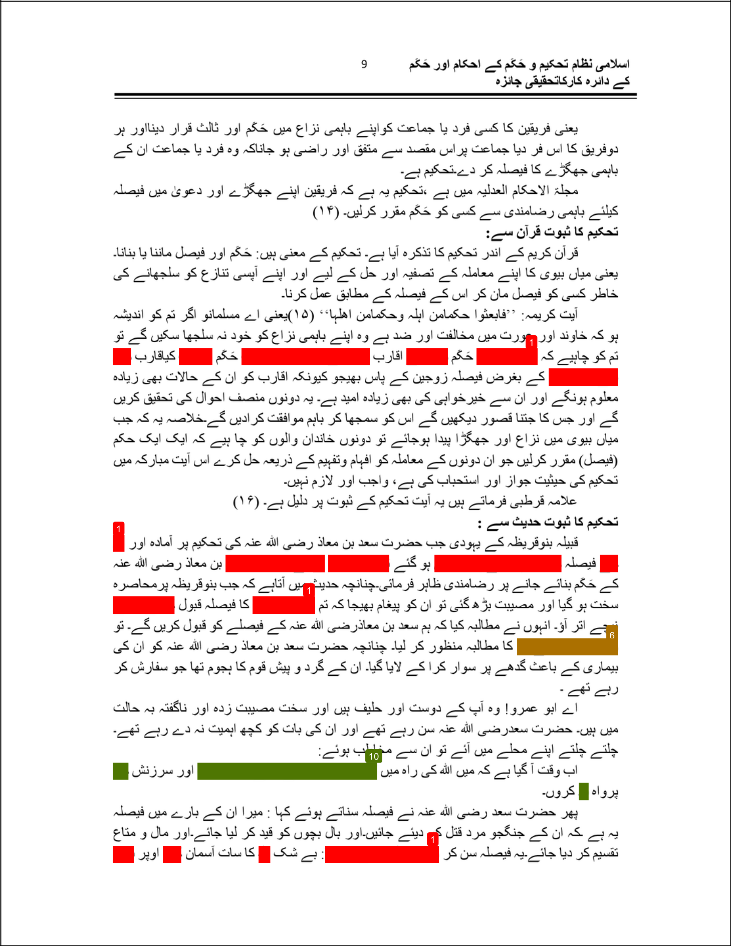

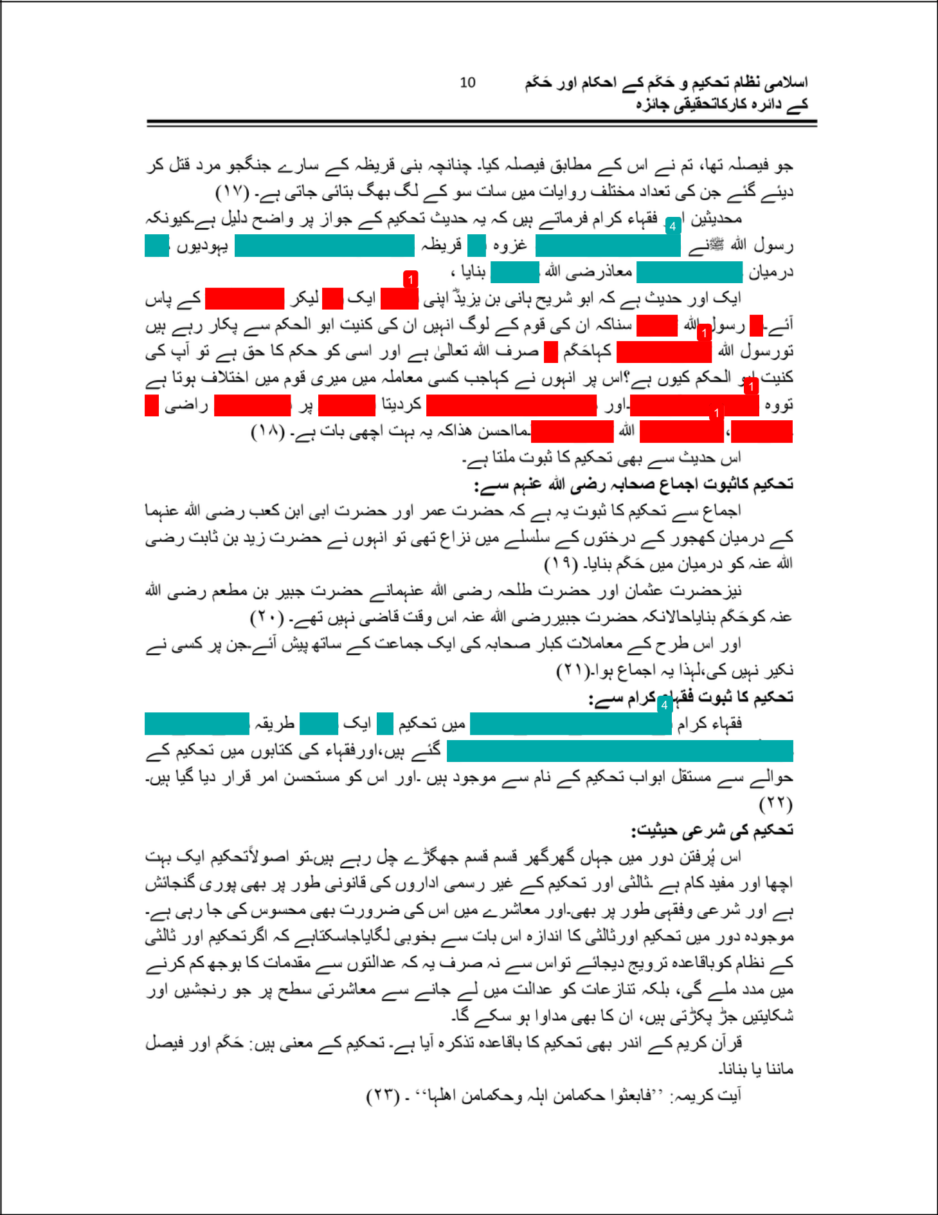

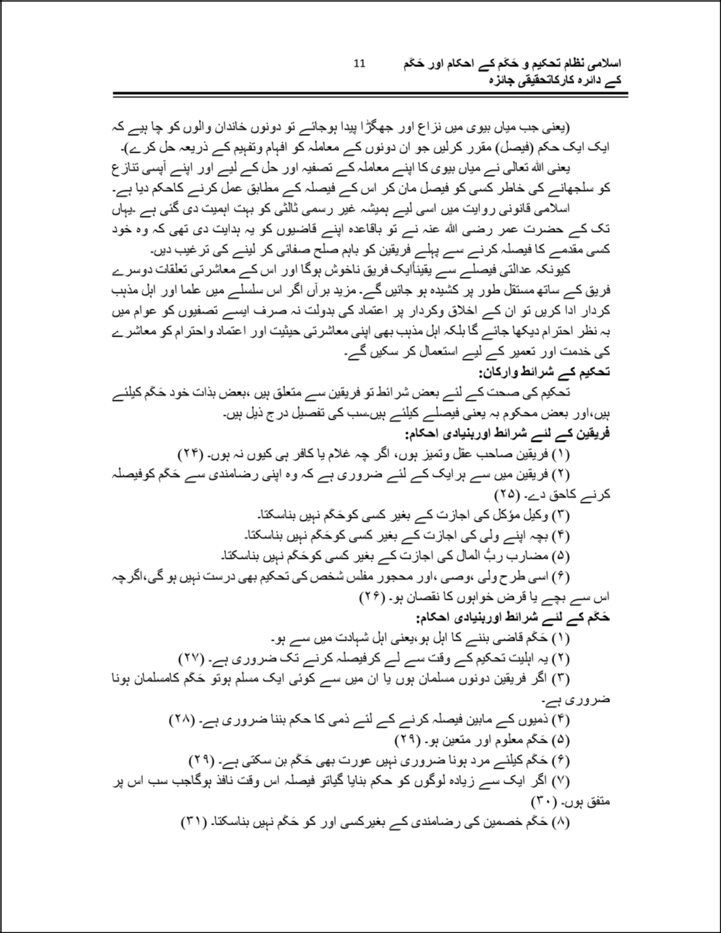

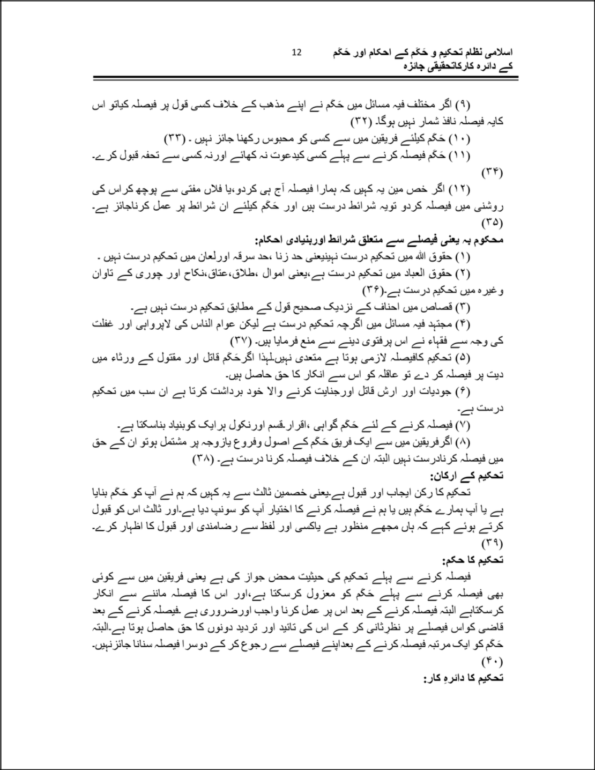

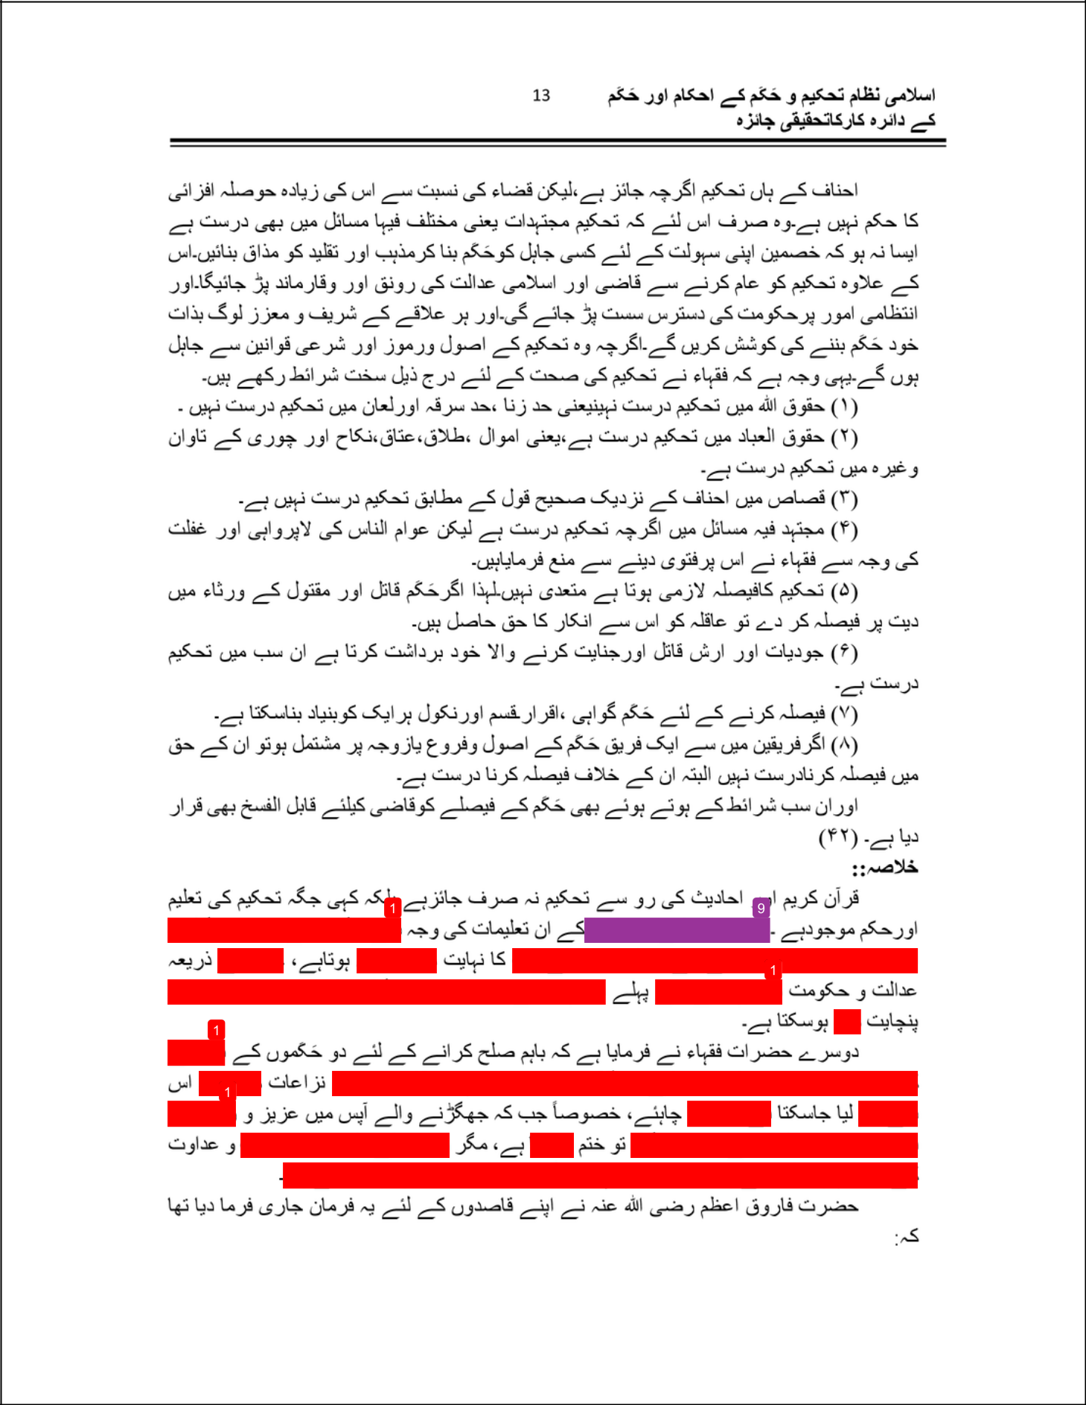

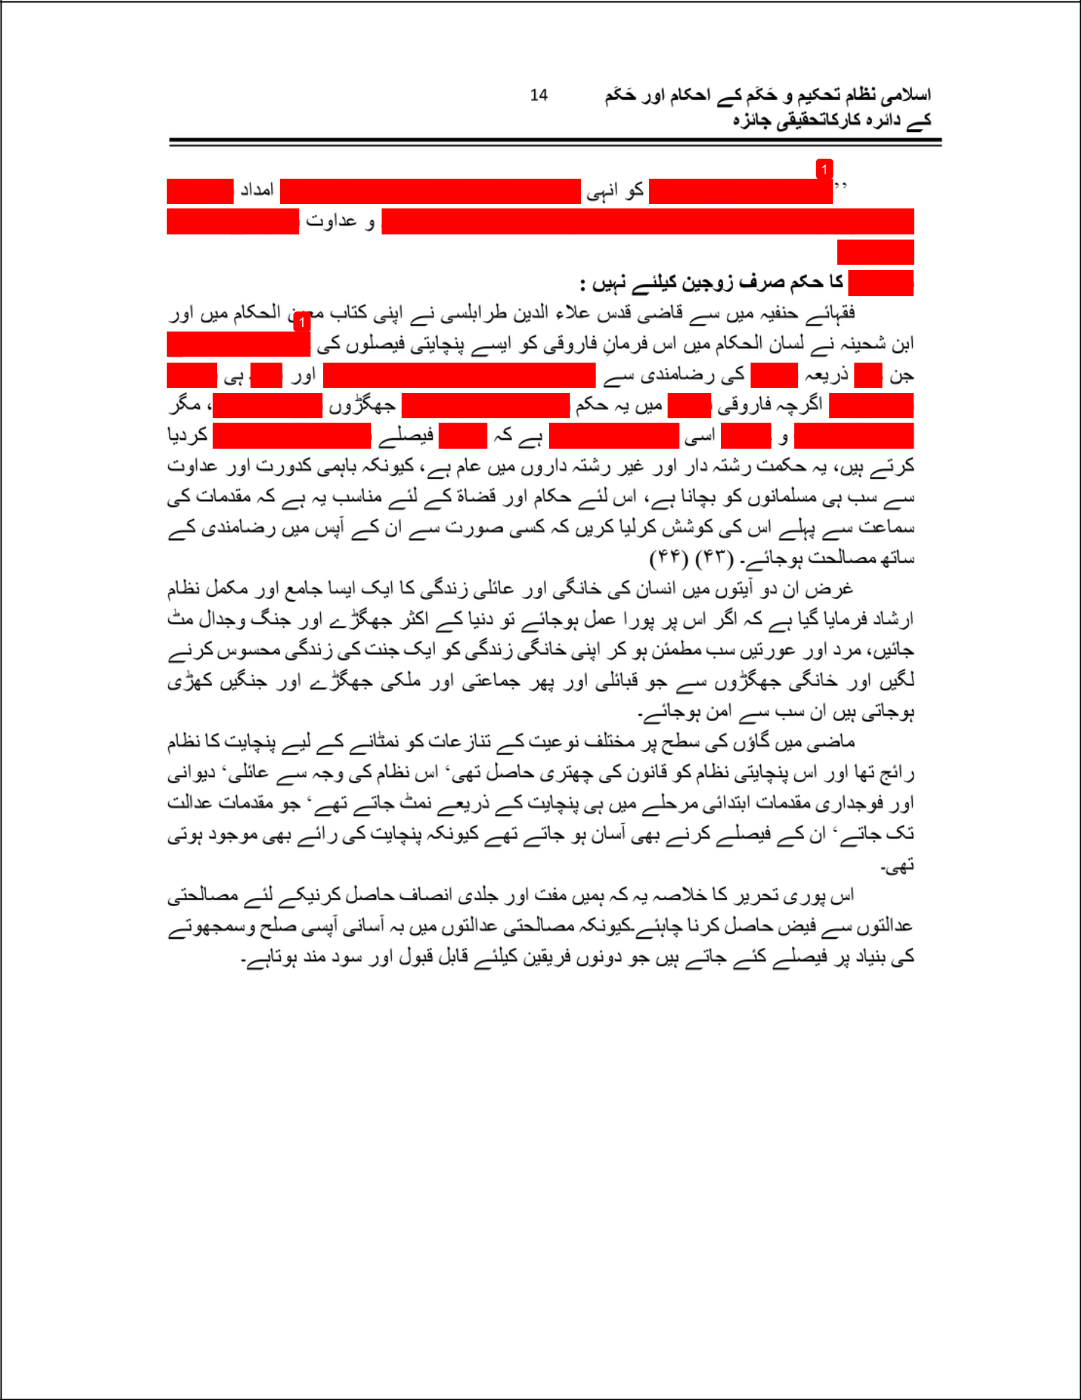

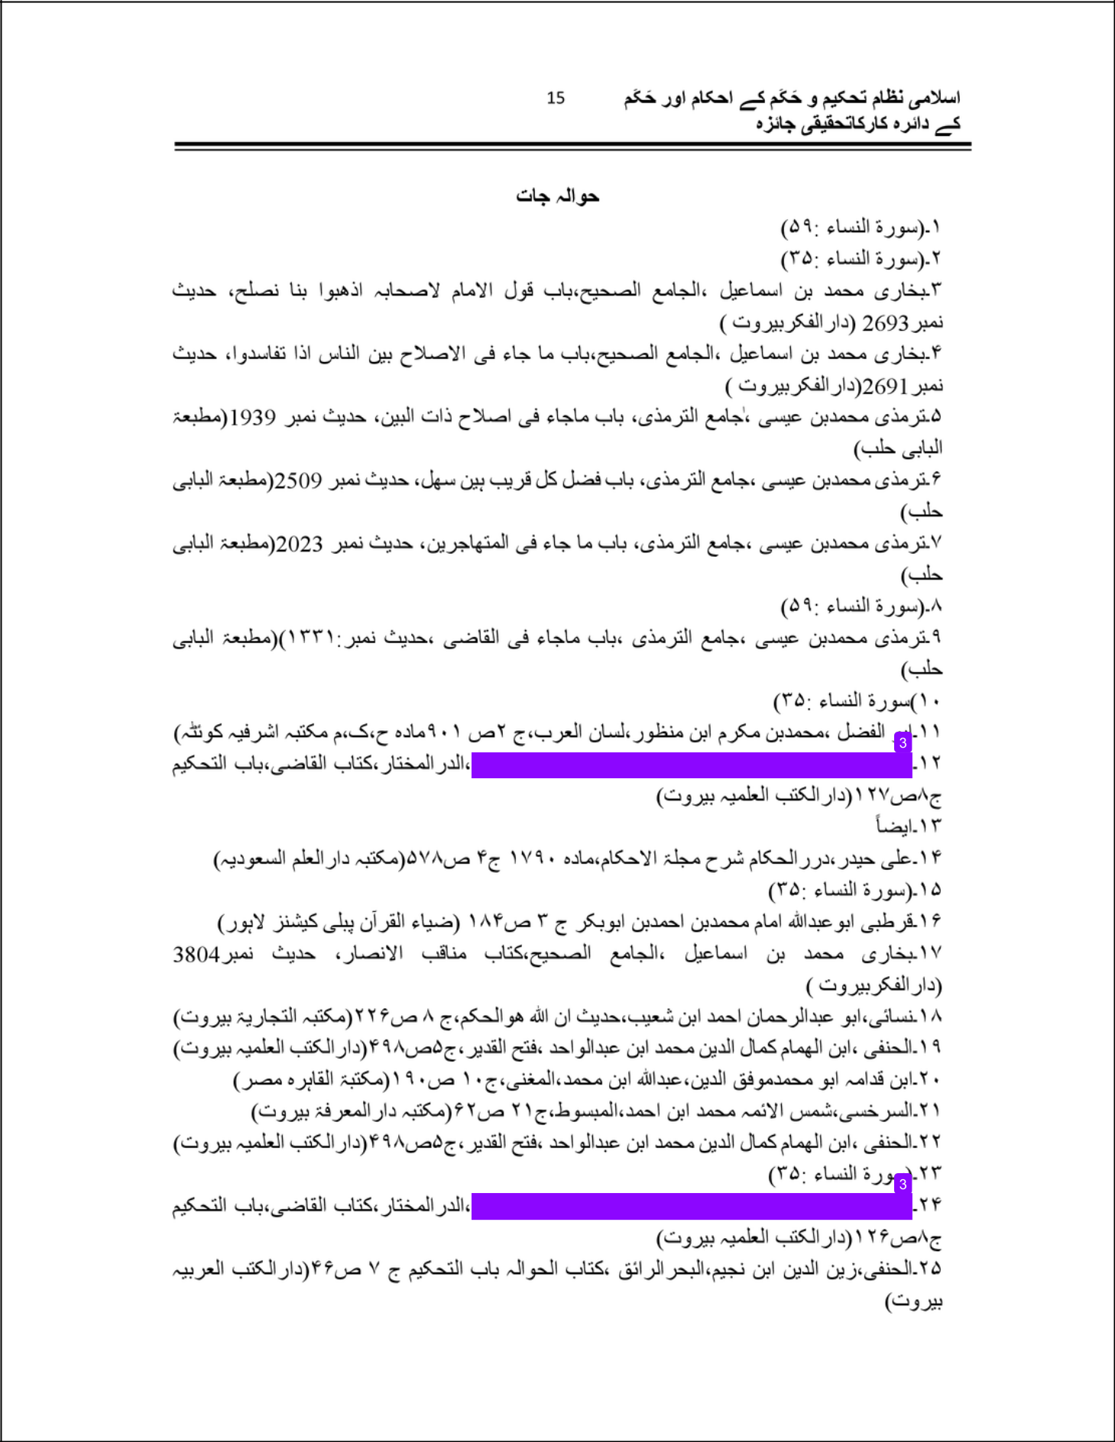

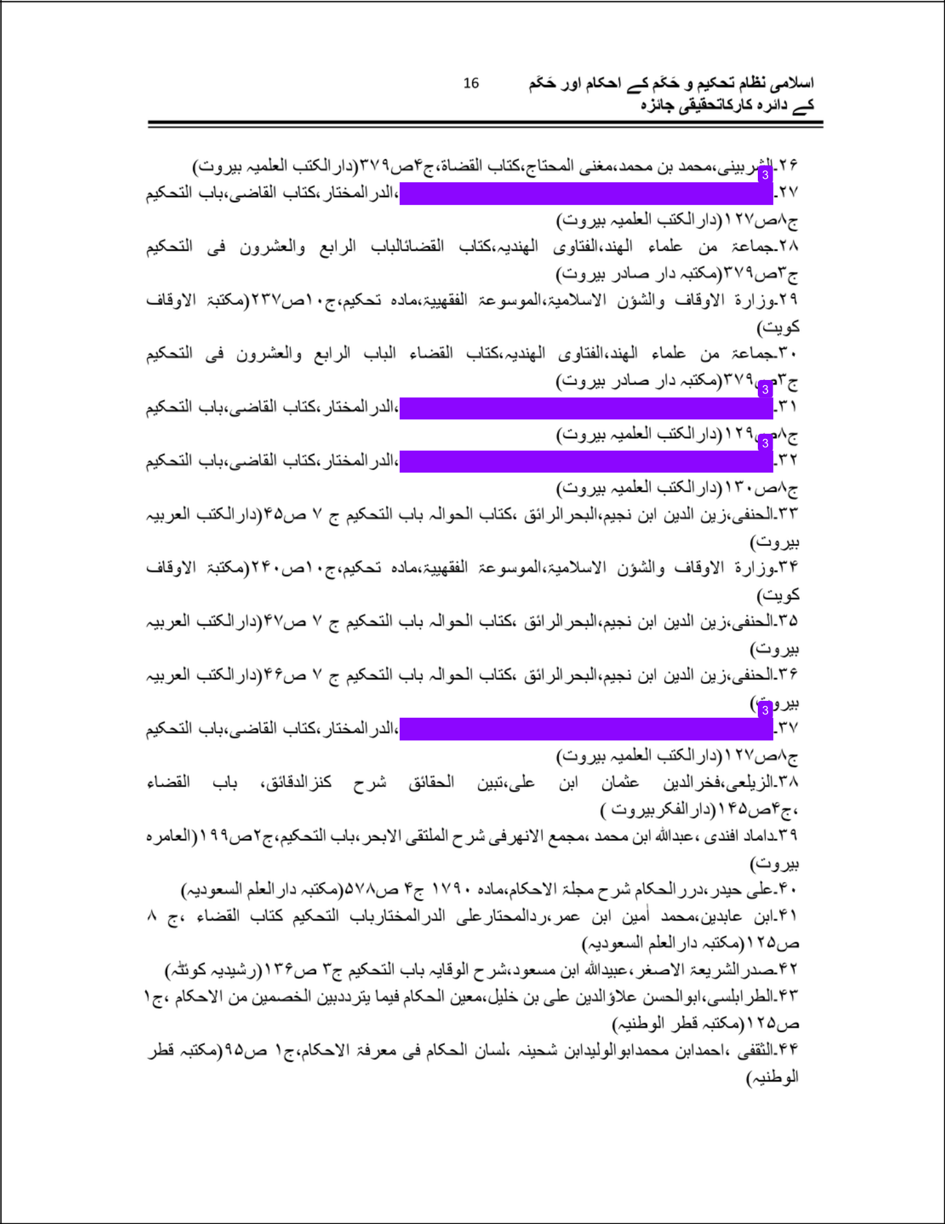

Mufti Abdul Waris Sb

ORIGINALITY REPORT

15% |  |  | 6% | 0% | 12%
 | SIMILARITY INDEX |  | INTERNET SOURCES | PUBLICATIONS | STUDENT PAPERS
 | PRIMARY SOURCES
 |  | Submitted to Higher Education Commission |  |  |  | 11%
 | 1
 |  | Pakistan
Student Paper

- pdxscholar.library.pdx.edu

Internet Source

- profdoc.um.ac.ir

Internet Source

- tablighijamaattruth.blogspot.com

Internet Source

- network.bepress.com

Internet Source

- www.farooqia.com

Internet Source

- urdublogz.com

Internet Source

- www.aanchal.com.pk

Internet Source

- allurdubooks.blogspot.kr

1%

1%

<1%

<1%

<1%

<1%

<1%

Internet Source

lib.bazmeurdu.net
10
Internet Source
mauripress.info
11
Internet Source
asianfoodworker.net
12
Internet Source
Kushner. Encyclopedia of Terrorism
13
Publication

<1%

<1%

<1%

<1%

<1%

Exclude quotes Of f Exclude matches Of f

Exclude bibliography Of f

