Shabir Ahmed​

by Salman Ahmed

Submission date: 02-Apr-2019 09:48PM (UTC+0500)

Submission ID: 1104576245

File name: .doc (167.5K)

Word count: 4595

Character count: 19394

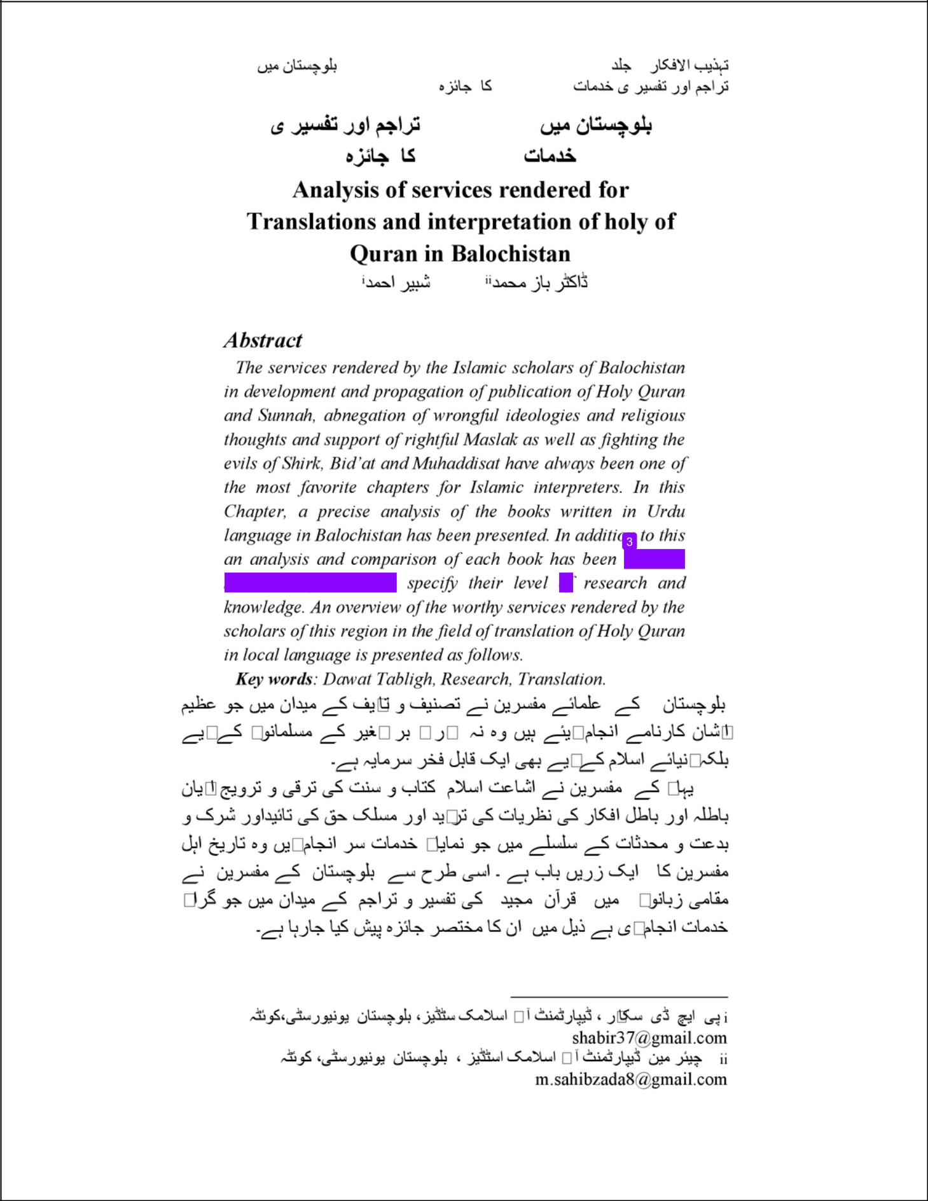

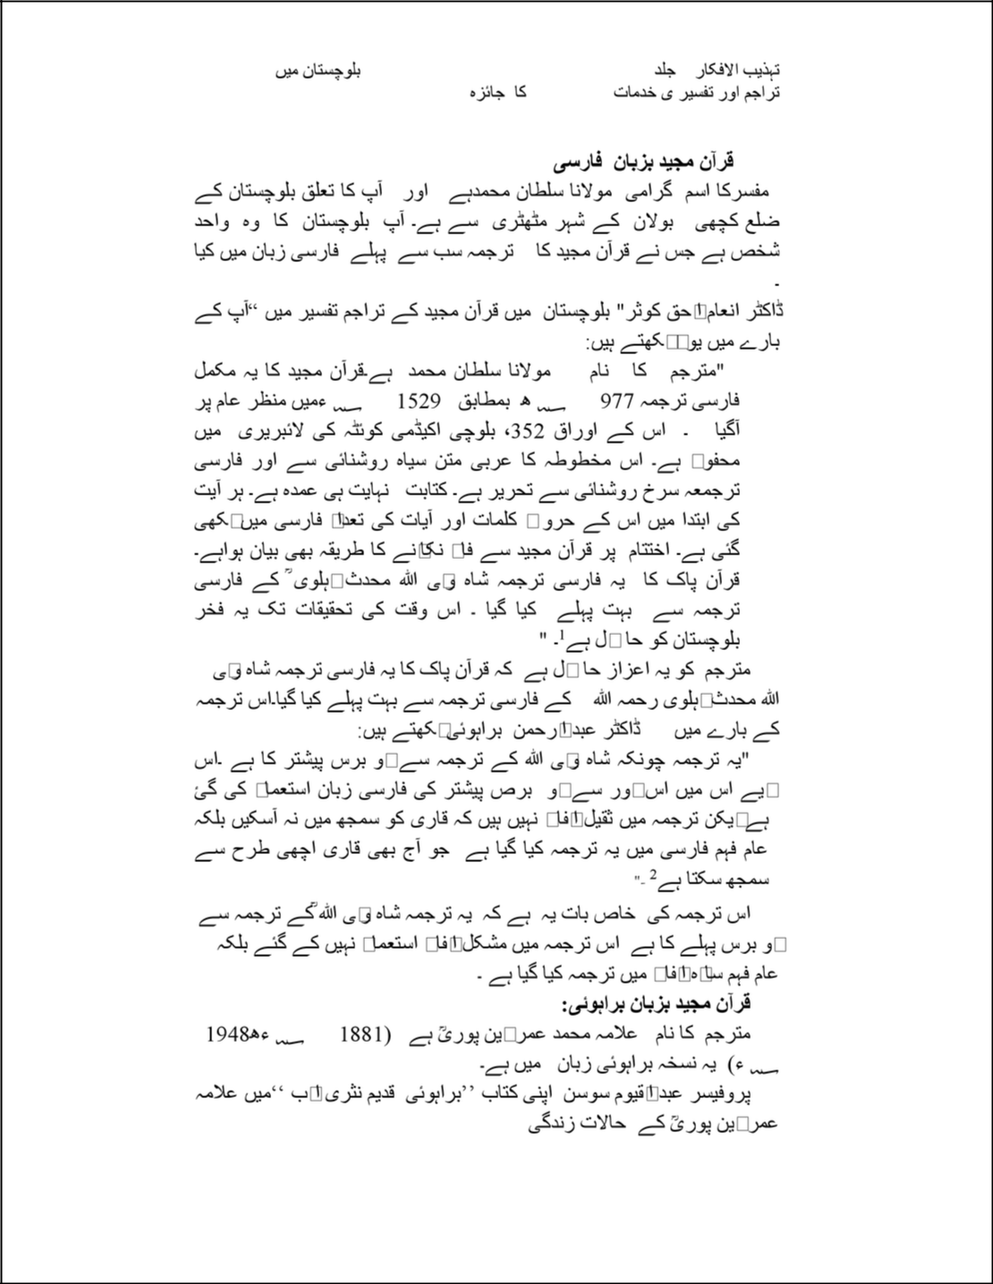

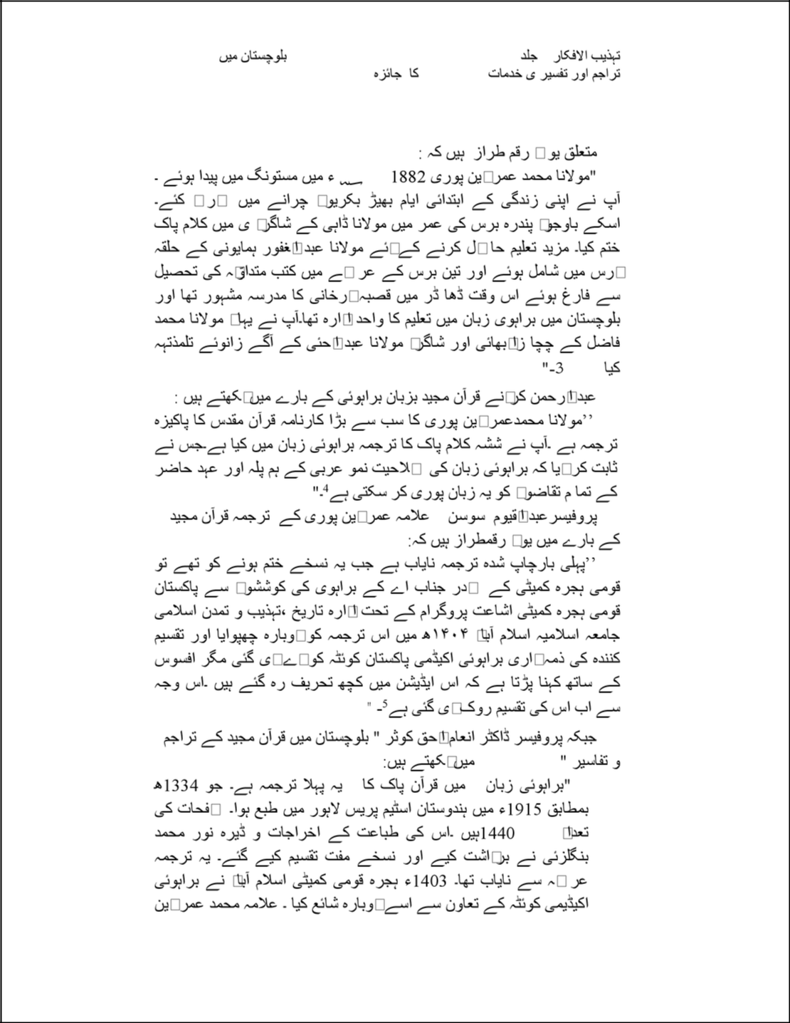

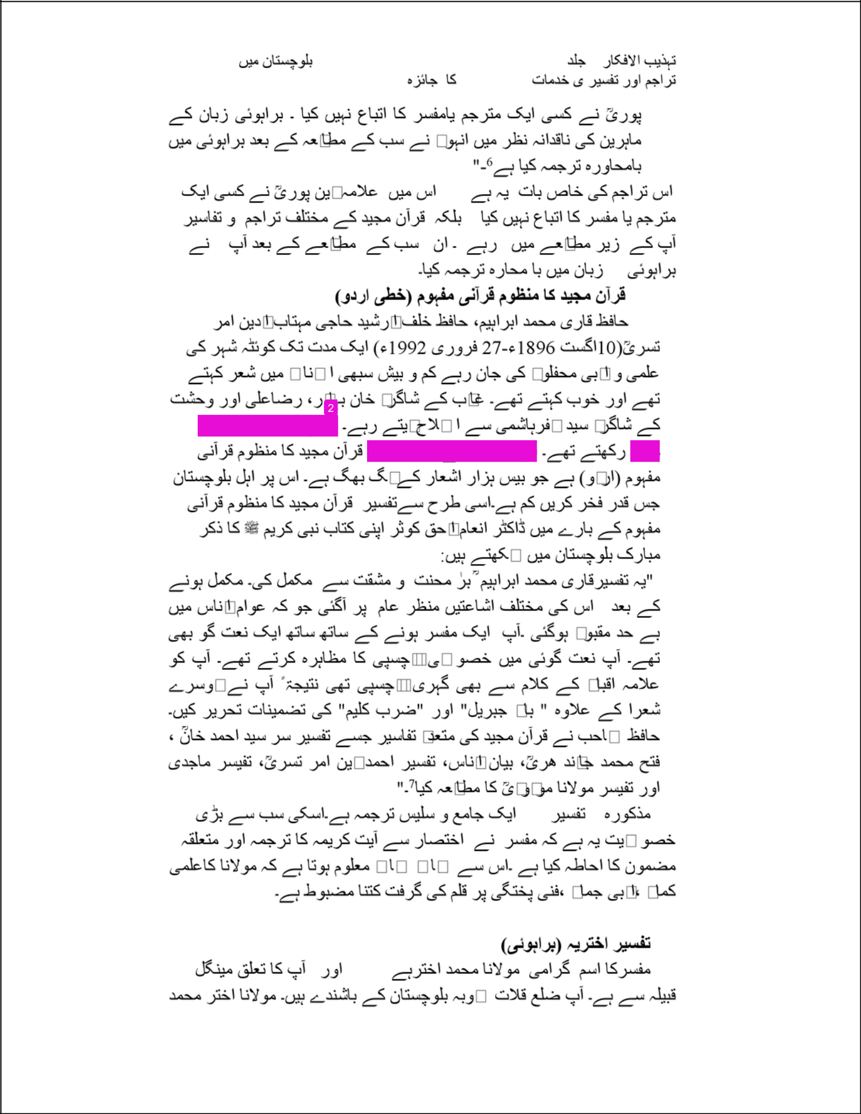

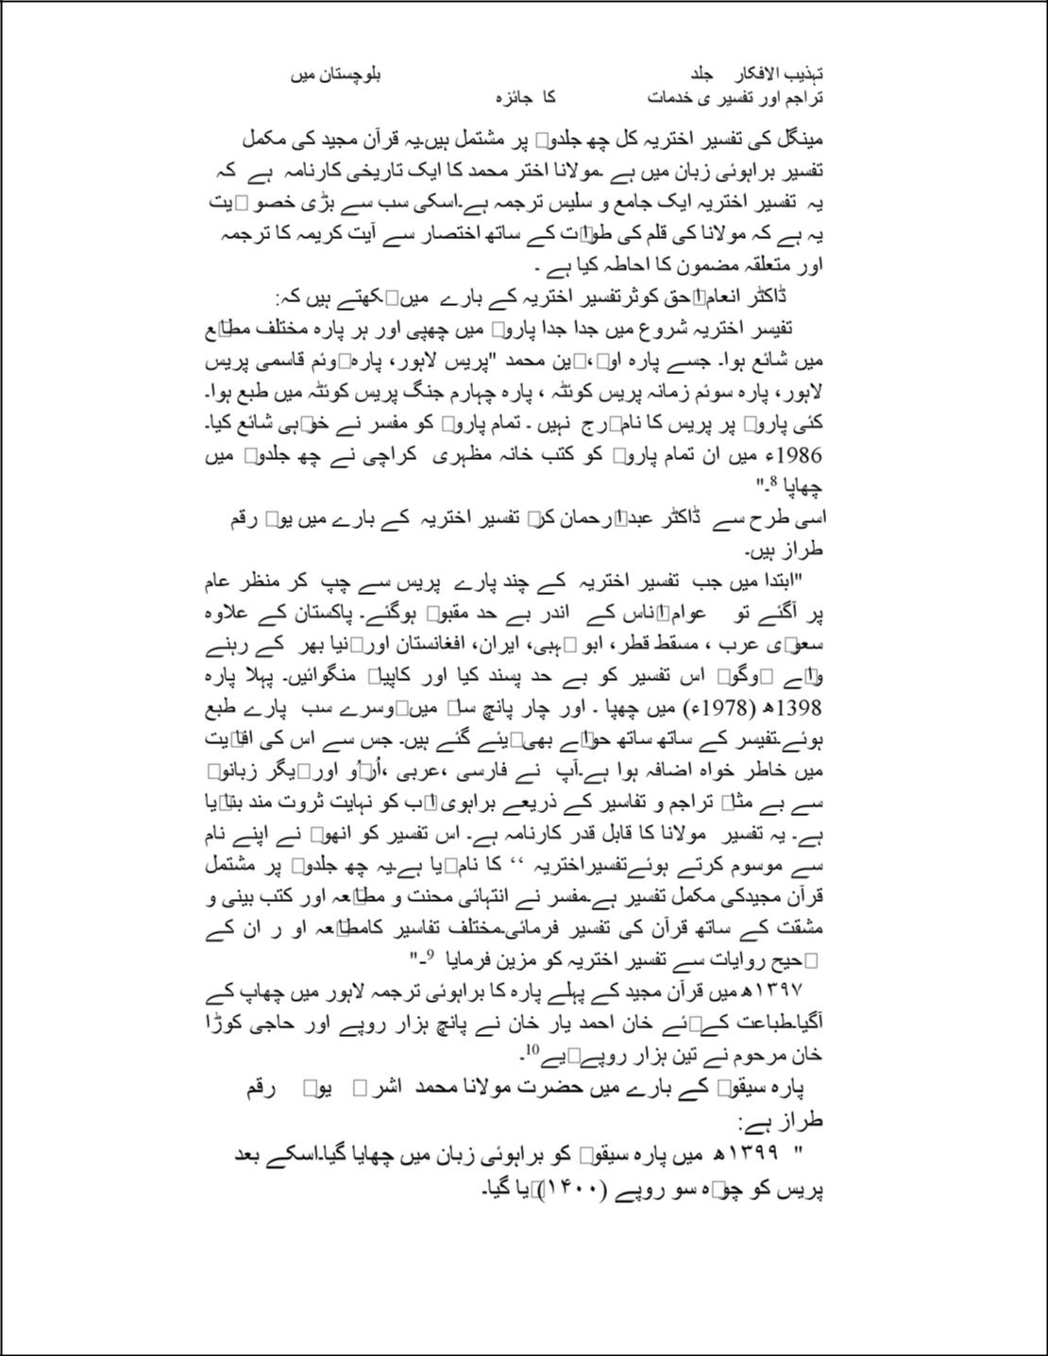

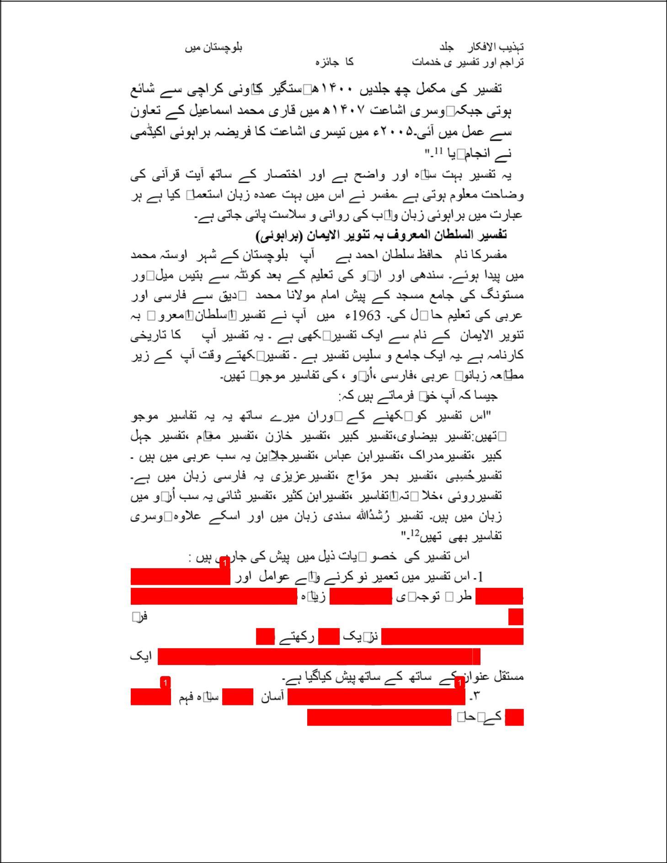

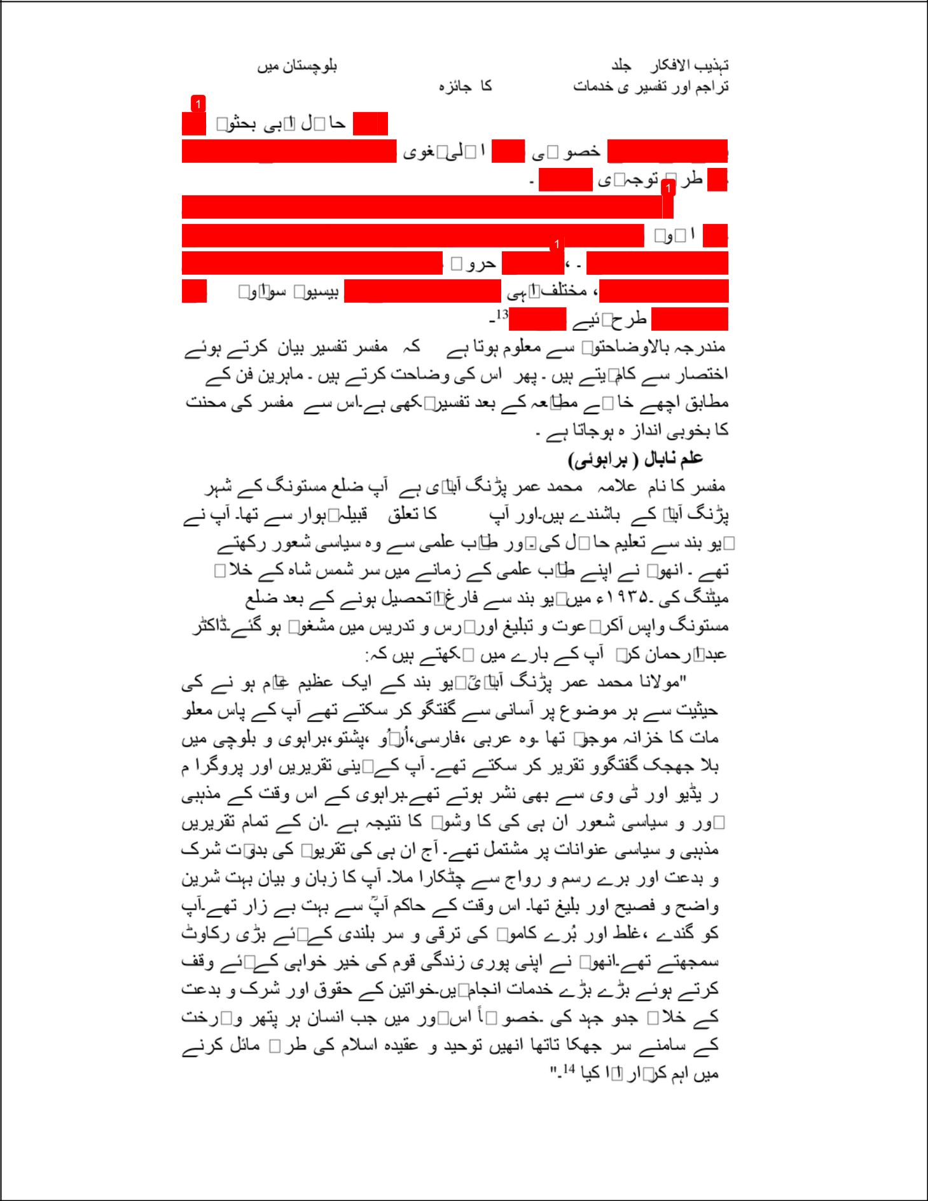

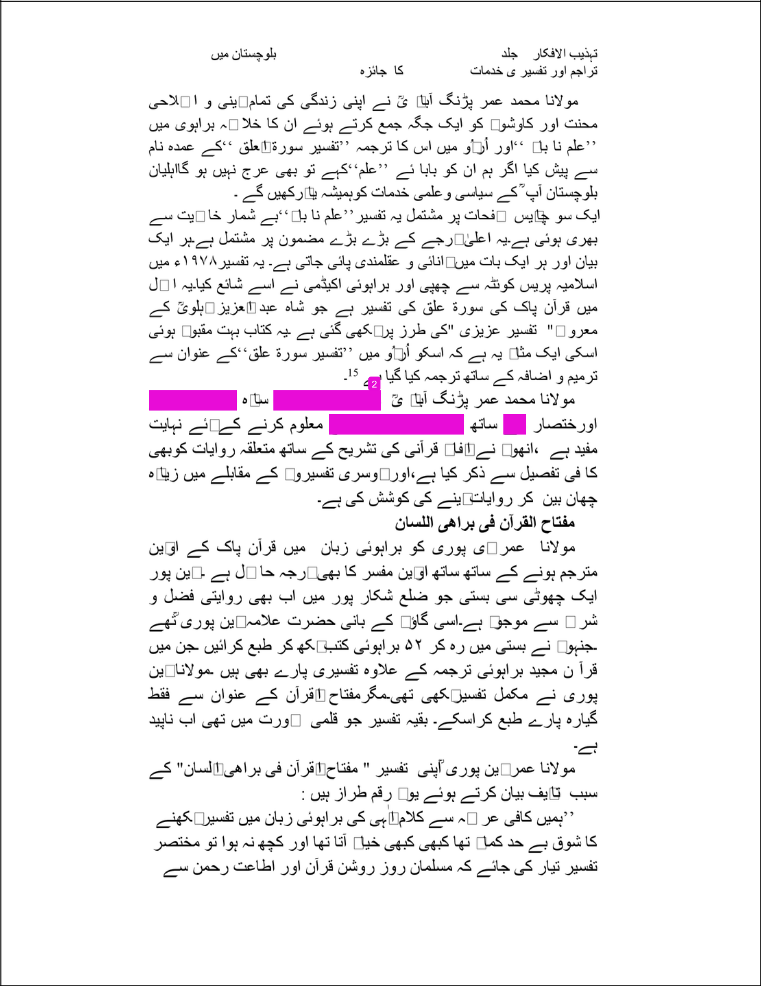

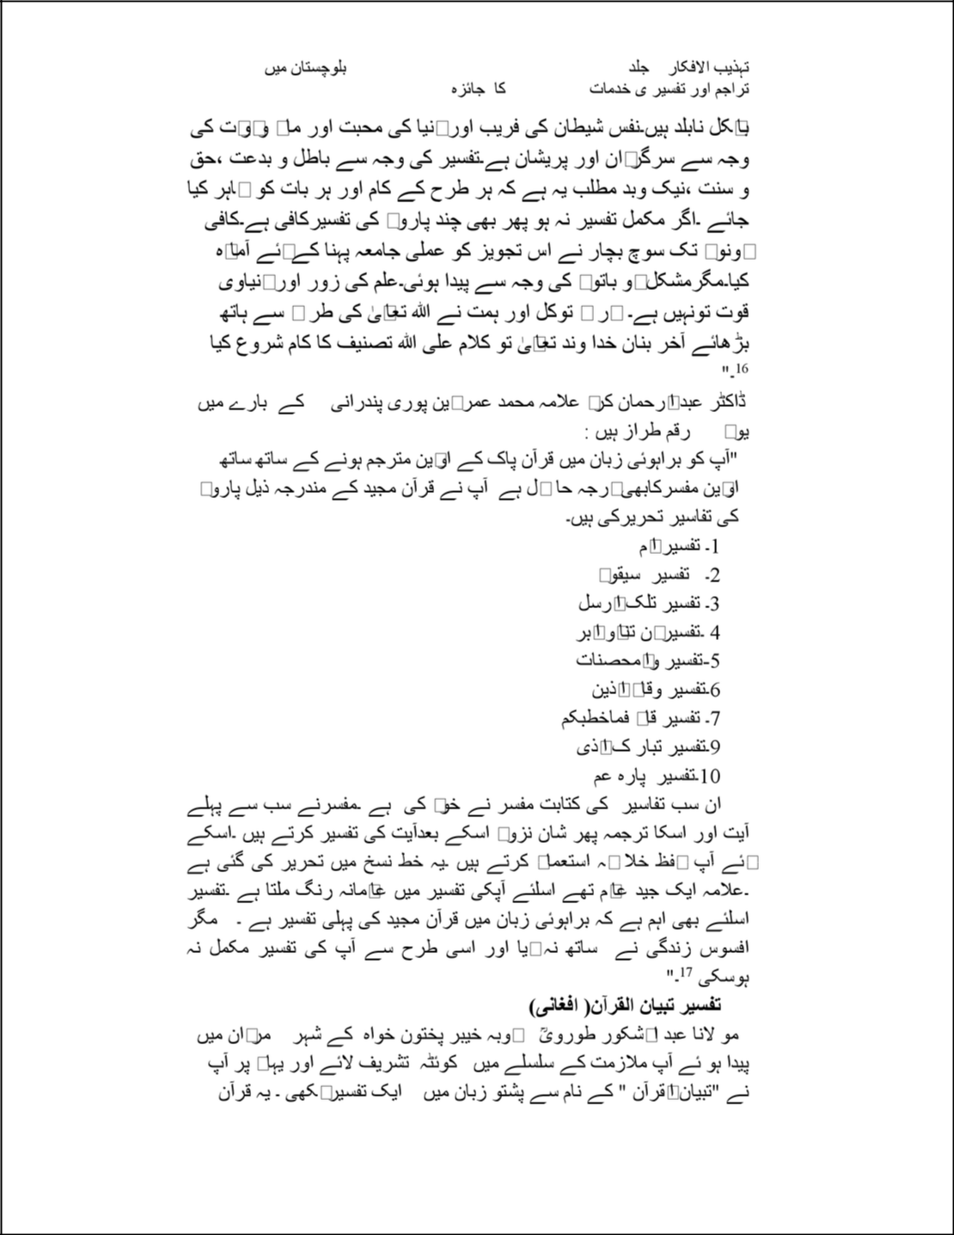

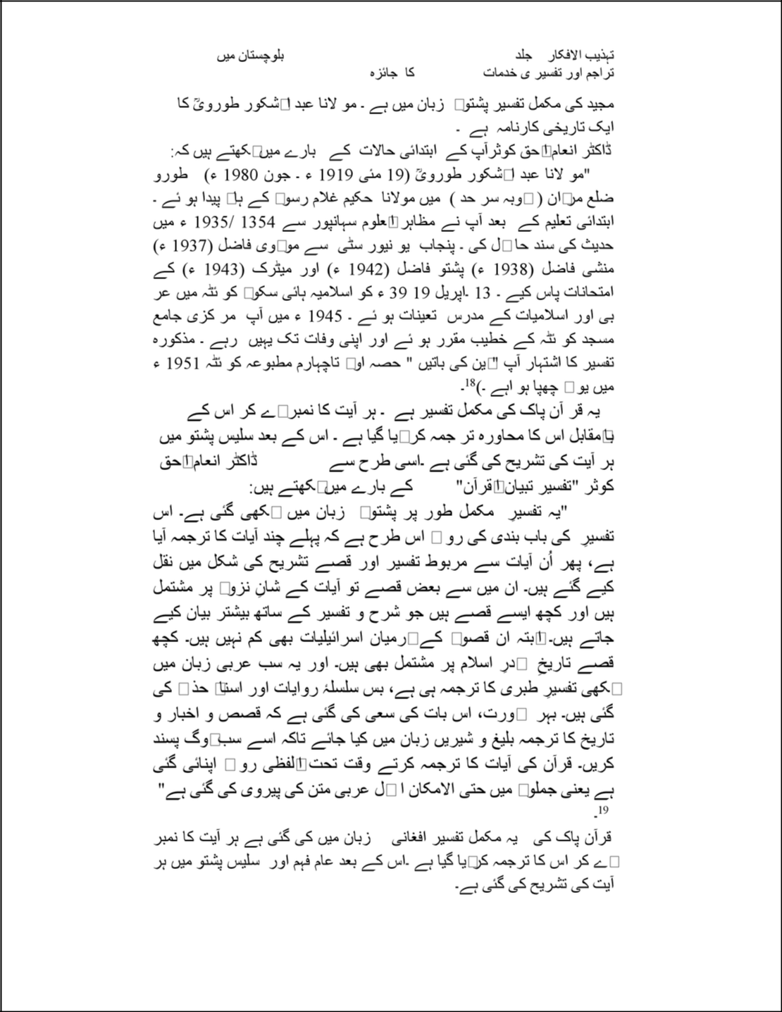

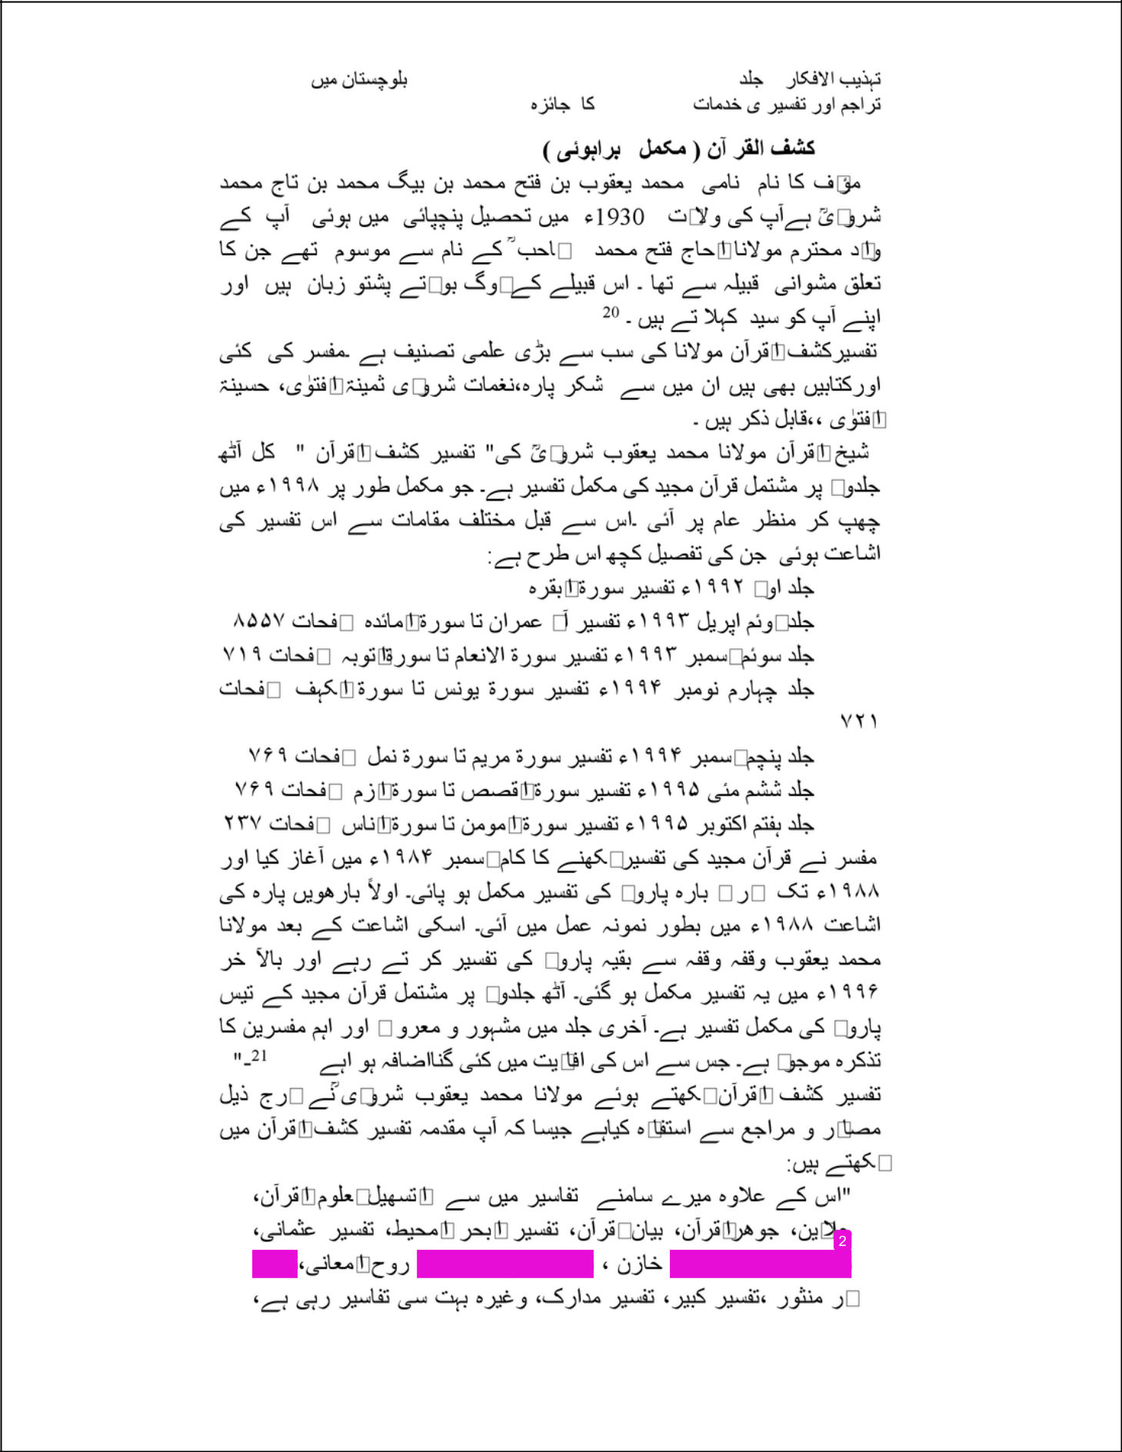

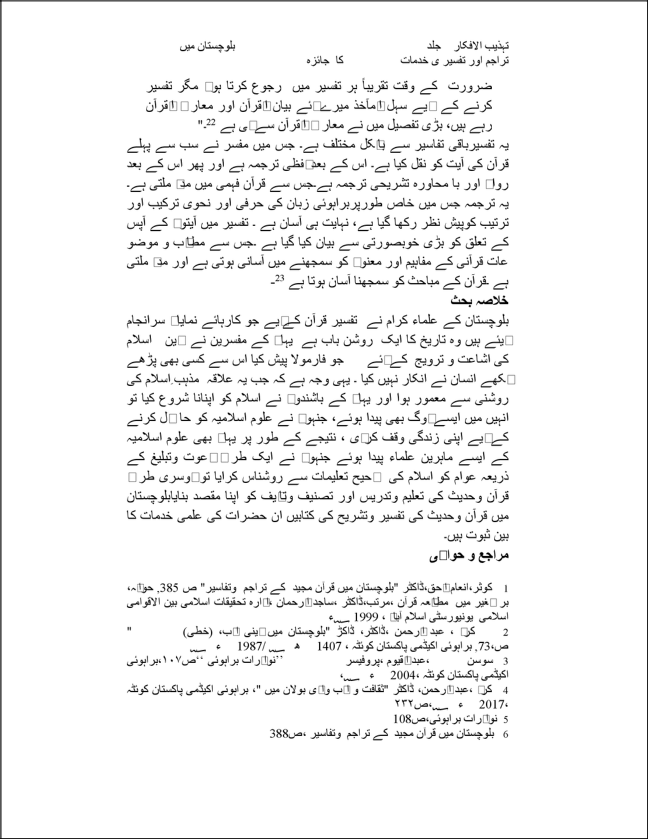

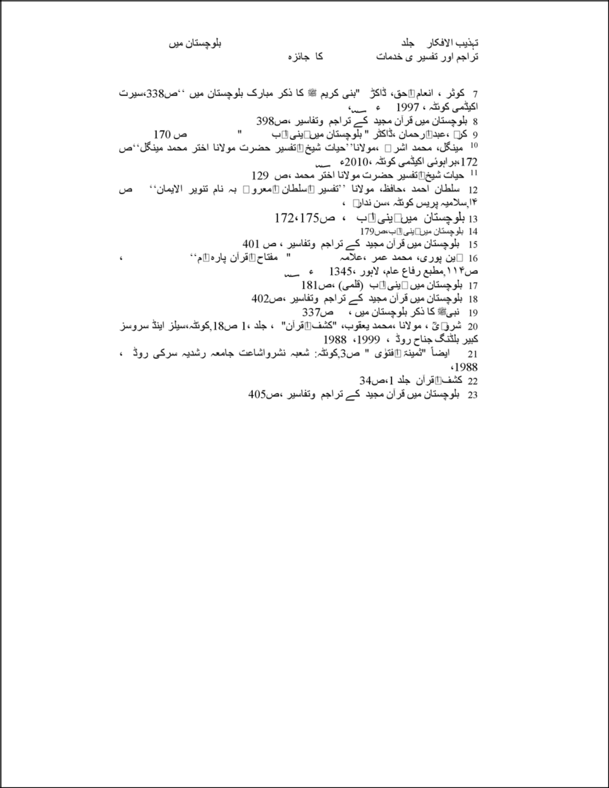

Shabir Ahmed​

ORIGINALITY REPORT

3% |  |  | 3% | 0% | 1%
 | SIMILARITY INDEX |  | INTERNET SOURCES | PUBLICATIONS | STUDENT PAPERS
 | PRIMARY SOURCES
 |  | islamicblessings.com |  |  |  | 2%
 | 1
 |  | Internet Source
 |  | Submitted to Higher Education Commission |  |  |  | 1%
 | 2
 |  | Pakistan
 |  | Student Paper
 |  | joetuna.com |  |  |  | <1%
 | 3
 |  | Internet Source

Exclude quotes

Of f

Exclude matches

Of f

Exclude bibliography

Of f

